Prusa Slicer
Prusa Slicer is the version of 3d Slic3r adapted for the Prusa i3 MK3S

Prepping your 3d model for printing
1 | Open the PrusaSlicer  application. If you are prompted that a Configuration Update is available, click to install the update before proceeding further.
2 | Use the Add  button to load models into PrusaSlicer
3 | Delete  Delete All buttons remove the model(s) from PrusaSlicer opens the detailed settings of print , filament and printer

4 | Use Move, scale, rotate , Place on Face  and cut tools  to prepare the model to printing in the most efficient/ effective orientation,
5 | 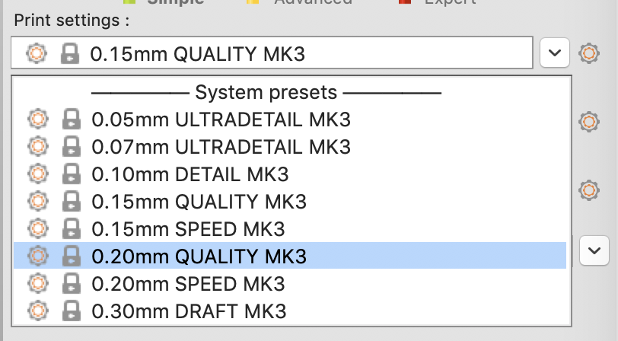  Select a Quality / Speed setting for your print
6 | 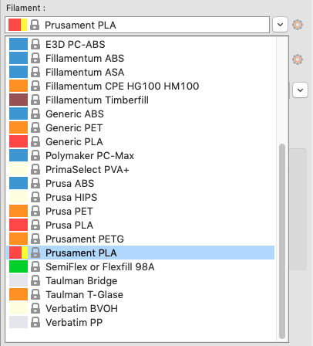  Material selection (on Fabrication Lab computers, only filament brands/polymers provided in the Lab will appear in the dropdown list)
7 | 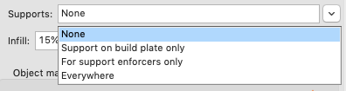  Select a Supports setting

8 | 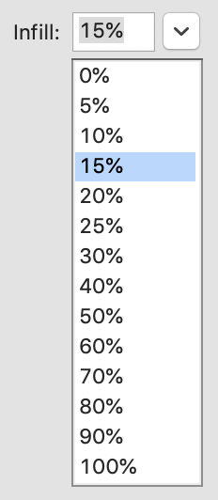  Select an Infill percentage
9 | Click Slice to slice the model into layers in the Z axis and select layers preview to view infill land

10 | 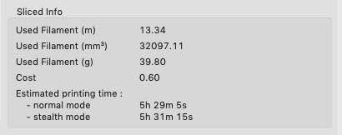  Check the Sliced Info for the cost and how long its going to take to print before exporting your gcode  The Edge charges 15cents / gram and your print needs to be finished before the Lab Closes - talk to the Fab Lab Supervisor if you have a long job you'd like to do .
11 | Generate and export gcode to the SD Card by clicking the Export G-Code button .

Hint | Right-click on model opens a context menu
Hint | Switch between 3D editor and Layer Preview by clicking  &

