Inductions- software & technology
Throughout the year there are a series of induction sessions in the fabrication lab, recording studio as well as the digital media lab, which give people (you) the basic skills, safety awareness and knowledge of how to efficiently use the resources on offer.
Book and complete a safety induction for your chosen resource, and then it’s yours to book and use for free during Community Lab times. Inductions are very popular and generally run once or twice a month, with just 5-10 participants in each; so you’ll need to book ahead of time. Each induction covers the safety procedures for the resource, along with how to operate it, presets and basic troubleshooting. During your induction, you will use the resource to make your own mini project, supplied by the facilitator.
For the latest available inductions, search eventbrite , and to keep informed about up-coming events you can subscribe to The Edge newsletter.
For an overview of our frequent inductions and the equipment used - see below.
( Resources and development of the in-house inductions are provided by programming staff and contractors at State Library The Edge. )

technology inductions

General Induction - Fabrication Lab

Laser Induction:
Our laser can cut and etch wood, plastics, paper, cloth and leather quickly and accurately. In this induction you will learn what software you can use, how to prepare design files and how to operate the machine safely. Use your creativity to personalise the design template provided, and take home your first project.
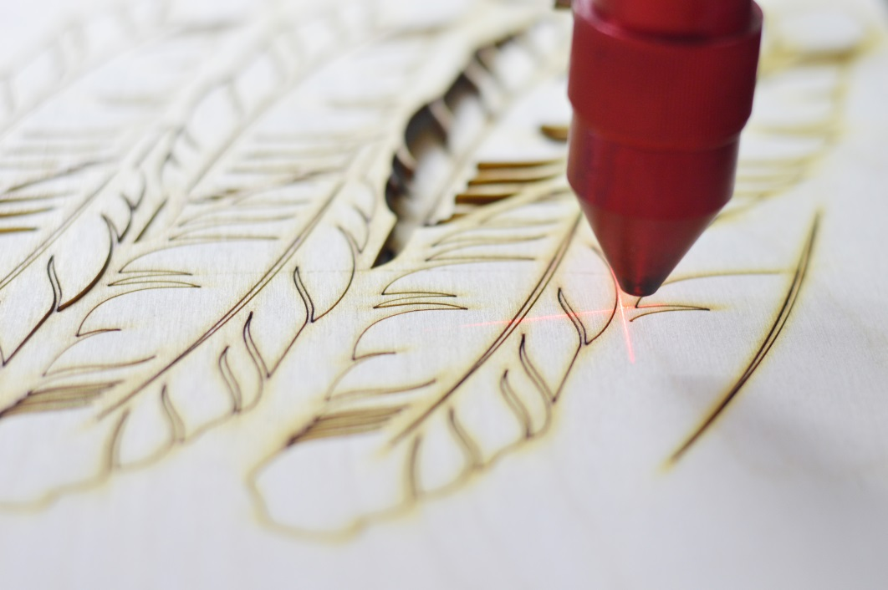

3D printing
Our 3D printers turn a virtual 3D model into a solid plastic object. You can create the virtual model from scratch, or make one from an existing object using a 3D scanner. In this induction you will learn what software you can use to create your model, how to load it into the printer, and clean up the product,. Use your creativity to personalise the design template provided, and take home your first project.
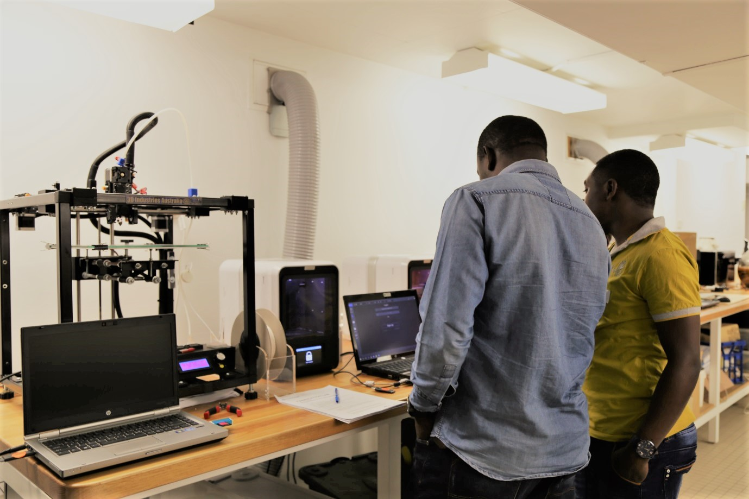

Sewing
Mend or make with our sewing machines to revive an old favourite, follow a pattern or test your design innovations. In this induction, you learn how to set up a machine, cut and pin, sew straight and make a handy tote bag you can take home.
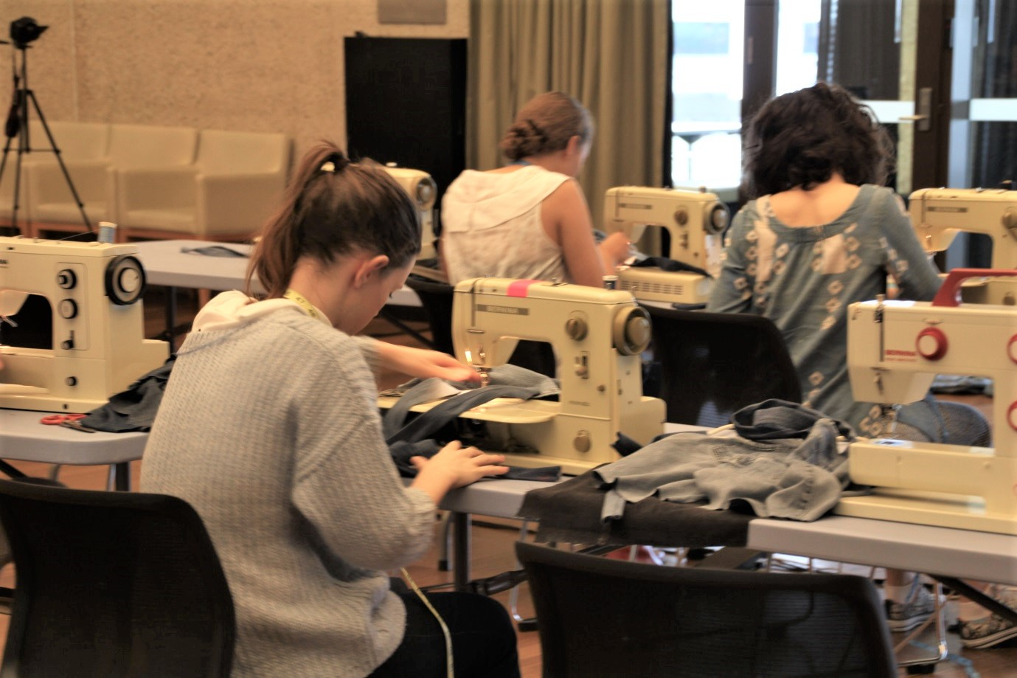

Electronics Bench
Our electronics workbench has soldering and test equipment that you can use to build, troubleshoot and repair your electronics projects. In this induction you will learn about some common components and how to safely use the equipment as you assemble a simple project kit.
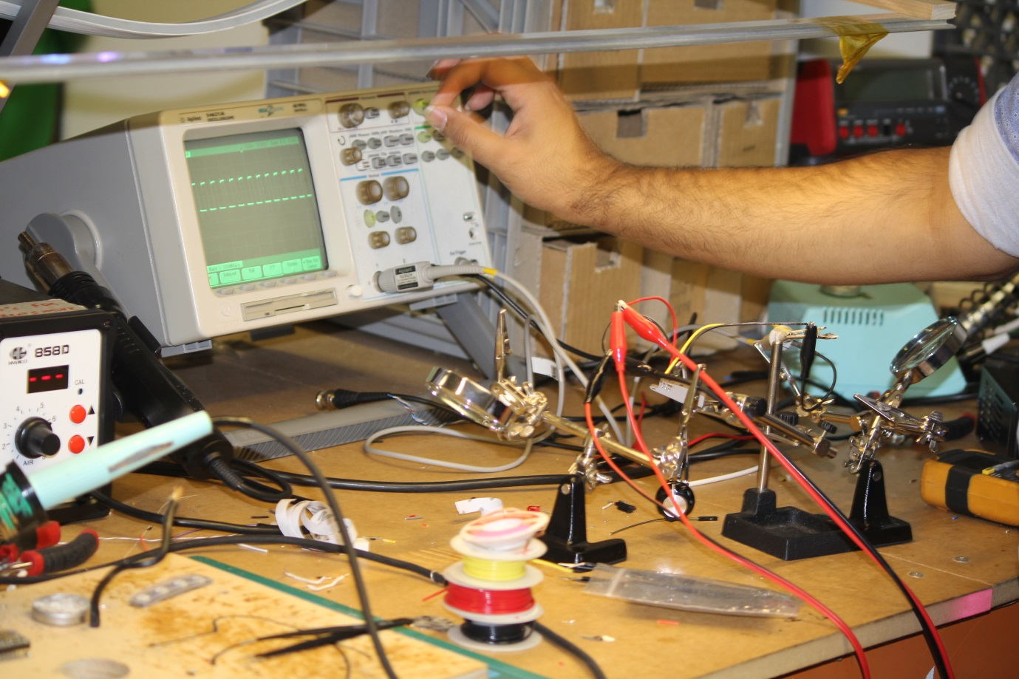

CNC Router
Our CNC router is an industrial scale machine that can cut and shape a sheet of plywood into flat-pack furniture, storage units or a cubby house from designs created using 2D drawing software. In this induction you will learn some practical tips for good designs, how to choose and use the right tools and operate the machine safely using specialized software. Use the template provided to make your own handy stool to take home.
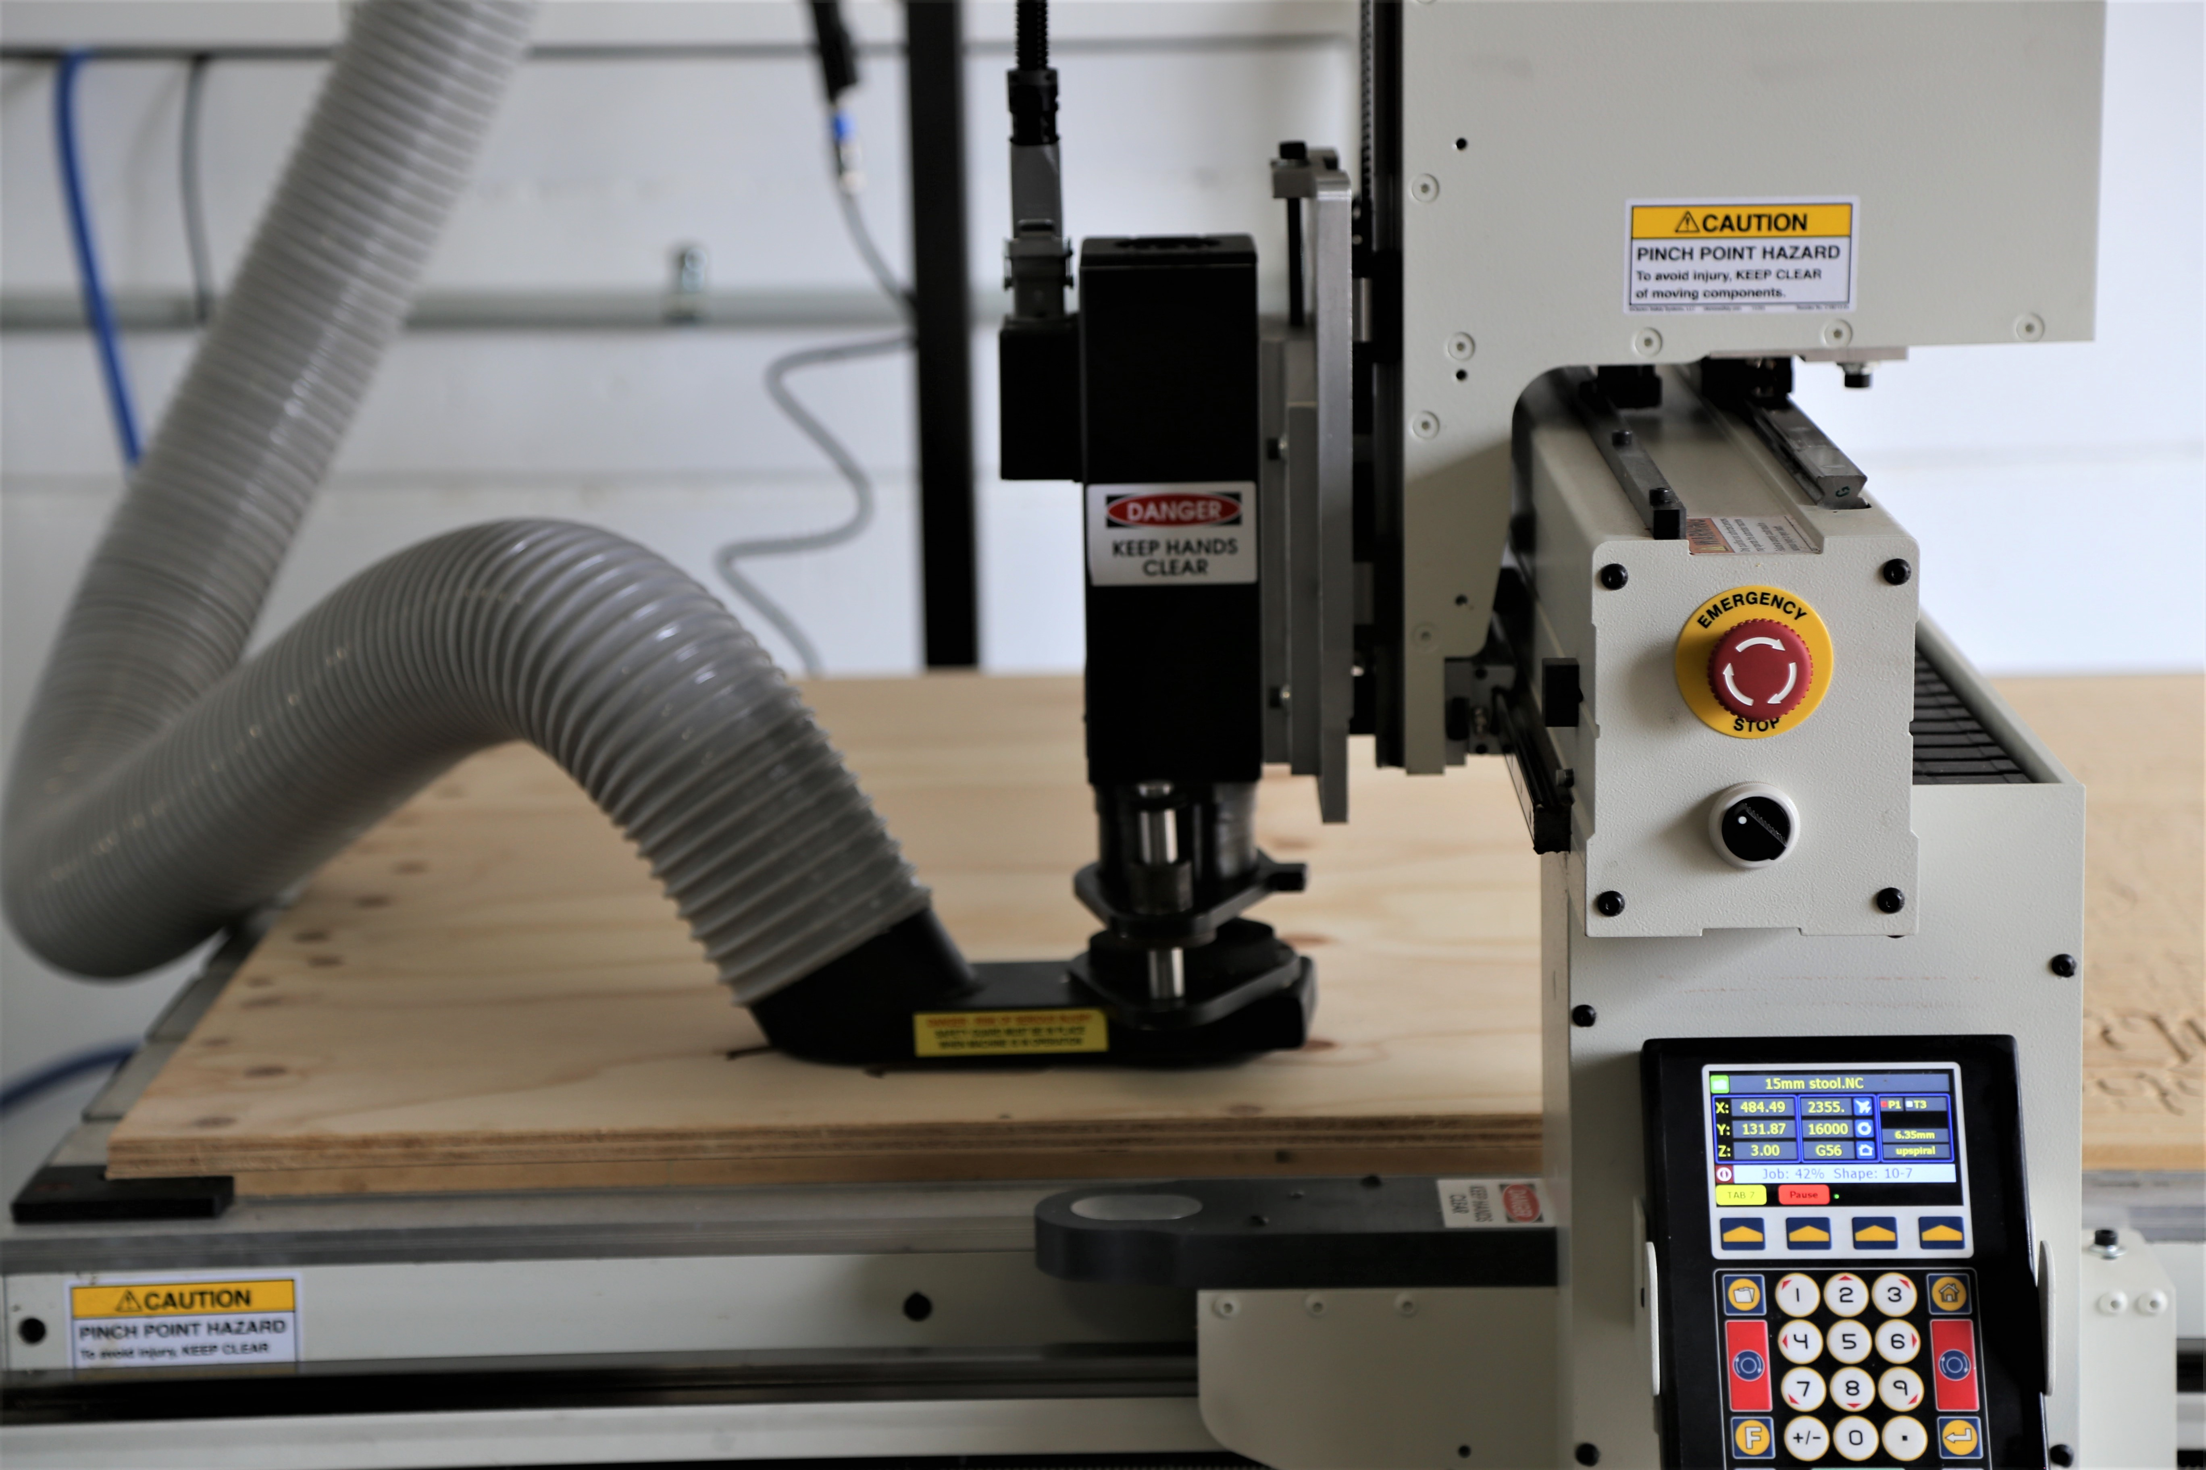

Recording Studio Induction
Book and use the Recording Studio for free, once you’ve successfully completed your induction.
The Edge’s Recording Studio provides access to near-professional equipment and specialist software for recording, mixing, editing and mastering. Recording studio hire is free; however you first must complete a Recording Studio induction.


