DIY Isolation Booth
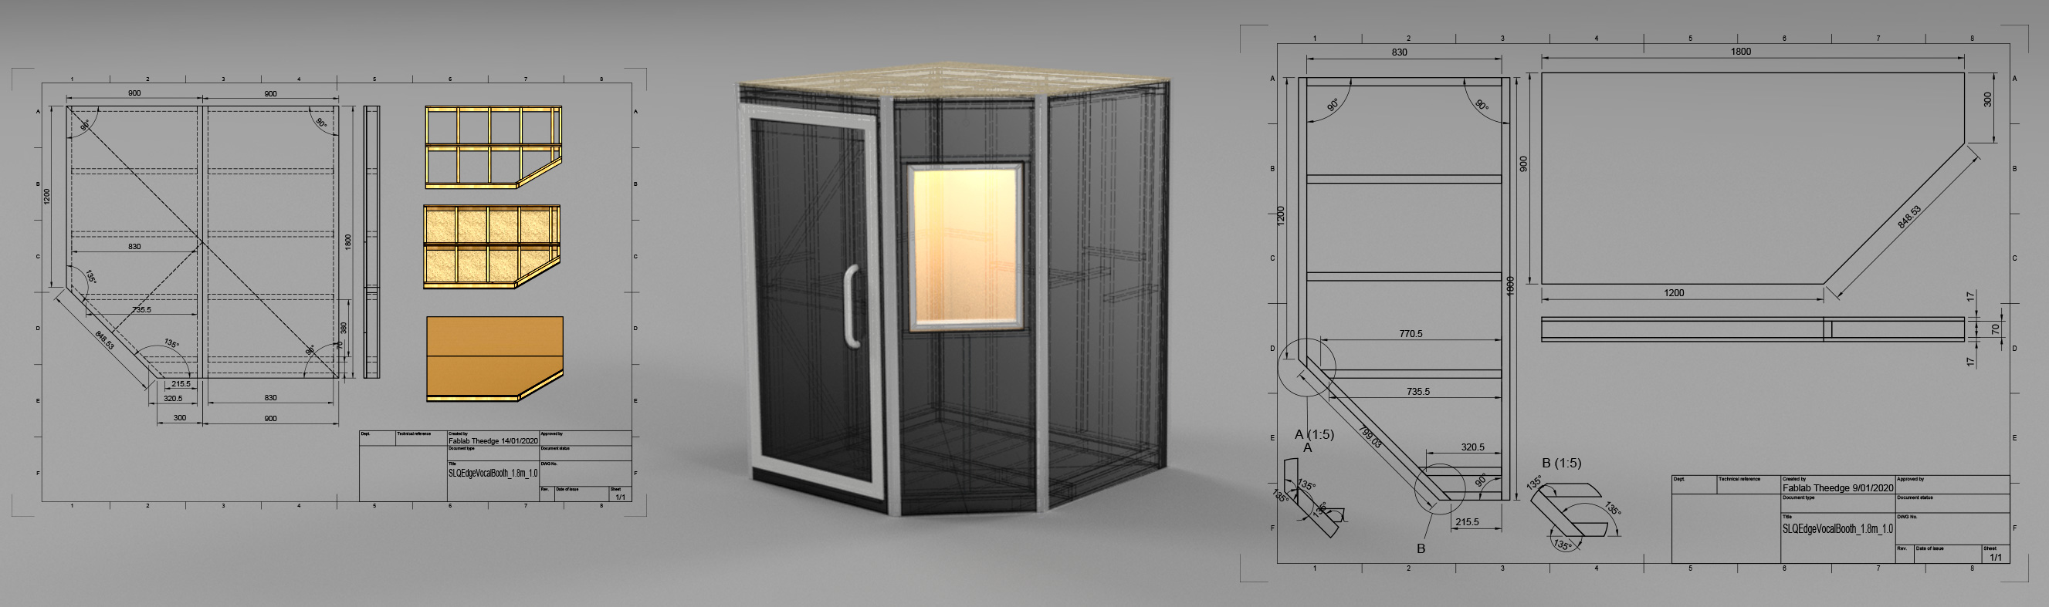

Brief
The brief is a modular, low cost DIY friendly isolation booth for The Edge Recording Studio. Although mainly for vocal recording, the booth should be large enough for two people podcasting, or a small drum kit set-up, solo instrumental recording or as in isolation booth for guitar amp.

Requirements
- fits minimum two people, including one wheelchair or mobility scooter
- meets or exceeds relevant ISO standards1) for acoustic isolation
- provides disability access
- uses commonly available, low cost materials
- fits with existing State Library decor and level of finish
- can be pre-assembled
- plans are open sourced at end of prototyping

Design
The prototype has been designed in Fusion 3602). The model is available on the web to view and annotate: https://a360.co/2Sfz8gC
The design is a basic double walled shell, with variable configuration of panels and some parameters.
The unit will fit within 1.8mx 1.8m, which is approximately half the width of the recording studio.
Acoustics, internal fittings, fixings, penetrations and ventilation need to be considered at the meet-ups.

Acoustics

Analysis
Thanks to Jon South and Adrian Diery we have a plot of the room resonances:
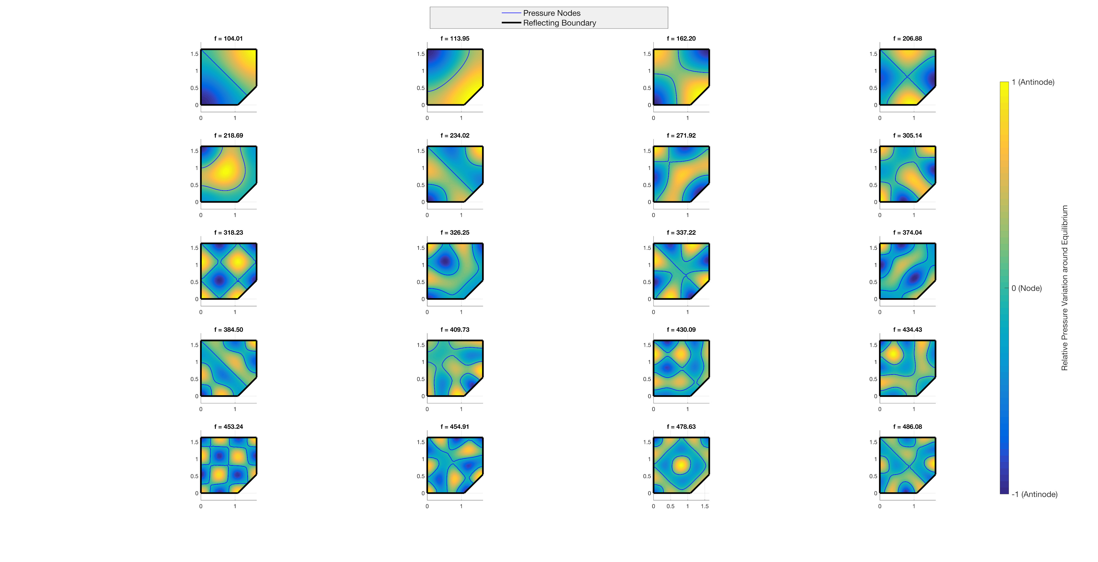
A similar tool can be found online here

Acoustic Treatment
Given the resonances present in the analysis, broad low frequency absorption is appropriate. Our challenge will be to fit effective absorption is such a small space. Options include:
- Panel bass traps
  - resonant
  - broadband
- Corner bass traps

Low Frequency absorption with Acoustic Metamaterials
Over the last few years, research into acoustic metamaterials produced with 3D printers has achieved some interesting results for low frequency absorbtion. While there have been no products released (that we can find) that use these materials, there are a couple of papers that explore some likely looking options.
https://www.nature.com/articles/s41598-019-49982-5
https://aip.scitation.org/doi/10.1063/1.4895617

Ventilation
Once the booth has been framed up, we will look at the best way to build in ventilation. Discussion at this point has been around a couple of boxes on the back of the booth, one for input, one for output, with a labyrinthine baffled passage to reduce noise transmission.

Cabling
Existing wall plate has a number of ports, wired into the studio patchbay :
- 4 XLR male sockets
- Stereo RCA
- HDMI
- 2 x ethernet
- 5 x BNC RGBHV
The aim is to patch from these ports where possible.

Audio
Six outputs from the booth (XLR) with 2 stereo inputs (TRS).

Video
Single HDMI input.

Disability Access
Wheelchair access requires doorway clear access of 850mm. The current door provides 880mm.

Access Ramp
Maximum slope for wheelchair access is 10:1. The base of booth is approx 116mm from the floor, which means the ramp must be approx 1200mm.

Door Access and Handle
AS 1428.1—2009 13.5.2 Design and performance - supplies the maximum force:
(i) To initially open the door. …………………………………………………….. 20 N
(ii) To swing or slide the door …………………………………………………….20 N.
(iii) To hold the door open between 60° and 90°……………………………..20 N.

Fittings

Furnishings
Laptop table/rest. Foldable?

Mic Stand
Permanent mic stand mounted on wall or ceiling with swing arm.

Plans
Plans will be generated as drawings from Fusion 360 - see examples in resources.

Materials

Outer Shell

Tools

Construction

Resources
slqedgevocalbooth_1.8m_1.0_drawing_base_v1.pdf
slqedgevocalbooth_1.8m_1.0_base_front_frame_v2.pdf

Research
https://www.bunnings.com.au/trade-essentials-3600-x-900-x-19mm-green-tongue-particle-board-flooring_p0460014
https://loopphonebooths.com/office-privacy-solutions/solo-office-pod/
https://zenbooth.net/blogs/zenbooth-blog/office-phone-booth-pricing-models-from-4999-18-999
https://www.frameryacoustics.com/en/products/
https://au.room.com/
https://www.iso.org/obp/ui/#iso:std:iso:23351:-1:dis:ed-1:v1:en
https://www.iso.org/obp/ui/#iso:std:iso:4043:ed-3:v1:en
https://www.ultrafonic.com.au/vocal-booth
http://www.jpemball.fr/eng/polytcab-interpretation-soundproof-booth.html

1) https://www.iso.org/obp/ui/#iso:std:iso:23351:-1:dis:ed-1:v1:en https://www.iso.org/obp/ui/#iso:std:iso:4043:ed-3:v1:en
2) Fusion360 has a hobbyist, education and start-up licenses available.

