~~REVEAL~~

Asgard Stool
The Asgard stool was created for initially for the 2017 Brisbane Makerfest where 30 participants built the stool in 45 minutes. The stools were pre-cut, a demo cutting was shown. The stools have been re-purposed to serve as the take-away for The Edge CNC inductions.

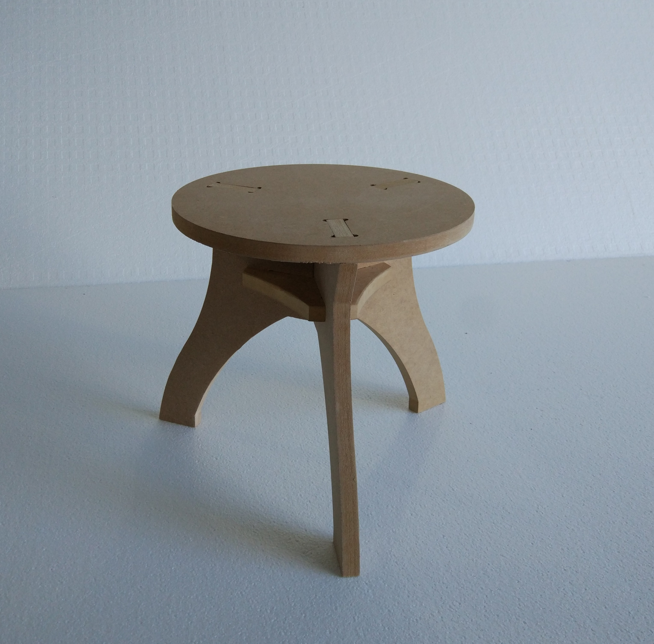
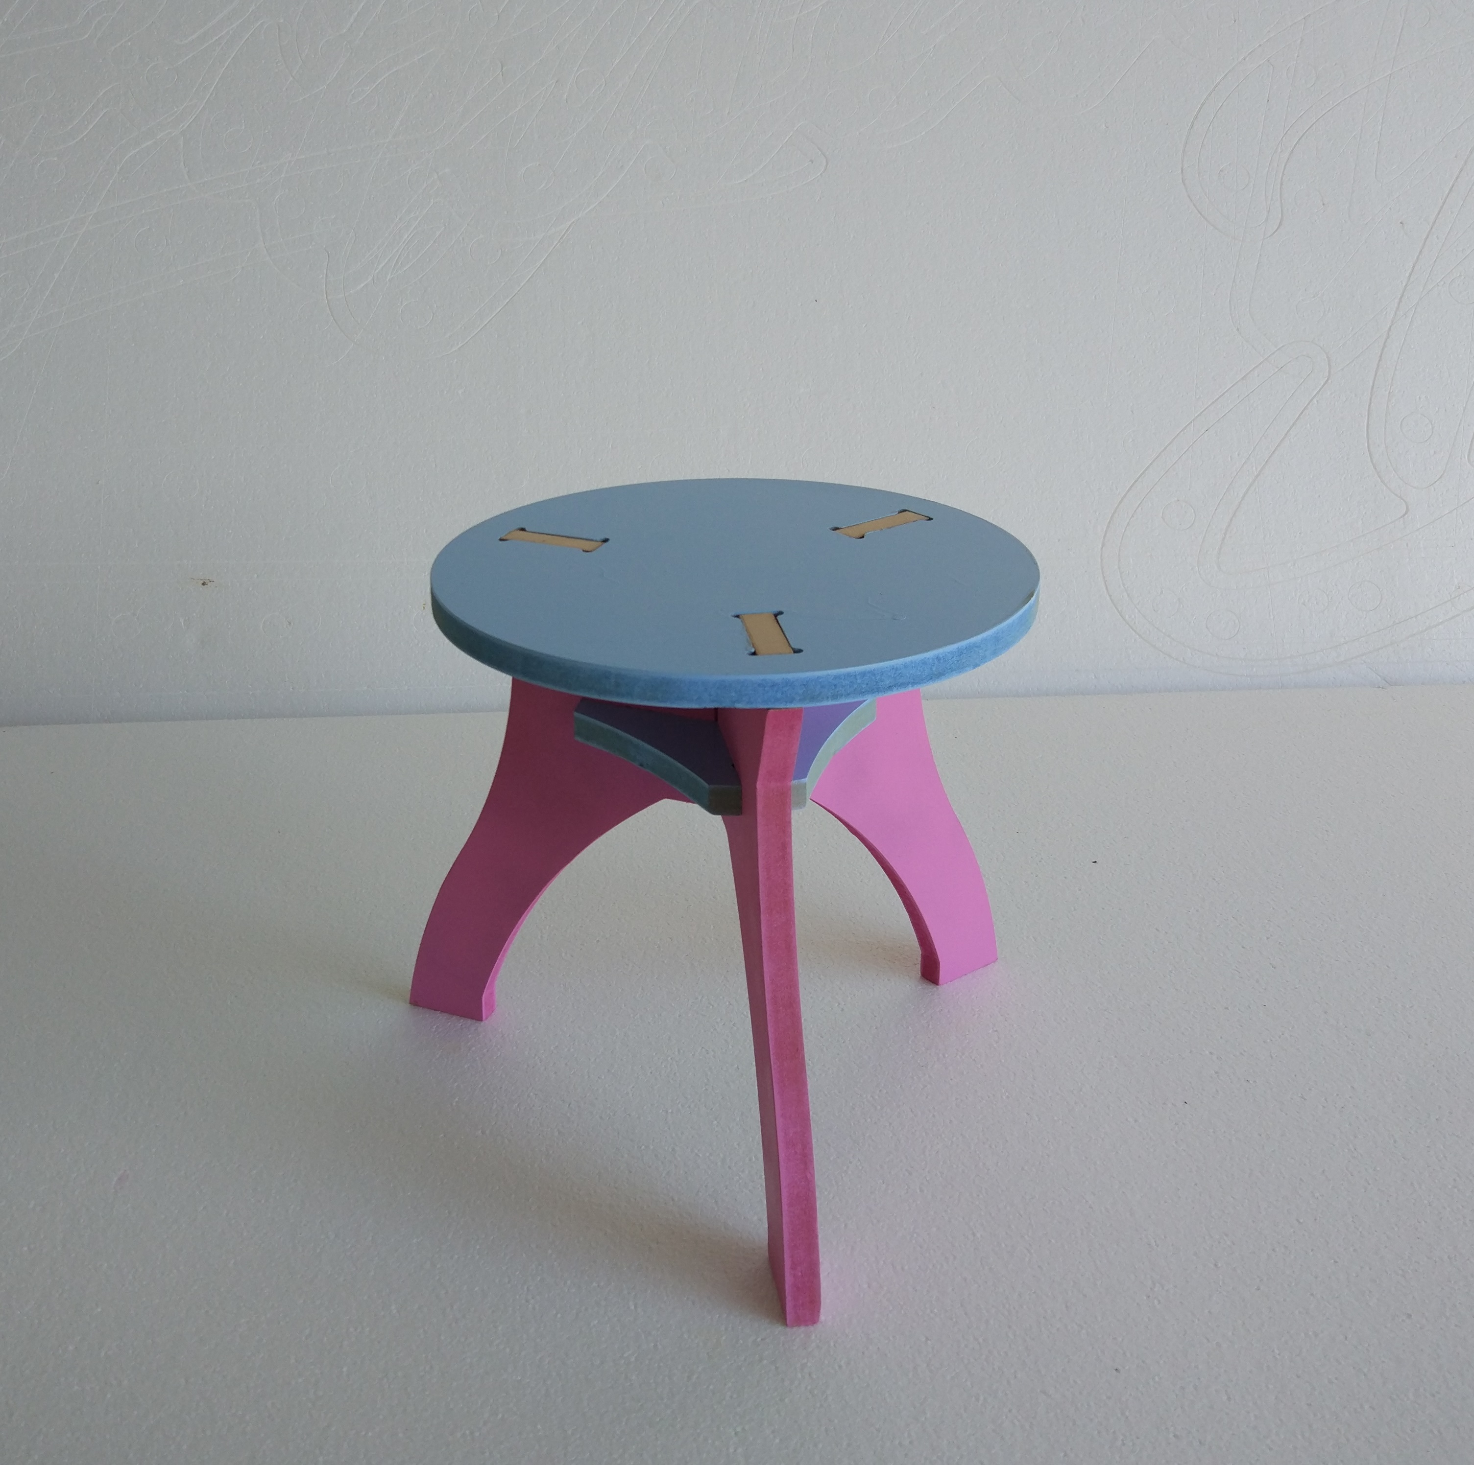

Build Instructions
These instructions cover using the files provided to;
- make existing design at The Edge (In-house)
- modify the design to suite other materials or sizes (Custom)
- make the existing design using another facility (External)

In-House

Materials
- 1200 x 1200 x15mm sheet of ply Plywood (purchased from fabrication lab )

Tools and Equipment
- CNC Router
- Vectrics Vcarve Pro
- Hand file (CNC Pit)
- Mallet (CNC Pit)

Instructions

Preparation
- Book some time of the CNC Router (if you need to do an induction you can find the latest announcements here)
- Download the latest Vcarve File

At The Edge
- Cut the stool with the settings in the Vcarve file.
- Clean the stool using hand file.
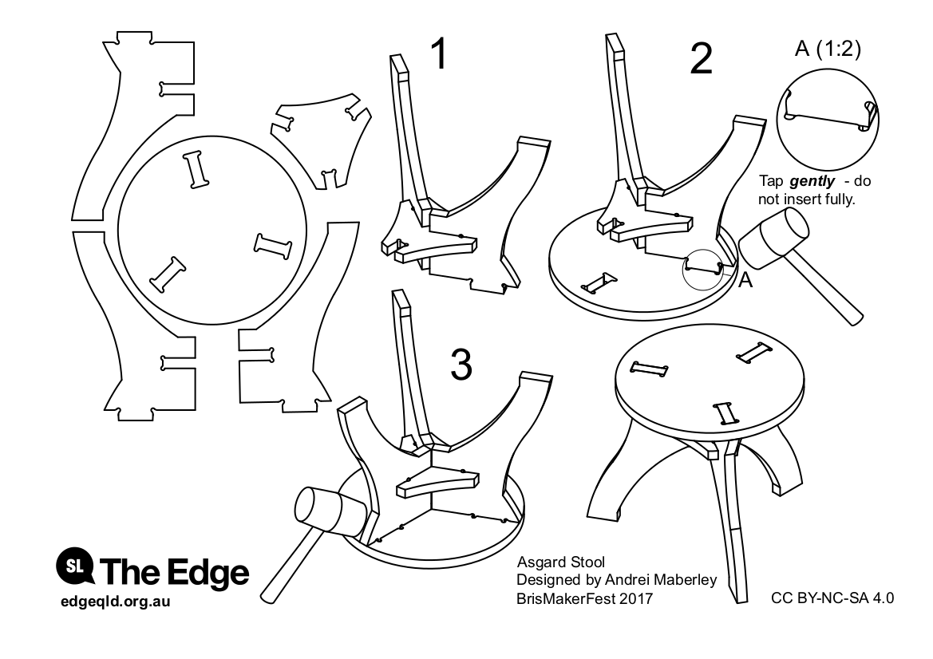
- Follow the assembly instructions.

Custom

Tools and Equipment
- CNC Router
- Vectrics Vcarve Pro
- Hand file (Machine Shop)
- Mallet (Machine Shop)

Preparation
- Download and install Fusion360
- Download the latest Fusion 360 Induction Chair
The 3D model can be viewed, interacted with here.

To customise the material thickness, dimensions and tolerances you can change the parameters of the original design in Fusion360..

Changing Parameters
Before playing with the parameters remember;
- that they can (and will) interact in strange ways.
- Undo early and often.
- adjusting material thickness can affect everything - after changing, close the paramater window to check the effect.
Open the model, then go to the parameters menu.

The parameters you will can change are favourites at the the top of the list.

Export DXFs
Once you have made all the required changes, select the correct sketches to export as DXFs.

External

The individual faces as DXFs are:
Layout for cutting - sheet dimension minimum 560mm x 320mm.
CNC Settings are:
Export for other formats:

Old Files
stoolcv3.zip
asgard_stool_instructions.pdf
asgard_stool_instructions.zip
asgard_stool_brismakerfest_final_v0.f3d

