~~REVEAL~~

Documentation Station
This station is a standalone system to capture desktop size and smaller scale projects. Used to document public and staff projects, generate comms material, the documentation station is the high quality tethered photo booth. It combines recycled SLQ computer hardware, second-hand and re-purposed fittings, and consumer DSLR driven by open source software.
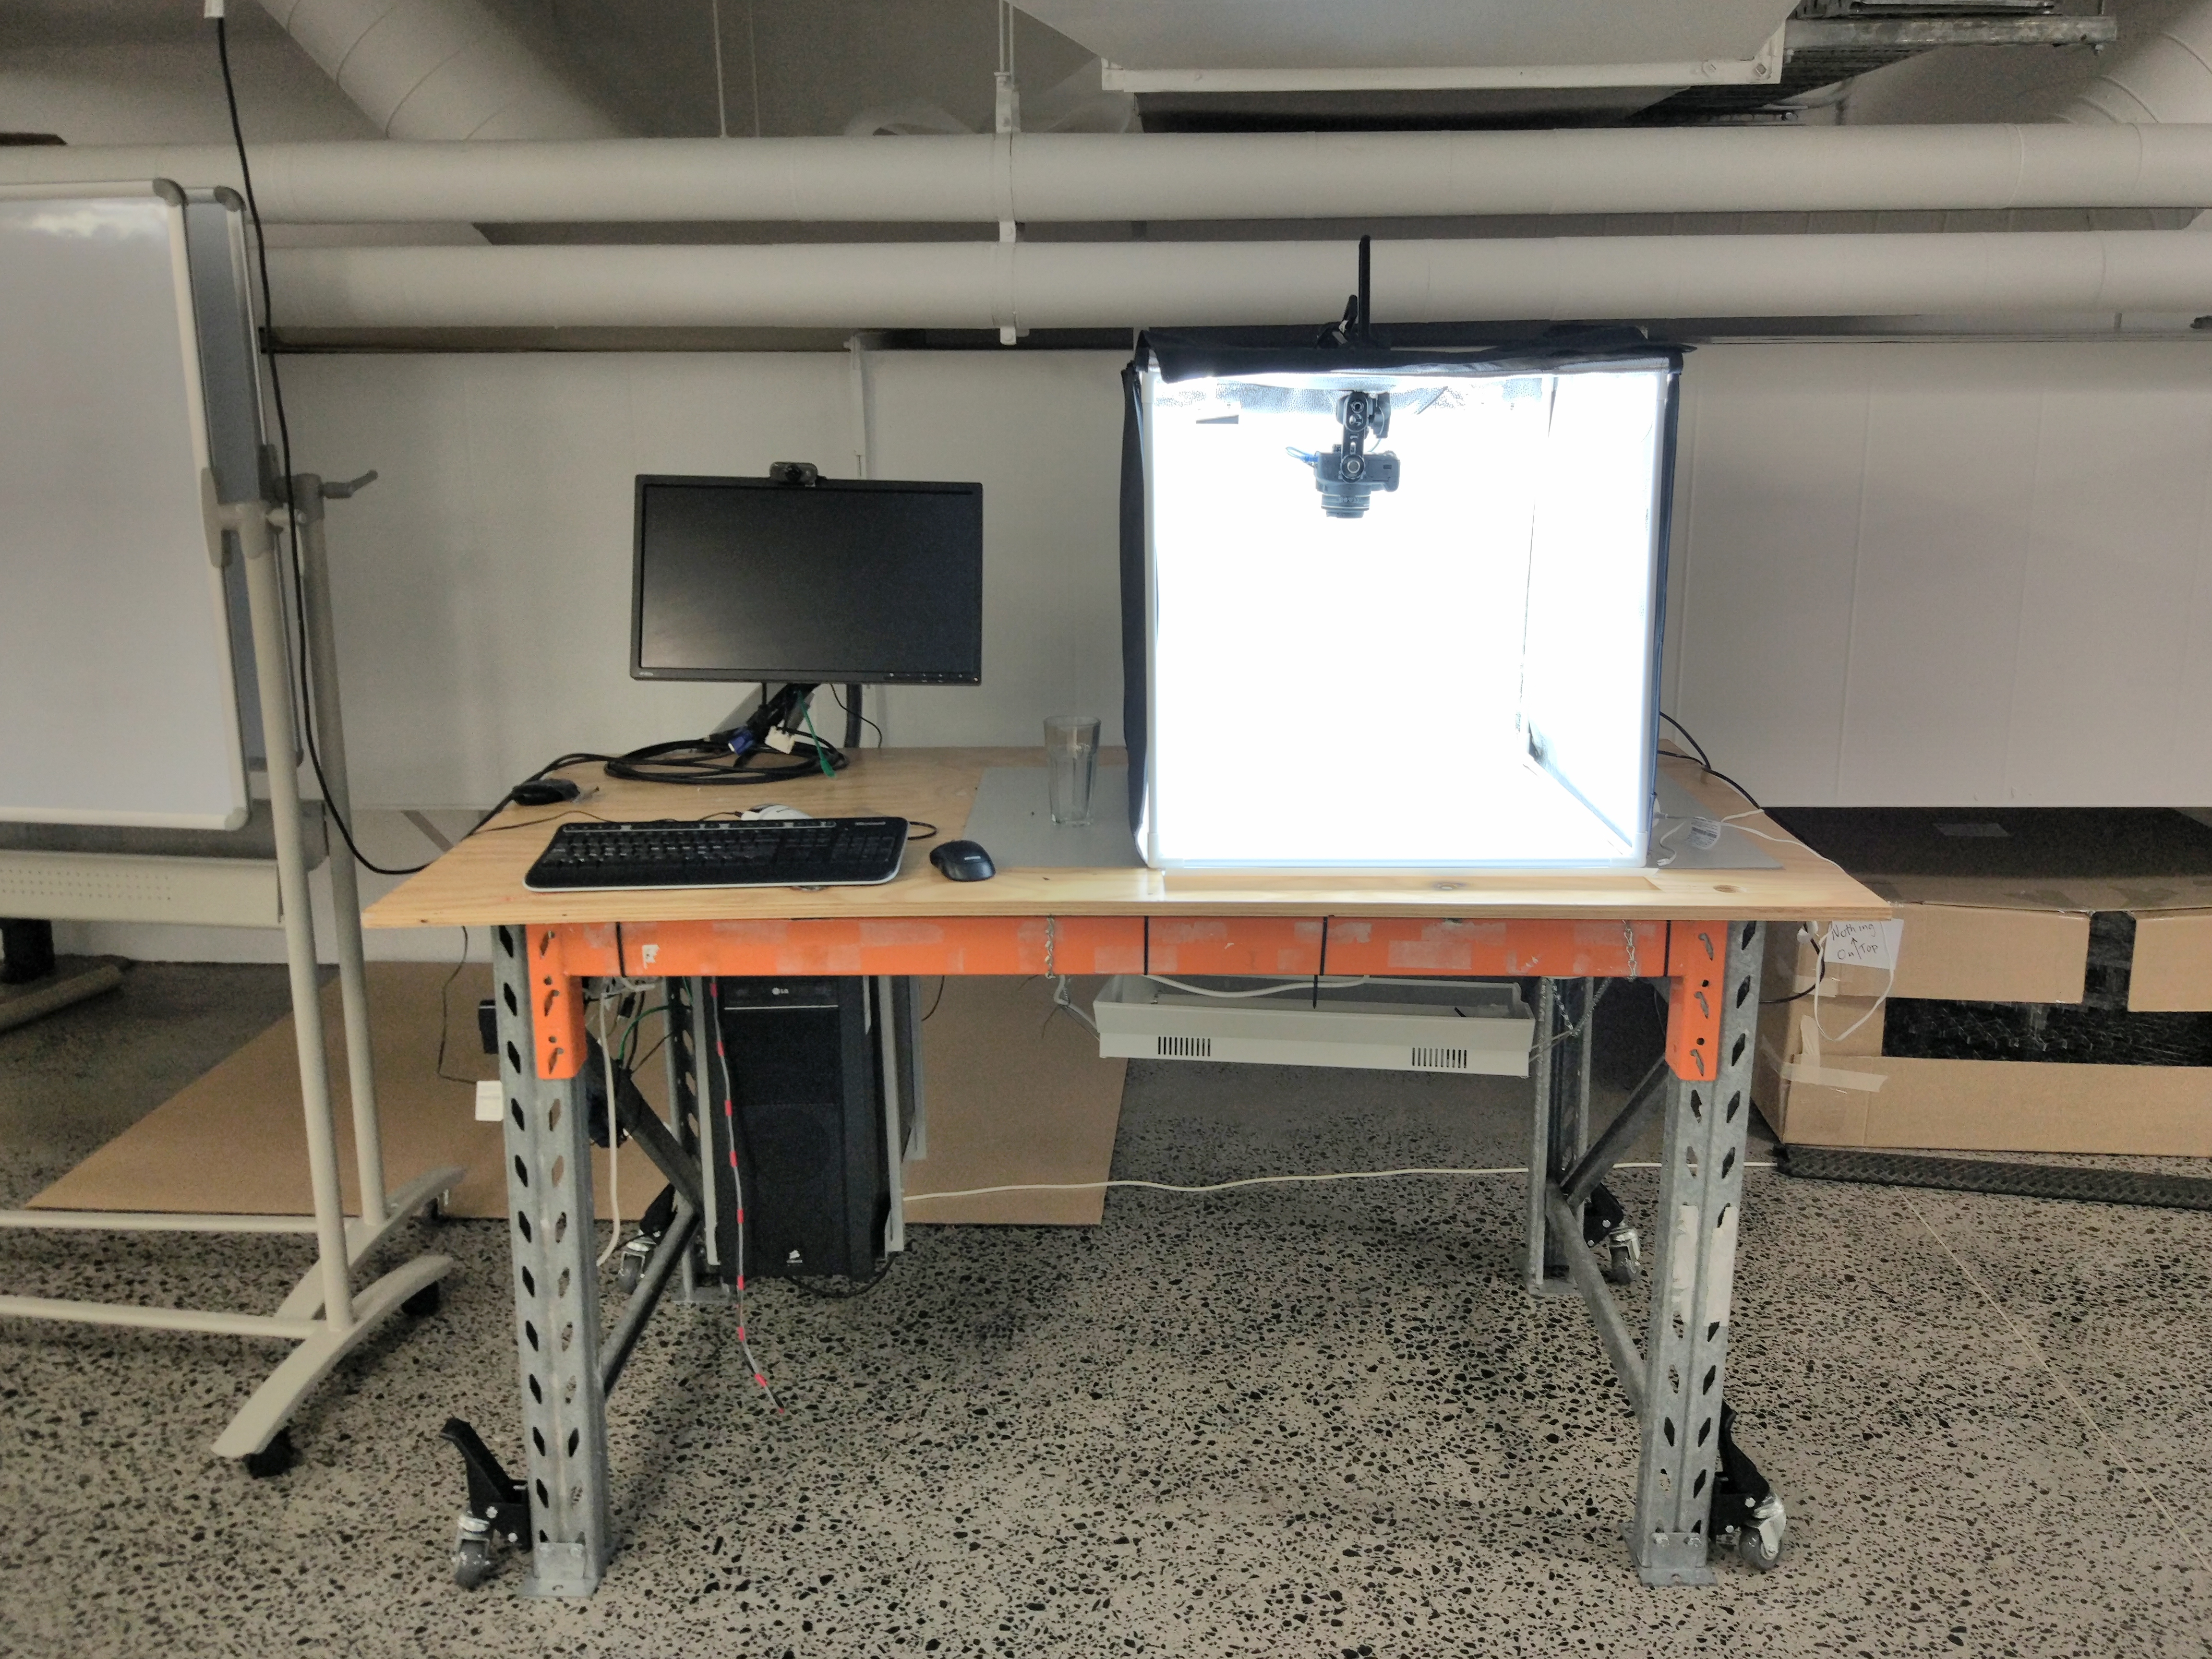

Use Cases
The documentation station has been used to create in-house documentation for workshops, events, digital signage and market materials.

History
This is prototype build for a documentation creation station. It was developed during the CCC-OPAL project as a solution for continuing the high quality documentation of computer tear-downs without needing to engage more than one staff member or external contractor to assist in the process.
Documentation Station Instructions

