Carboard Jigs
Jigs for cutting down large cardboard sheets to size for the laser-cutter.

7000mm 400mm
This zip includes Fusion360, DXF and Enrroute file. The simple outline is probably the best to use.
700x400_jig_v2.zip

A2, A3, PET and Rayjet 300
Jigs for cutting material
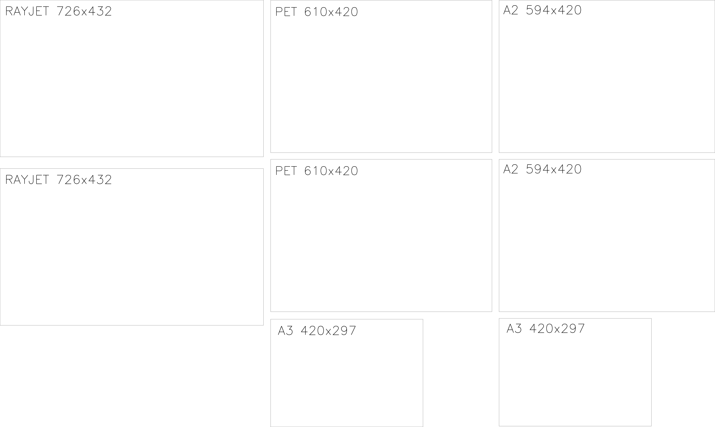
jigs_a2_a3_pet_rayjet.dxf

