Wacom Tablet
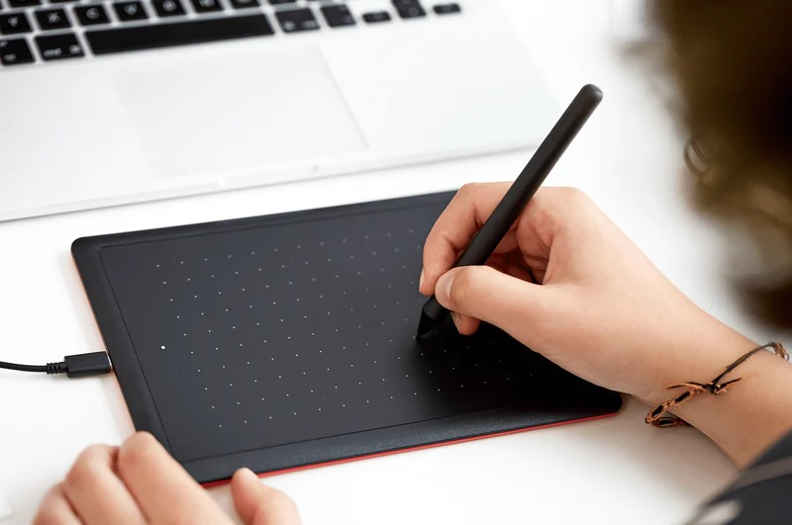
Wacom One by Wacom (Medium)
The Edge has three One by Wacom tablets available for creative use within the building available to use with your own laptop or one of The Edge computers. Wacom tablets allow you to utilise precise pen control to create digital drawings and are compact and intuitive tablets offering integration with most creative software.
Equipment may only be borrowed by people with a State Library of Queensland membership with Queensland residency status who have completed a General induction at The Edge.
Ensure the tablets are used within The Edge building only.
Please read through our Terms of use on our Getting Started page on the State Library of Queensland website.

