Production Computers

Guide to using Production PC 1 and 2 at The Edge, State Library of Queensland
Production PC's are high-end specialist computers at The Edge, designed for heavy-duty rendering, and graphics-intensive work. Additionally, Production PC 2 offers patrons computer hardware that is equipped for AI research and development. This guide will help you get started, understand the available resources, and ensure you use the equipment responsibly.

Specifications of Production PC 1
- CPU: 13th Gen Intel Core i9-13900k vPro
- GPU: Nvidia GeForce RTX 4080 16GB
- RAM: 64GB DDR5
- Monitor: 32“ 4K
- Operating System: Windows OS

Specifications of Production PC 2
- CPU: AMD Ryzen 9 7950X 16 Core 4.5GHz​
- GPU: Nvidia GeForce RTX 4090 24GB​
- RAM: 64GB DDR5​
- Monitor: 32” 4K​
- Windows or Linux OS available

Who Can Book
Available to individuals with a State Library of Queensland (SLQ) membership who have completed the Specalist Computing Registration Patrons that are using the Production PC for A.I projects, must read through the The Edge - Production PC User Guidelines for A.I Projects Registrations will be processed within 4 business days. After which, approved applicants will be given access to a booking page.

Booking Duration
The computer can be booked for up to 4 hours.

How to Book
Once you have completed the Specialist Computer Registration Form and you have have received notification that it has been approved, you can book via the SLQ website.

On Arrival
Upon arrival for your booking, please notify The Edge Reception staff to receive the password for the computer. Data Management:
Important: All user files will be deleted from the computer at the end of each day. Ensure you back up your work before the end of your booking. After Use:
Prepare the computer for the next user by saving your work and closing all applications. Troubleshooting:
If you encounter any issues, please see a staff member for assistance.

Available Software
Production PC's comes pre-installed with a variety of creative software, including:
- Adobe Creative Cloud
- Maxon One Suite
- Inkscape
- GIMP
- Blender
- Fusion 360
- FreeCAD
- Unity
- Unreal Engine
- Godot Engine
- Audacity
- Arduino IDE
- TouchDesigner
- DaVinci Resolve
- Meshmixer
- Python
- Atom (JS editor)
- Scratch
- Spark AR
- PrusaSlicer
- Lens Studio
- Insta360 Studio

Accessing Linux OS on Production PC 2
Linux is widely used for AI projects due to its open-source nature, flexibility, and compatibility with powerful AI tools and frameworks, making it ideal for customisation and performance optimisation.Production PC 2 offers a dual boot system to allow patrons to access Linux or Windows OS for their projects. Production PC will automatically boot to the Windows OS each day. To access the Linux OS, restart the computer and select the Kubunto Linux option from the menu and hit Enter. 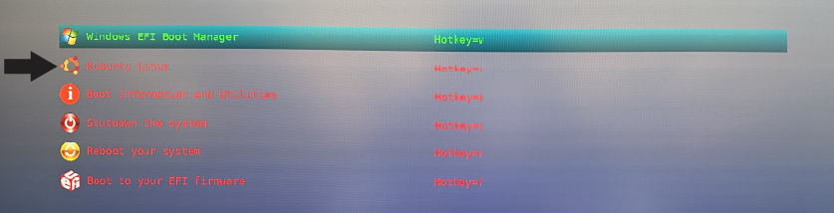 NOTE: Please restart the computer once your booking has finished so the computer can default back to Windows operating system.

Responsibilities and Terms of Use
Eligibility: Production PC's are available for booking by approved users with a valid SLQ membership who have completed a general induction at The Edge and completed the Production Workstation User Registration Patrons that are using the Production PC for A.I projects, must read through the The Edge - Production PC User Guidelines for A.I Projects Age Requirements: Users aged 16+ may book and use the equipment independently. Users under 16 may use the equipment only with parent/guardian permission. Safe Usage: All users must adhere to the Safe Operating Procedures and SLQ policies. These can be reviewed at SLQ Policies and Guidelines. Reporting Issues: Report any technical or hardware issues to staff immediately. Care of Equipment: Users must take due care of the equipment and monitor against theft, loss, or damage. Any unavoidable loss or damage must be reported to SLQ staff immediately. Any devices identified as missing may be rendered inoperable using tracked serial numbers. Modifications: No modifications to any part of the equipment are permitted.
By following this guide, you’ll be well-equipped to make the most out of Production PC's for your creative projects at The Edge. If you need further assistance, feel free to ask The Edge staff for help.

