Rayjet Mini Manager and Rayjet Commander
This is the software supplied by trotec to manage the laser cutter. On this page we cover settings not used in the inductions or everyday use.
The Minimanager is used to control the cutter.
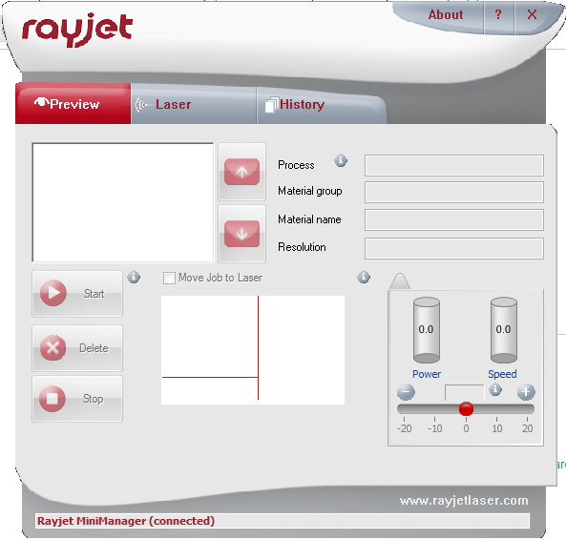
The Rayjet Commander is used to manage materials.
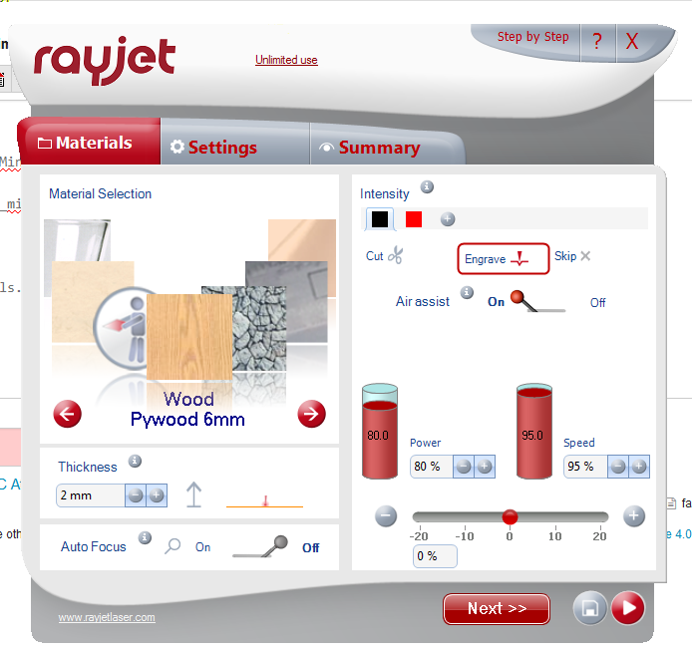
We have updated the materials listed to comply with our standard materials.

Using the Minimanager
The Minimanager should be available from the taskbar on start-up.

Right click and select Options...' to change options.
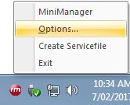
The only options we regularly change are Maximum Number of Jobs in Queue
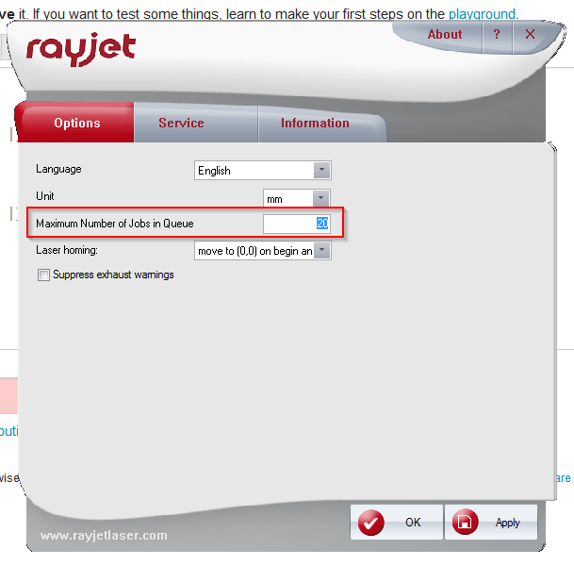
And the Laser Homing
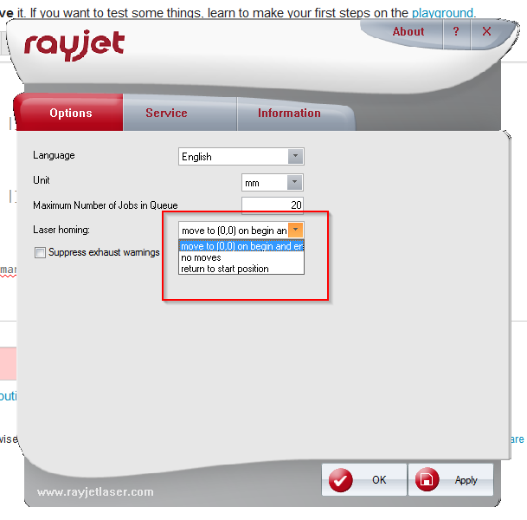
Change the homing to no moves if you are using nuts to hold down a warped material.

The RayJet Commander Materials Database
The materials database is read by the Rayjet Commander from a file called TR_CO2_Material.dat located in C:\ProgramData\Trotec\MiniManager\2.4.1 on the LasercutterPC
To ensure we have consistent settings for the Laser, the materials database is copied on start-up from a master version using the windows task scheduler to trigger a powershell script.
The Script is called Copy_TR_data.ps1 and is located C:\StartupScripts
It contains just one line that copies and renames the master .dat file to the working .dat file.
Copy-Item C:\ProgramData\Trotec\MiniManager\2.4.1\master\TR_CO2_Material_Master.dat C:\ProgramData\Trotec\MiniManager\2.4.1\TR_CO2_Material.dat
Here is a backup of the file and here is the start-up script and task scheduler job export.

Updating the Database
Here is a test file for use with new materials.cut_tests.cdr
To update the database,
- launch the Rayjet Commander using printer preferences.
- Add or change any materials, beware the CYAN and 'too many changes' bugs..
- shut the Rajet Commander.
- Go to C:\ProgramData\Trotec\MiniManager\2.4.1 (you may have to make hidden system folders viewable)
- Copy the file TR_CO2_Material.dat
- Paste into C:\ProgramData\Trotec\MiniManager\2.4.1\master\
- Delete the existing TR_CO2_Material_Master.dat
- Rename the new TR_CO2_Material.dat to TR_CO2_Material_Master.dat
- Restart the computer to test.

