Laser Condition Log
This page is to document the condition of the Laser Cutter. For each entry, please make a new level 3 heading with ===== Date - component ==== I will start each monday with a photo of the lens.

6-03-2017 Lens
Lens One week old. Two small scratches.
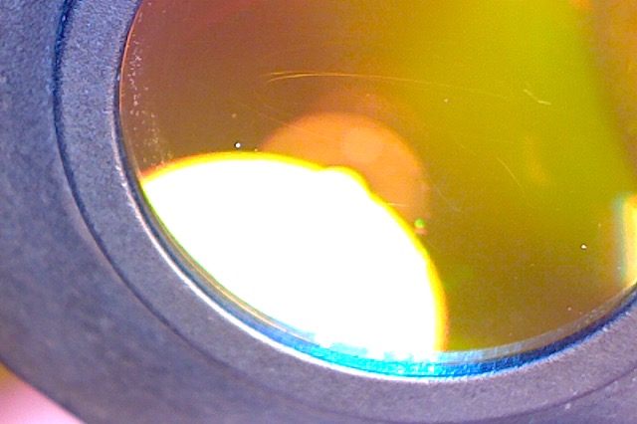

14-03-2017 Lens
log

