Portable Audio Equipment
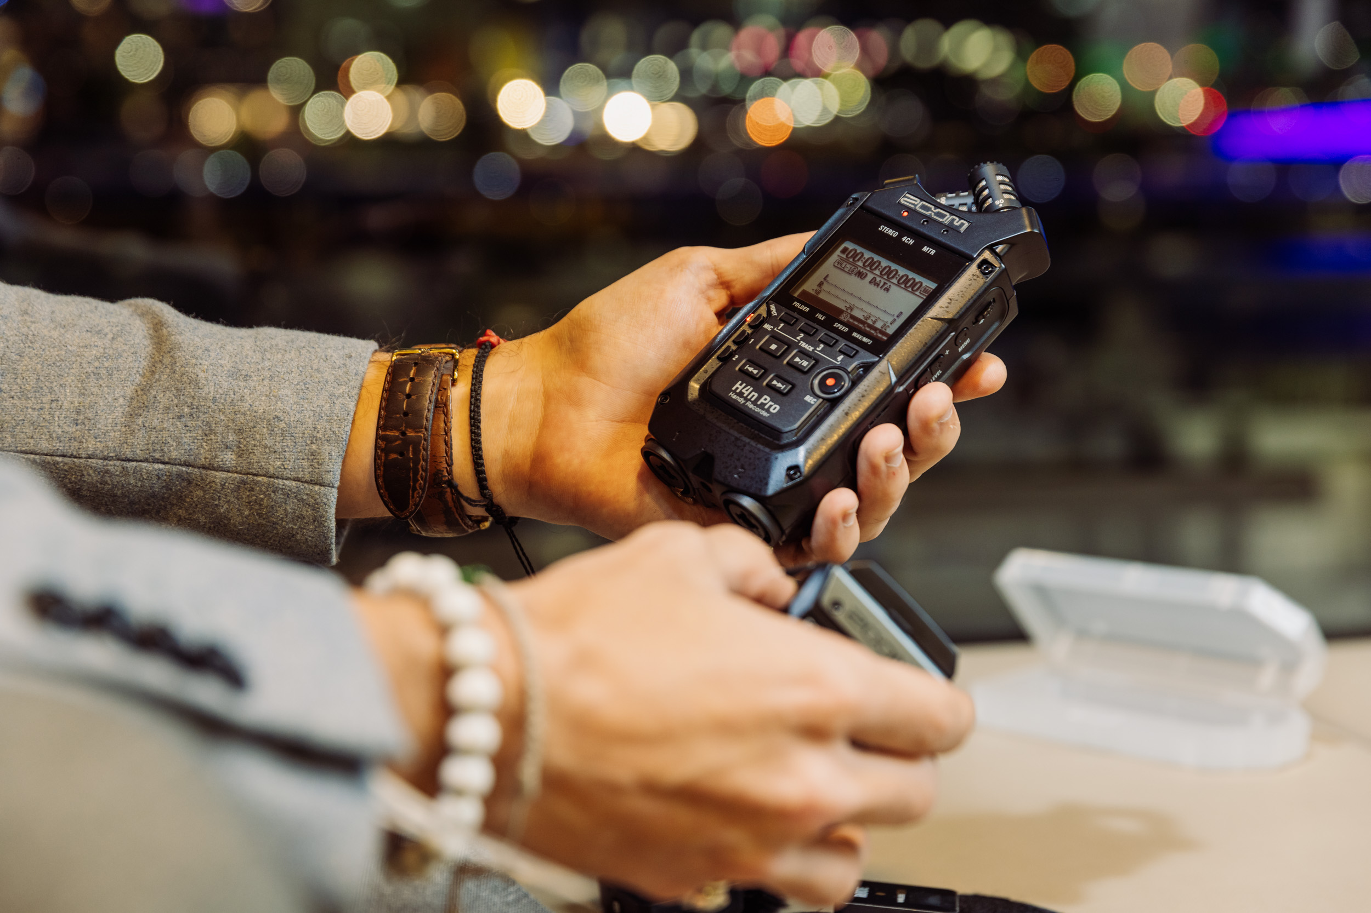
Audio equipment Kits must not leave level 1 of The Edge building.
Located at Level 1 of The Edge.
Equipment may only be borrowed by people with a State Library of Queensland membership with Queensland residency status who have completed a General induction at The Edge

Rode NT-USB Condensor Microphone
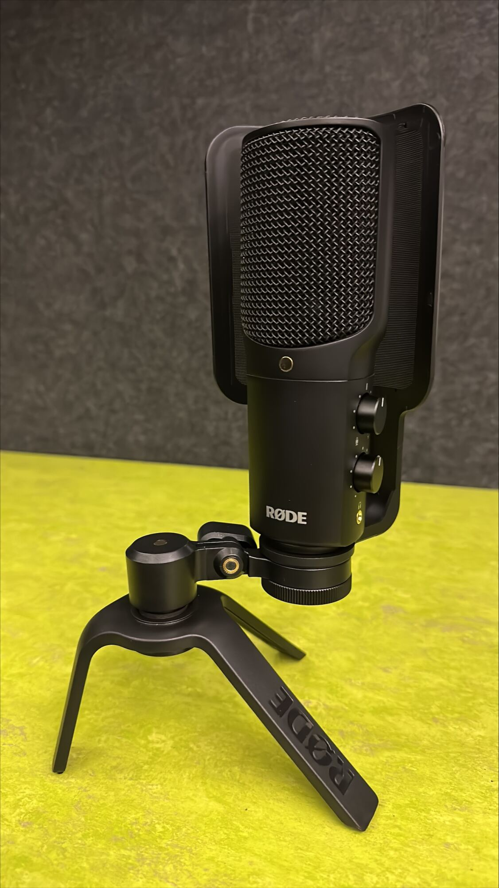
Kit contents
- Rode NT USB condenser Mic
- Long USB A- B Cable
- Built in Pop filter and desk mic stand.

Rode Go 2 Wireless Lapel Microphone Kit
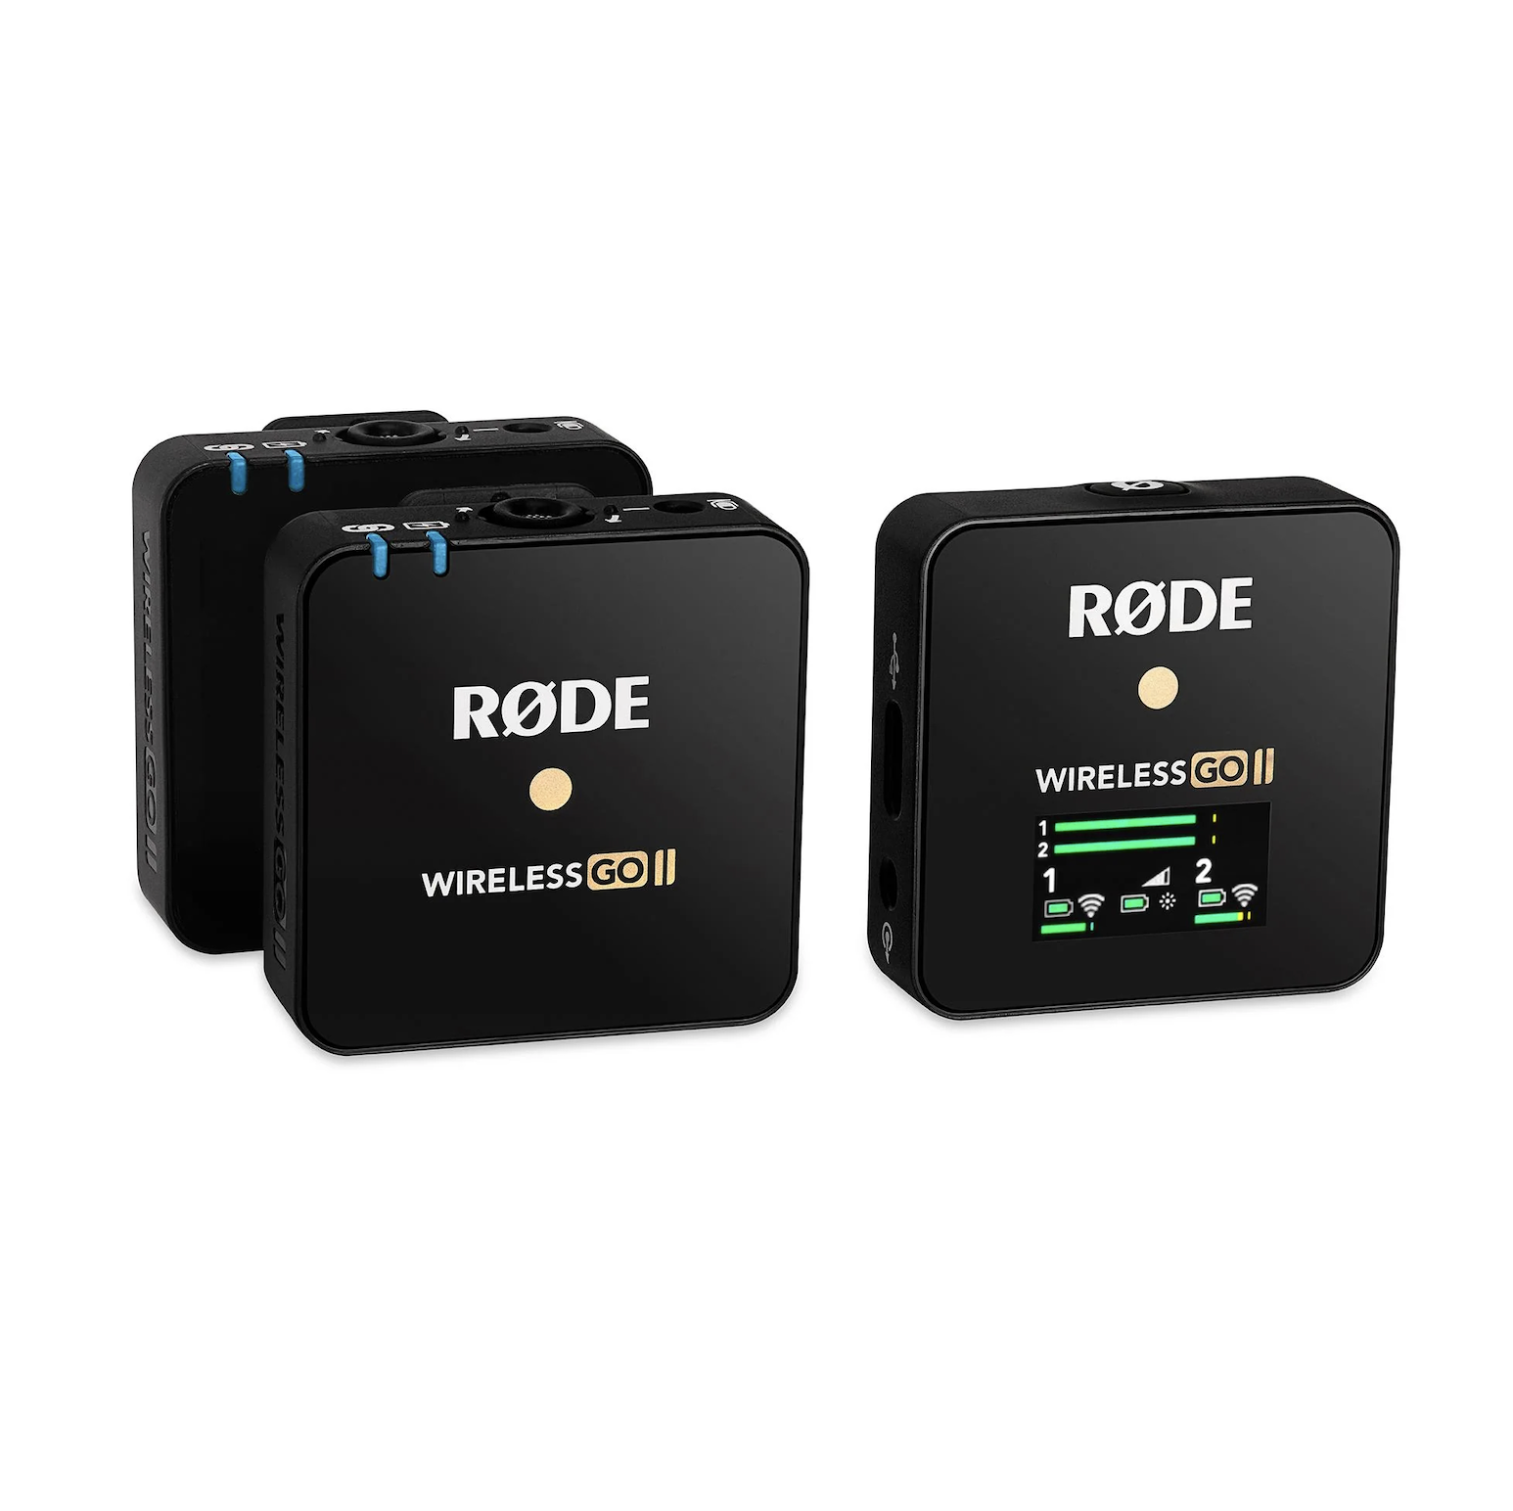
Kit contents
- 4 x Rode Go 2 Wireless Lapel Microphones

Zoom F1 Audio Recording Kit
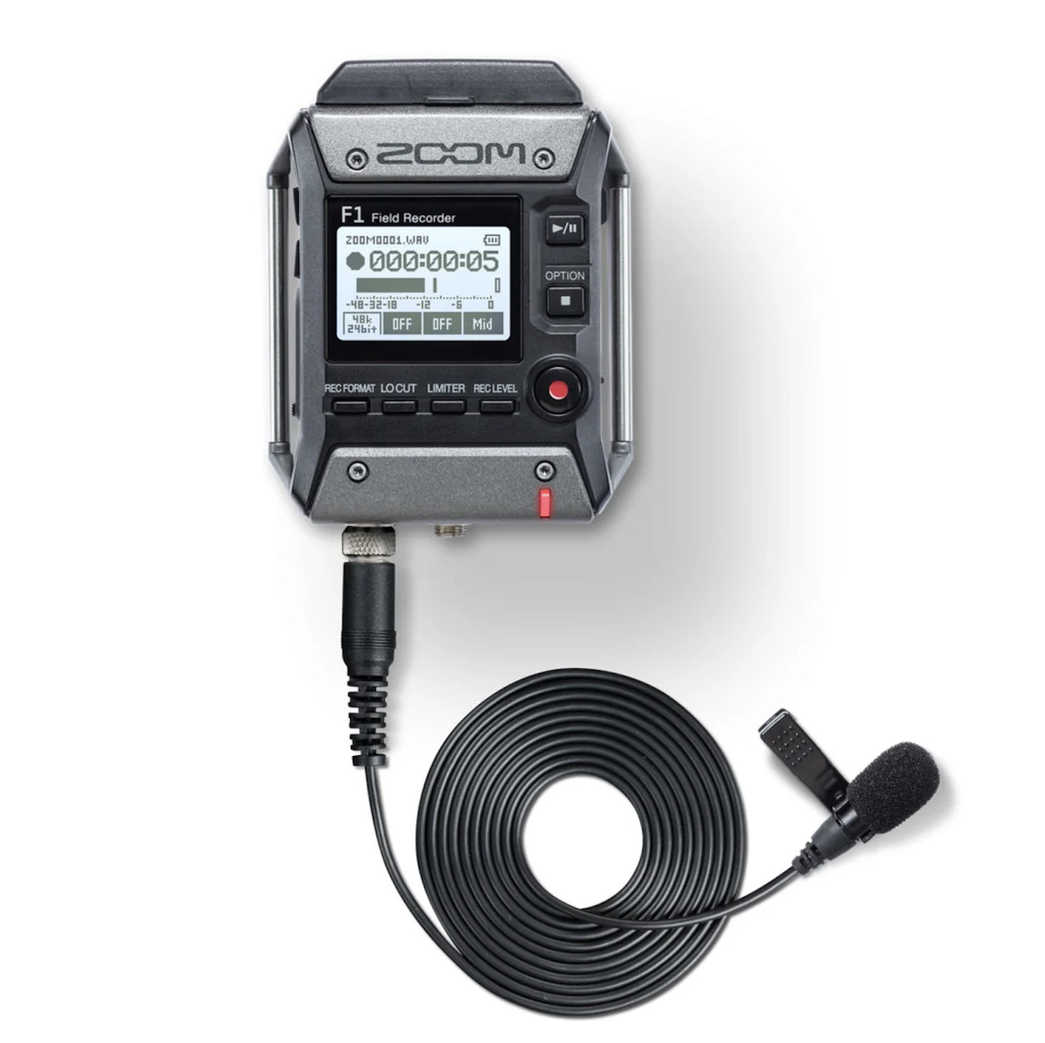
Kit contents
- 2 x Zoom F1 Portable Recorder
- 2 x Zoom F1 Lapel Microphones
- 2 x SD Card

Zoom H4n Pro Audio Recording Kit
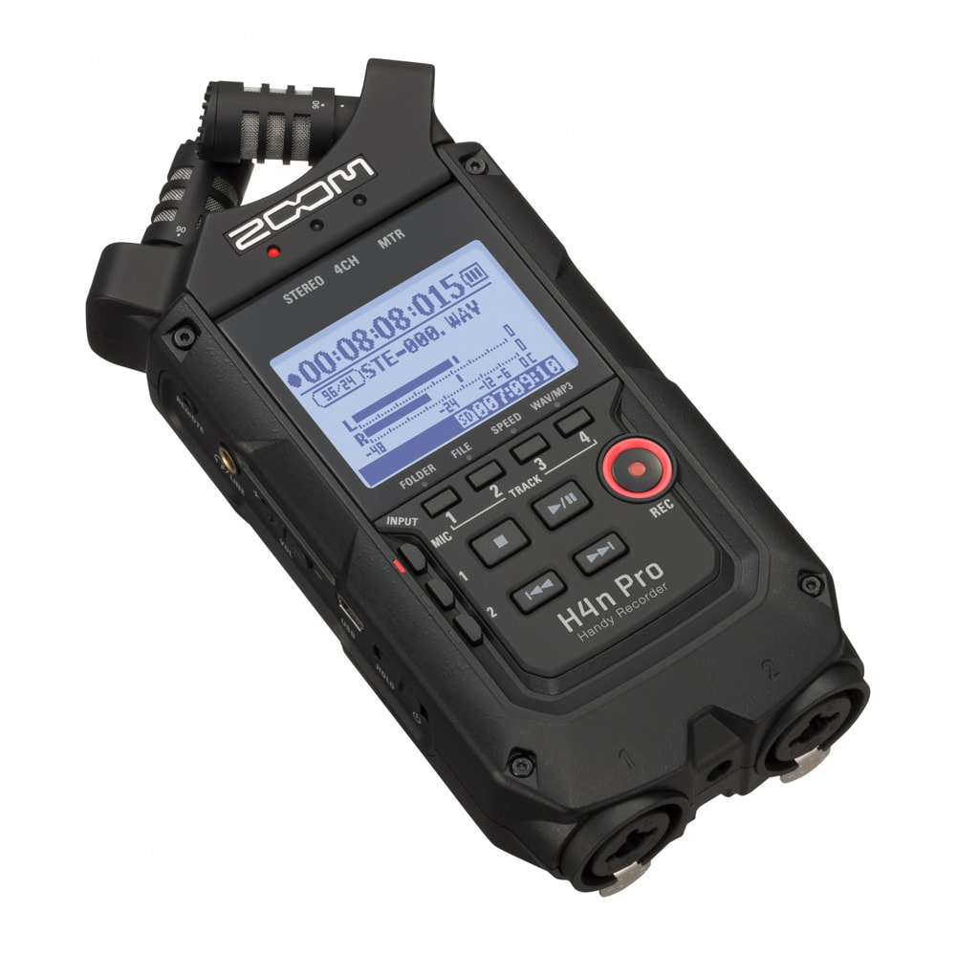
Kit contents
- Zoom H4n Pro Audio Recorder
- SD Card

