Machine Safety
- When machine is running, keep clear of any rotating or moving parts eg. the cutting bit, spindle moving gantry and head parts.
- Do not lean on machine whilst in operation.
- Parts of the machine , particularly cutting bits, will get hot so you may need gloves when handling/ or changing tooling.
- Maintain a clean workspace-check that the gantry and rails for tooling/materials left behind.
- Clean up as you work. The machine does the messy work for you to clean up!
- Use the right tool for the job. Different tooling pieces have a specific purpose and material.

Safety - Emergency Stop
The CNC is fitted with an emergency stop.
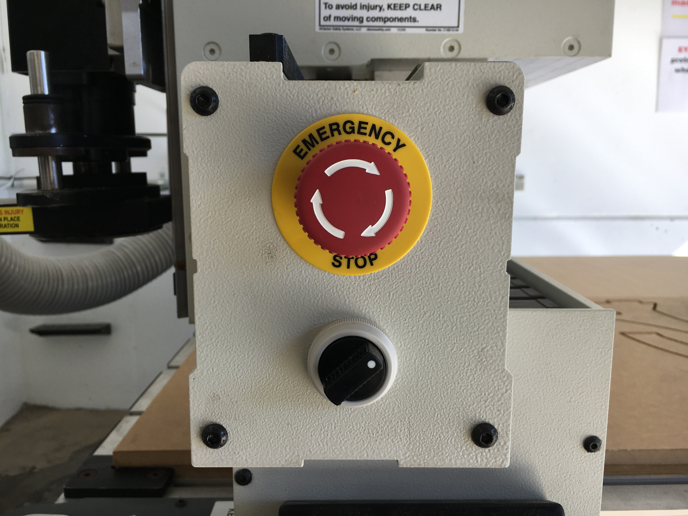
This can be activated to bring the machine to an immediate stop in an emergency.
Note -if the machine is turned OFF mid operation, wait 1 minute to turn ON. After activating emergency stop, needs to be homed.

Safety - Operator Hazards
The CNC router is capable of directly causing death or serious injuries, including amputations, fractures, de-gloving, lacerations, contusions and crush injuries. The hazardous parts of the machine are:

The spindle
- The spindle spins at up to 18,000 rpm - capable of cutting at over 10 metres/minute (m/m)
  - through metal
  - (or flesh)
- The bit takes at least 30 seconds to come to a complete stop.
  - Every time.
  - Even if you touch it.
- The bit can fracture, break or shatter.
  - A bit rotating 18,000 RPM will fly out about 50 km/hr
    - at your eyeball

The Gantry and Machine Head
The gantry can move at over 10 meters/min and weighs over 100 KG.
It can hit with enough force to knock a person over, or trap and mangle a limb.

Safety - Damage to Machine
- The vacuum bed is soft aluminium. If it is damaged the machine is unusable.
- Drill bits are brittle, and will shatter or crack if dropped on concrete.
- The router will cut through metal clamps and screws

LINKS
CNC Router Operations
Other Operations - Staff Only
Multicam CNC Induction

