iPad 11 Pro
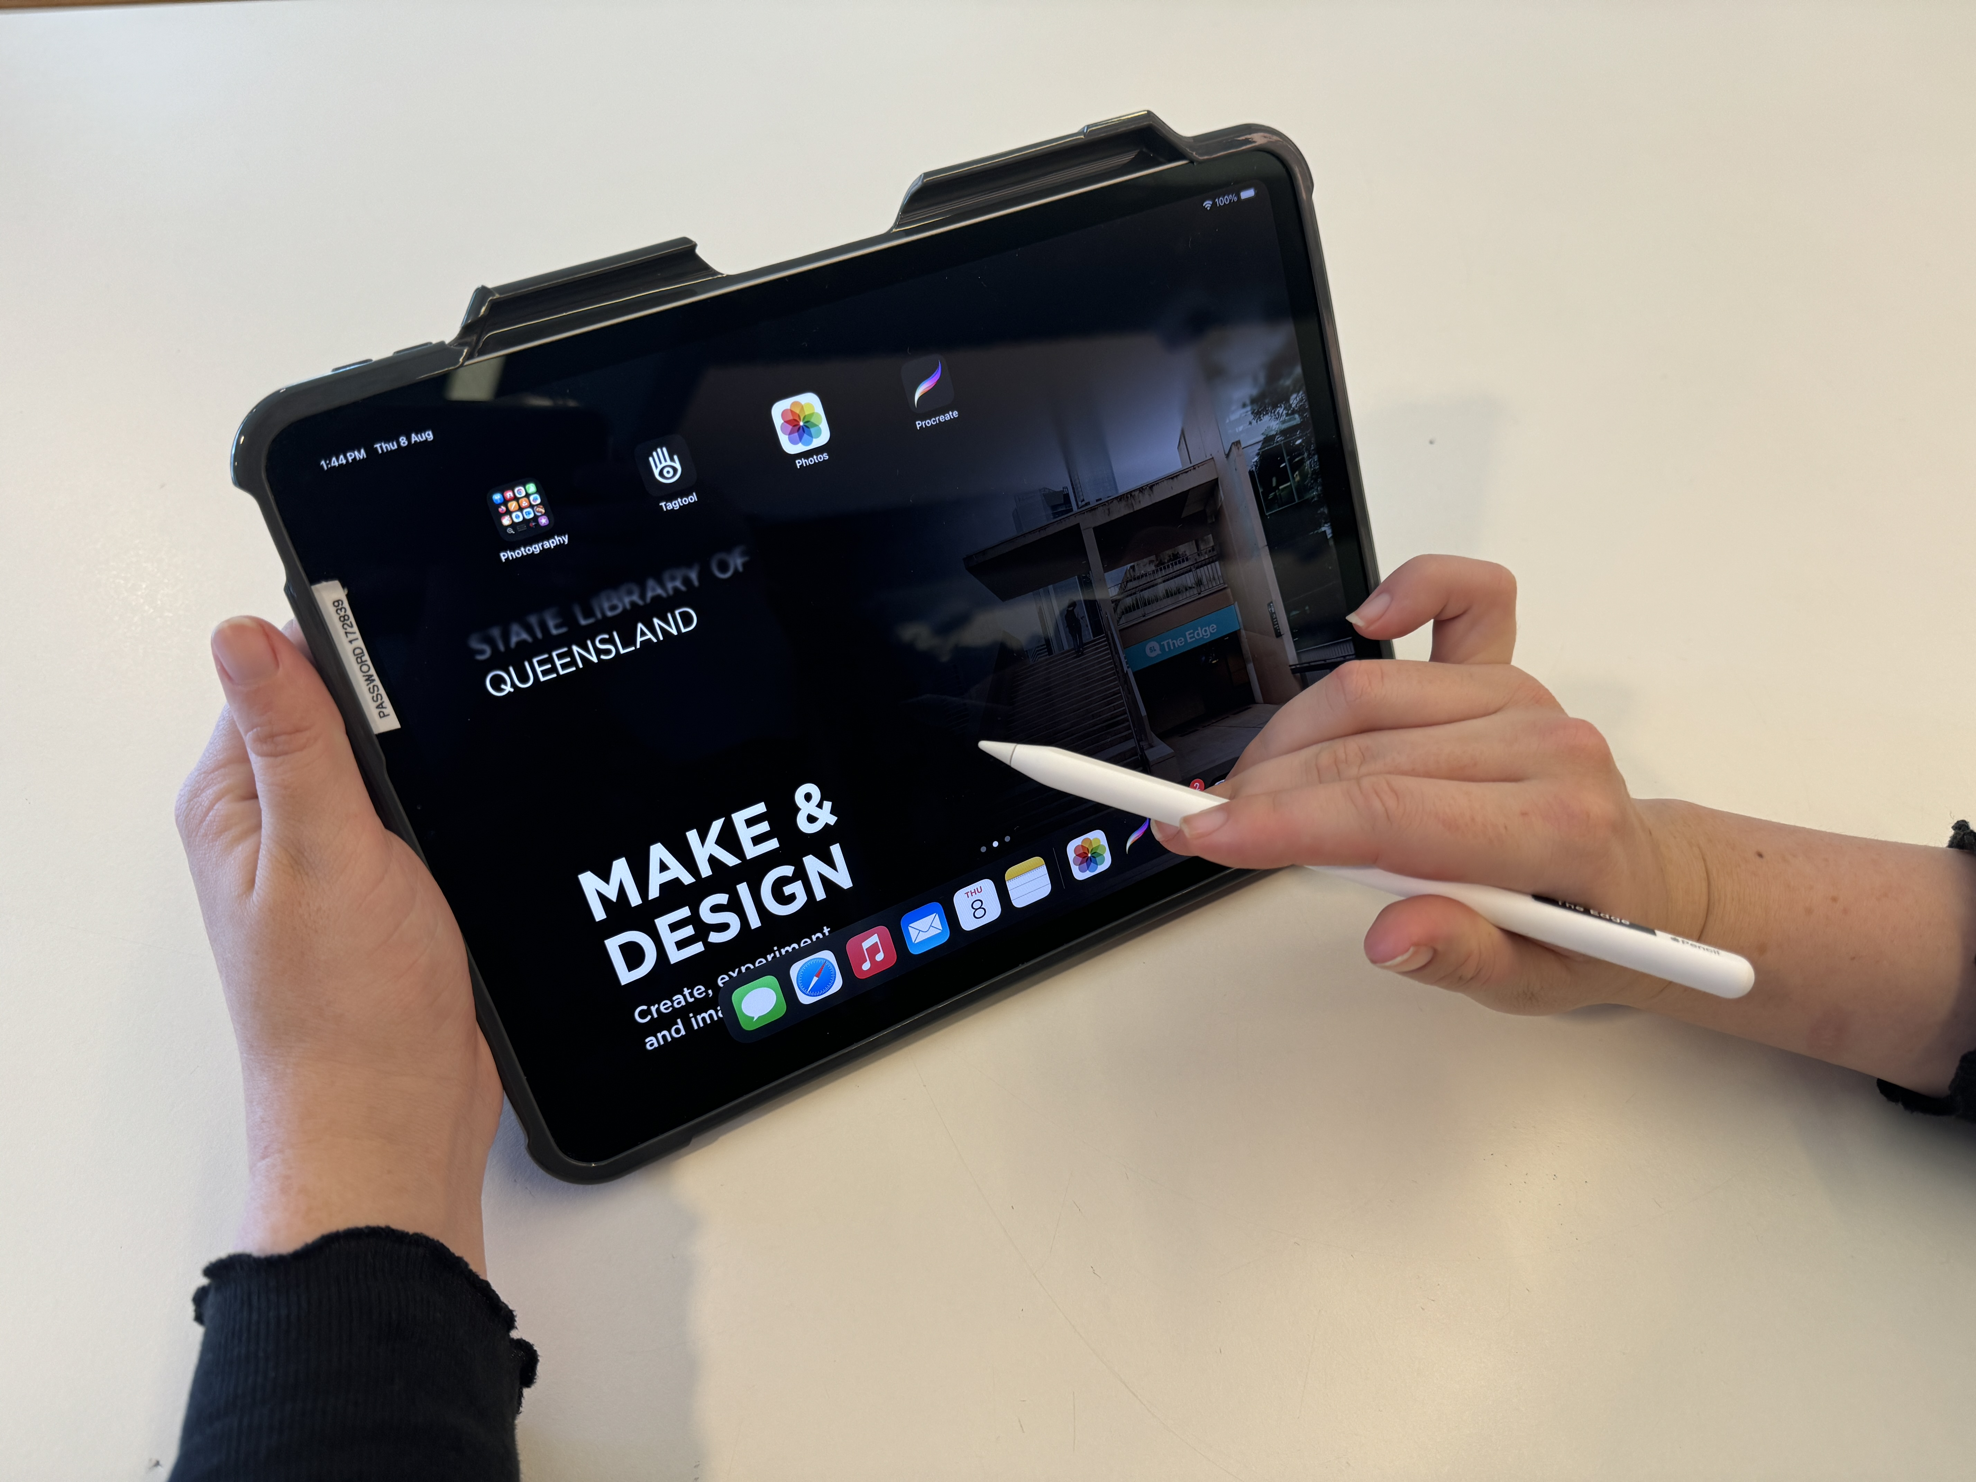//Image of iPad here//
The iPad 11 Pros from The Edge offer versatile tools for creative pursuits such as tablet-based drawing, design, 3D scanning, photogrammetry, and audio-video applications. State Library members can access a variety of make and design programs on these iPads, along with provided Apple Pencils.
Find some terrific activities to follow along with on your own below.

