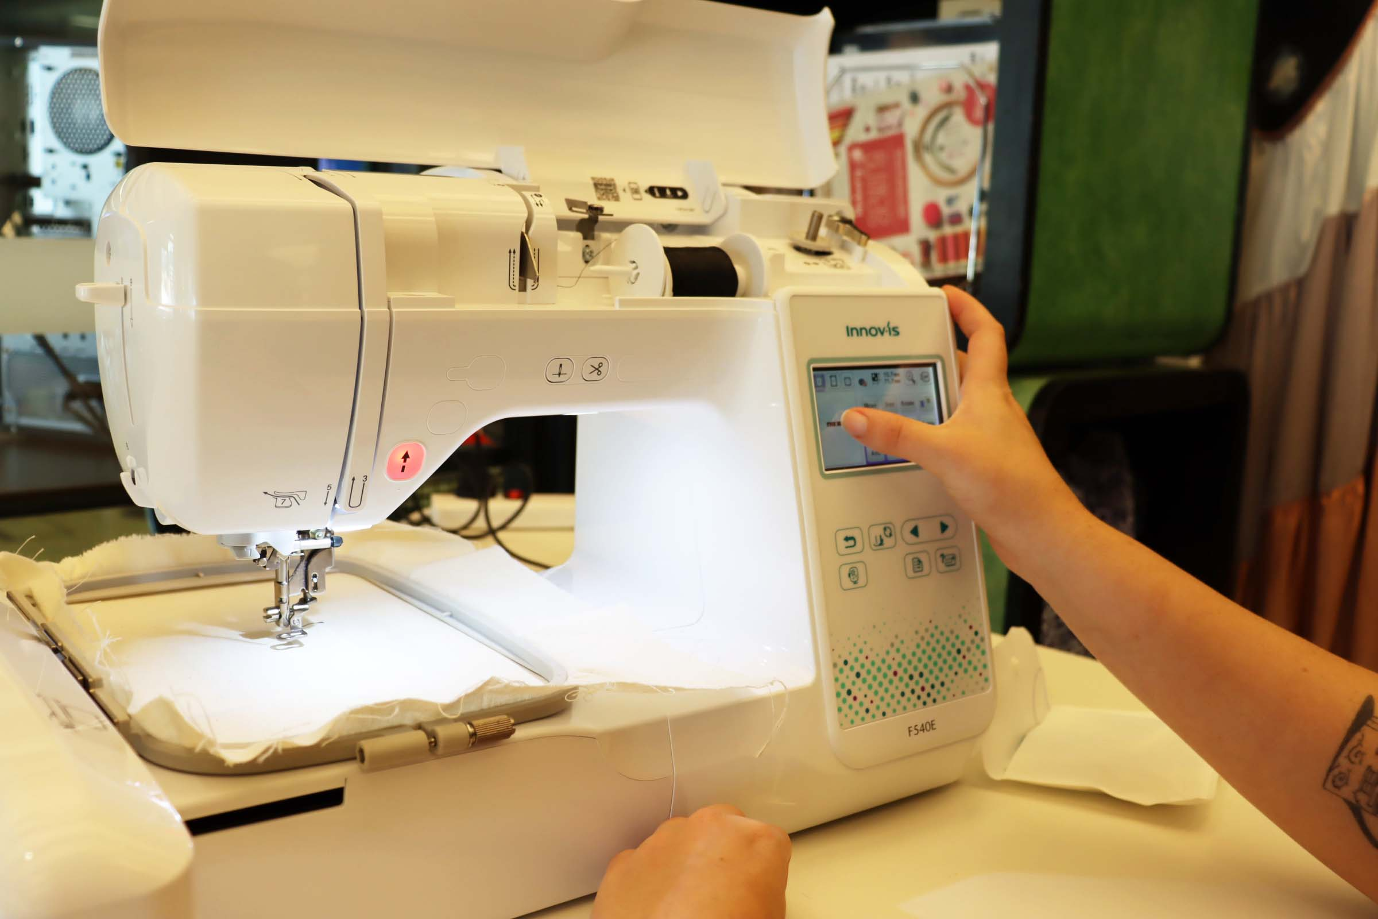

Embroidery Machine
Embroidery Machine
Video Induction Link
The Brother embroidery machine can be used to create a range of fun designs! With 193 Built-in Embroidery Patterns, 13 Adjustable Embroidery Fonts, Advanced Needle Threading System, Colour Sorting, Jump Stitch Trimming & On-screen Editing.​
AVAILABLE:​
- Brother F540E Embroidery only machine ​
- Embroidery sewing kit ​
- Embroidery Frame Set 180 x 130mm (7×5“)​
Additional equipment available:​
- Irons and ironing boards x 2​
- Mannequins x 2​
- Bernina 700/800 series domestic machines & overlocker (further inductions required)​

Safety Information
Here is the safe operating use of the machine, here are the potential hazards.
- Cuts (from needles and scissors) make sure when the machine is embroidering you keep your hands away from the needle.
- Eye strain (overworking and frustration) Take breaks regularly and look for some resources for problems.
- Crush injury (manual handling) Use the correct manual handling procedures
- Electrocution (cords) Cords and cables within the space regularly tagged and tested, if there are any issues let a staff member know.
Never lift the machine with the Embroidery unit attached to the machine and always check the safe operating procedures regularly and ask a staff member for help if you have any problems or concerns.
Make sure you read the SOP for this machine.

Creating Embroidery Designs with Inkscape and Ink/Stitch
You can create your own designs to use with the embroidery machine using Inkscape a free, open-source software for creating scalable vector graphics. With the free Ink/Stitch plugin, you can convert your vector designs into embroidery files.
Ink/Stitch allows you to export your vector designs as .pes files, which can then be saved to a USB drive and inserted into the embroidery machine. The .pes file format contains coded instructions that the embroidery machine reads to stitch your design onto fabric.
If you’re new to creating vectors, check out the following resources: • Creating vectors in Inkscape • Understanding vector graphics To save your design as a .pes file in Inkscape:
- 1. Select File > Export.
- 2. Click on the file name to change the save location and rename your file if needed.
- 3. In the dropdown menu, select Ink/Stitch: Brother Embroidery Format (.pes).
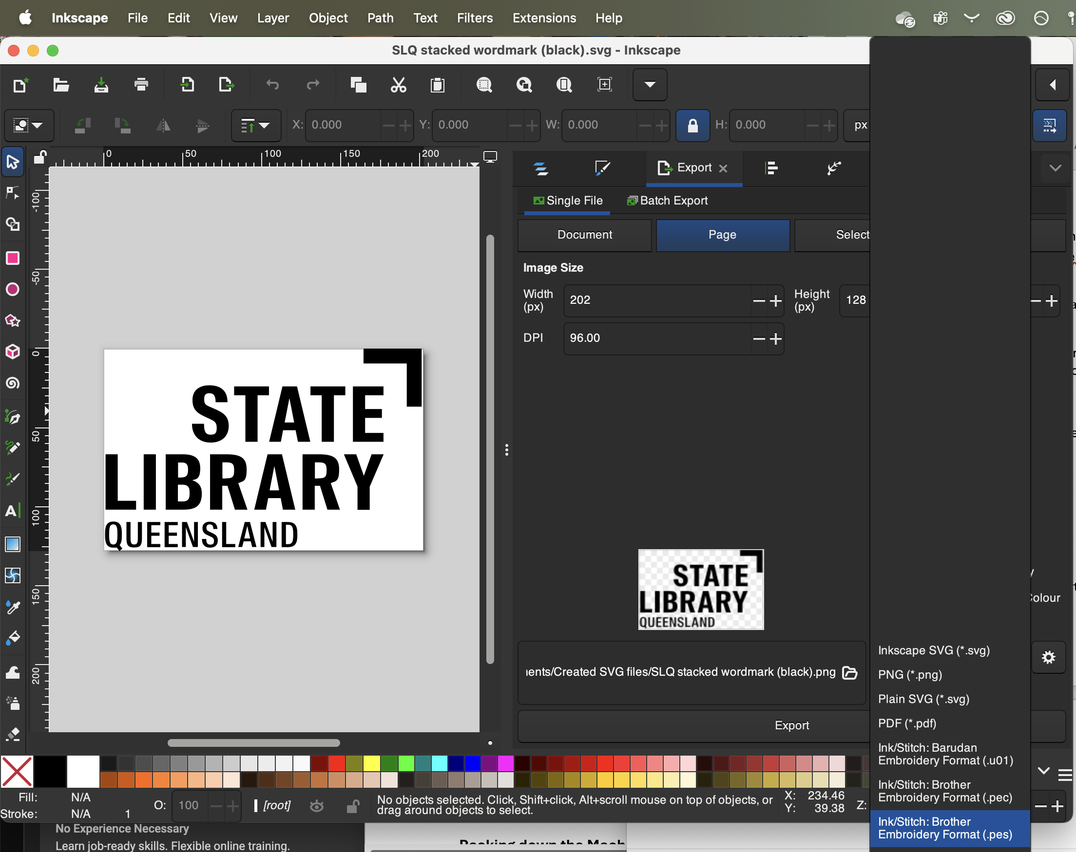

FAQS

Further support
How to thread the Brother F540E | Echidna Sewing
How to wind and insert a bobbin on the Brother F540E | Echidna Sewing
Combining designs on the Brother F540E | Echidna Sewing
HOW TO TURN YOUR DRAWINGS INTO EMBROIDERY FILES! Using Procreate, InkScape & InkStitch!

Further resources
Take a closer look at the Brother F540E Embroidery Only Machine | Echidna Sewing
Intro to - F540E Embroidery Machine
Introducing Brother Design Database Transfer
Embroidery design guide
https://embroiderylegacy.com/small-embroidery-fonts-how-to-get-best-results/
https://inkstitch.org/tutorials/resources/beginner-video-tutorials/

