HP Probook 645 G4 (2019)
These laptops are for running in-house programming and general Fabrication Lab use. Basic specs are;
- System Manufacturer: Hewlett-Packard
- System Model: HP Probook 645 G4
- Processor: AMD Ryzen 5 PRO 2500U w/ Radeon Vega Mobile Gfx
- Memory: 8192MB RAM

A mix of commercial and FOSS software is installed including:
- Corel Draw 2017
- Vcarve (makerspace client edition)
- Fusion360
- Gimp
- Inkscape
- Meshmixer
- Prussaslicer

Admin
Previously we have used local mandatory profiles to manage and refresh the public user profile (edgeuser) account on log-in. This worked up until Windows 10 v1803. For now we are using a simple shutdown script that triggers a restore of the edgeuser account from back-up. Takes about 1min on shutdown.

User Backup
A .cmd file is run to create the initial backup.
echo d | robocopy c:\Users\edgeuser c:\Users\edgeuser_bak /mir /xj

User Restore
A .cmnd file is created to restore.
echo d | robocopy c:\Users\edgeuser_bak c:\Users\edgeuser /mir /xj /w:1 /r:1
This script is triggered on shutdown with a local computer policy.
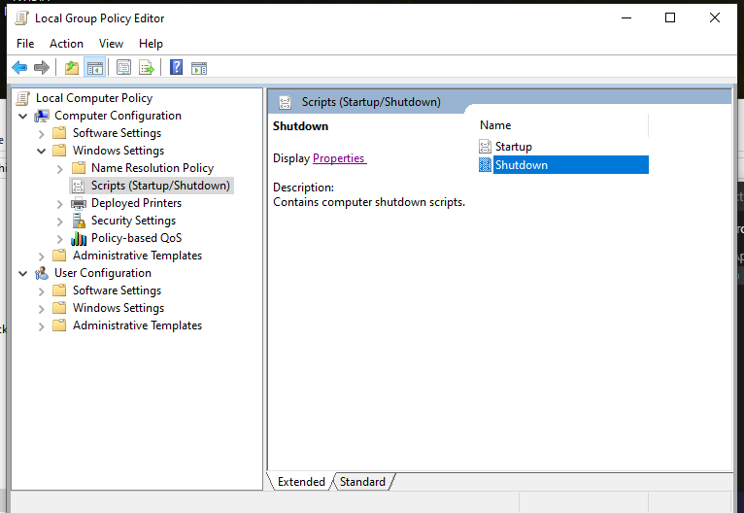

Files
copyonshutdown.zip
bkupuserprofile.zip

References
https://james-rankin.com/articles/creating-a-custom-default-profile-on-windows-10-v1803/
https://www.intel.com.au/content/www/au/en/support/articles/000023992/memory-and-storage/intel-optane-memory.html
https://james-rankin.com/articles/creating-a-mandatory-profile-on-windows-10-1803/
https://forensit.blogspot.com/2010/09/changing-default-profile-on-windows-7.html
https://community.spiceworks.com/topic/430755-is-it-possible-to-revert-an-image-back-to-audit-mode-after-sysprep
https://community.spiceworks.com/how_to/148624-how-to-clean-up-a-single-windows-10-machine-image-using-decrapifier

