Multicam M-2412 CNC Router
The Edge's M-2412 is manufactured locally in Brisbane by Multicam CNC and features:
- A2MC Controller
- ELTE COLLET ER32 - 3HP Spindle with max speed of 18000RPM
- Vacuum Machine Bed
- Multicam Vision System
- 5 hp Dust Extractor

CNC Router Operations
The Edge has developed a CNC Router Operations e-manual in order to safely and efficiently promote public engagement with this piece of equipment.

The Edge's operation e-manual will be made available to CNC router users via the Edge's wiki served Raspberry Pi digital signage system.

This e-manual can be broken down into the following sections.

Contents
- Other Operations - Staff Only

Machine Safety
- When machine is running, keep clear of any rotating or moving parts eg. the cutting bit, spindle moving gantry and head parts.
- Do not lean on machine whilst in operation.
- Parts of the machine , particularly cutting bits, will get hot so you may need gloves when handling/ or changing tooling.
- Maintain a clean workspace-check that the gantry and rails for tooling/materials left behind.
- Clean up as you work. The machine does the messy work for you to clean up!
- Use the right tool for the job. Different tooling pieces have a specific purpose and material.

Safety - Emergency Stop
The CNC is fitted with an emergency stop.
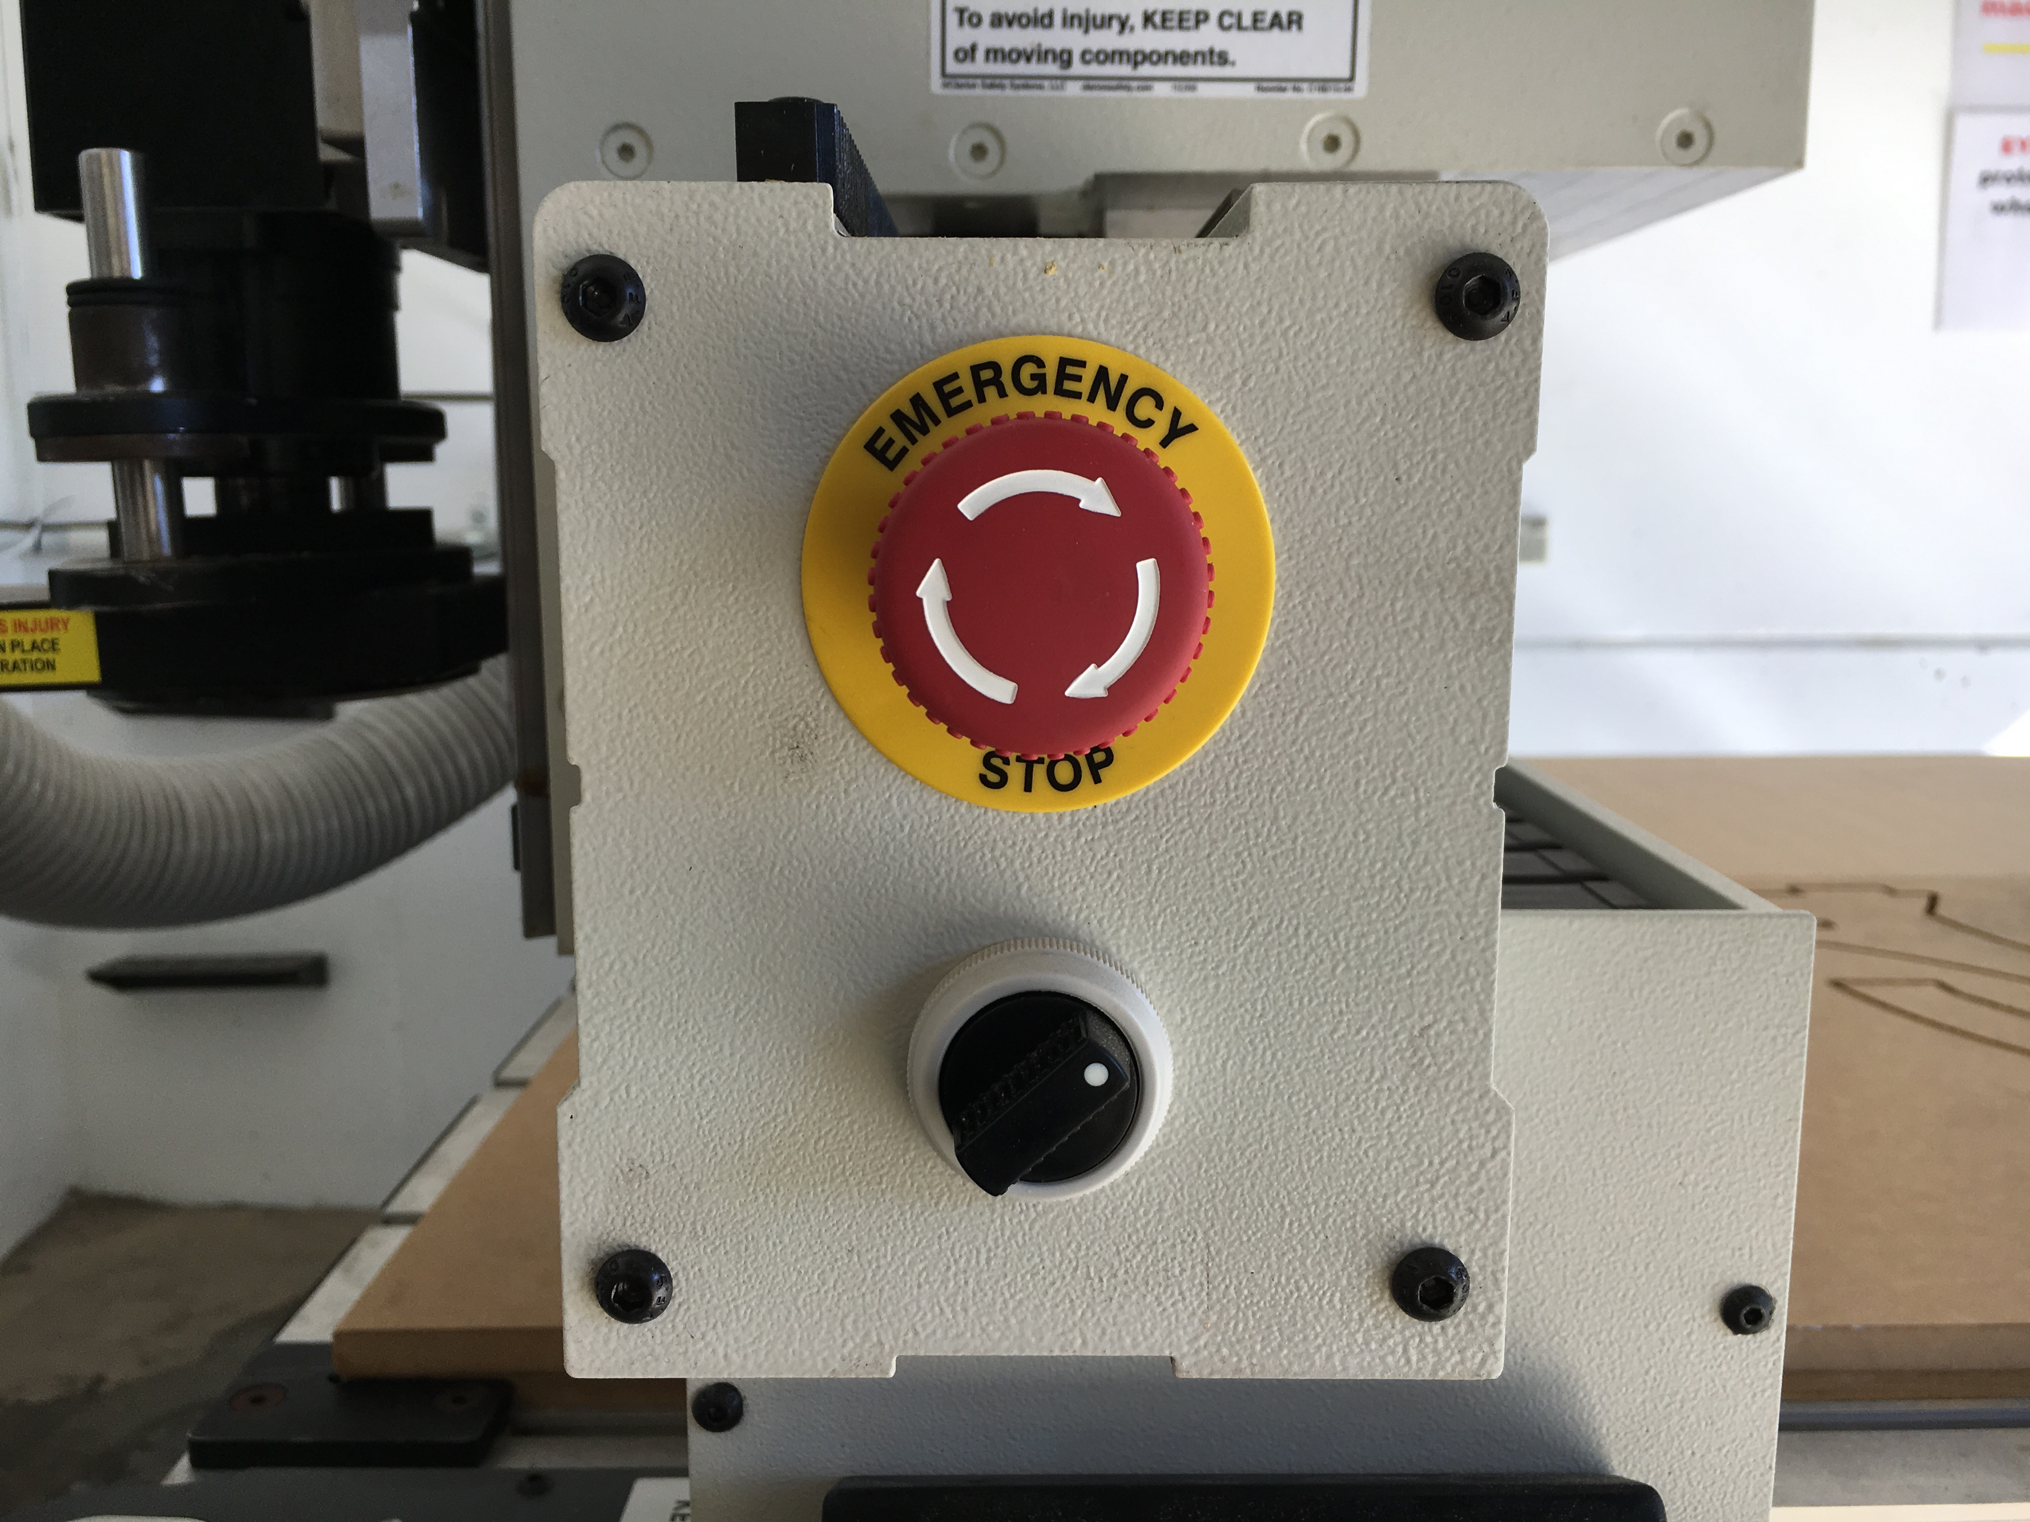
This can be activated to bring the machine to an immediate stop in an emergency.
Note -if the machine is turned OFF mid operation, wait 1 minute to turn ON. After activating emergency stop, needs to be homed.

Safety - Operator Hazards
The CNC router is capable of directly causing death or serious injuries, including amputations, fractures, de-gloving, lacerations, contusions and crush injuries. The hazardous parts of the machine are:

The spindle
- The spindle spins at up to 18,000 rpm - capable of cutting at over 10 metres/minute (m/m)
  - through metal
  - (or flesh)
- The bit takes at least 30 seconds to come to a complete stop.
  - Every time.
  - Even if you touch it.
- The bit can fracture, break or shatter.
  - A bit rotating 18,000 RPM will fly out about 50 km/hr
    - at your eyeball

The Gantry and Machine Head
The gantry can move at over 10 meters/min and weighs over 100 KG.
It can hit with enough force to knock a person over, or trap and mangle a limb.

Safety - Damage to Machine
- The vacuum bed is soft aluminium. If it is damaged the machine is unusable.
- Drill bits are brittle, and will shatter or crack if dropped on concrete.
- The router will cut through metal clamps and screws

LINKS
CNC Router Operations
Other Operations - Staff Only
Multicam CNC Induction

CNC Materials
The Edge currently holds a stock and sells 1200x1200mm (half sheets) 15mm Plywood. Participants are also welcome to have a look in the offcuts for suitable material (this is for prototyping only- no commercial/professional jobs)
We also have a small reserve of 15mm ply and 18mm Formply in full sheets (2400×1200)
These are stored offsite and require extra handling. Prearrange if you want to organise a full sheet for your next booking
The Edge has also started experimenting with Expanded PVC Board and Expanded Polystyrene Foam.
Talk to your Fab Lab Supervisor if you have a specific material you would like to trial on the machine.

LINKS
CNC Router Operations
Other Operations - Staff Only
Multicam CNC Induction

Router Tooling, Feed Rates and Cutting Speeds

Tool Geometry
You always want to use the right tool for the job.
Different tool geometries produce different effects and results with the range of materials that can be cut on this machine.
Tool Geometry
Straight Flute | Will not lift material out of cut.
Spiral Flute | Spiral Flute lifts swarf or pushes it towards cut. depending on geometry
Flute Geometry
Single Flute | Single Flute cutters only have one cutting edge. These are good for faster feed rates in softer materials.
Double Flute | Double Flute cutter have cutting surfaces and are good for cutting harder materials at slower feed rates.
Upcut Spiral | The geometry of an upcut spiral draws swarf up and out the top surface providing the best finish on the down side of the material
Downcut Spiral | The geometry of an downcut spiral draws swarf down and out the bottom surface providing the best finish on the upper side of the material.
Compression Cutters | Compression Cutter have both upward and downward spiral geometry that forces swarf both upward and down and produces a clean finish on both upper and under sides of the materials and is particularly useful in applications with laminated materials.
O Flute | Identified by the Half moon shape, OFlute cutters have a single flute that ejects swarf effeciently. As such they are suited to cutting timbers and plastics (softer materials ) at high speeds.

Suggested Feed Rates - Soft woods/Plywood
Tool Type | Tool Diameter | Spindle Speed | Feed Rate | Plunge Rate | Direction | Attribution
Single Spiral | 3.175mm | 16,000rpm | 2,000mm/min | 1,000mm/min | Conventional
Single Spiral | 6.35mm | 16,000rpm | 4,800mm/min | 3,000mm/min | Conventional
Double Compound Spiral | 9.5mm | 12,000rpm | 11,280mm/min | 9,000mm/min | Conventional
Double Compound Spiral | 10mm | 12,000rpm | 11,280mm/min | 7,000mm/min | Conventional
Triple Compound Spiral | 10mm | 12,000rpm | 16,920/min | 12,000mm/min | Conventional
Triple Compound Spiral | 12mm | 8,000rpm | 13,320/min | 11,000mm/min | Conventional

Suggested Feed Rates - MDF, Particle Board
Tool Type | Tool Diameter | Spindle Speed | Feed Rate | Plunge Rate | Direction | Attribution
Single Spiral | 3.175mm | 16,000rpm | 2,240mm/min | 1,200mm/min | Conventional
Single Spiral | 6.35mm | 16,000rpm | 5,280mm/min | 3,500mm/min | Conventional
Double Compound Spiral | 9.5mm | 12,000rpm | 13,080mm/min | 9,500mm/min | Conventional
Double Compound Spiral | 10mm | 12,000rpm | 13,080mm/min | 9,500mm/min | Conventional
Triple Compound Spiral | 10mm | 12,000rpm | 16,920/min | 12,000mm/min | Conventional
Triple Compound Spiral | 12mm | 8,000rpm | 15,360/min | 11,000mm/min | Conventional

Suggested Feed Rates - Hardwood
Material Size | Tool Diameter | Spindle Speed | Feed Rate | Plunge Rate | Direction | Attribution
Single Spiral | 3.175mm | 16,000rpm | 1,680mm/min | 1,000mm/min | Conventional
Single Spiral | 6.35mm | 16,000rpm | 4,800mm/min | 3,000mm/min | Conventional
Double Compound Spiral | 9.5mm | 12,000rpm | 10,080mm/min | 8,500mm/min | Conventional
Double Compound Spiral | 10mm | 12,000rpm | 10,080mm/min | 7,000mm/min | Conventional
Triple Compound Spiral | 10mm | 12,000rpm | 15,120/min | 12,000mm/min | Conventional
Triple Compound Spiral | 12mm | 8,000rpm | 12,120/min | 11,000mm/min | Conventional

Suggested Feed Rates - Acrylic
Material Size | Tool Diameter | Spindle Speed | Feed Rate | Plunge Rate | Direction | Attribution
Single Spiral | 3.175mm | 16,000rpm | 6,000mm/min | 2,000mm/min | Climb
Single Spiral | 6.35mm | 16,000rpm | 3,200mm/min | 1,500mm/min | Climb
Double Compound Spiral | 9.5mm | 12,000rpm | 6,000mm/min | 2,000mm/min | Climb

NOTES
The above setting are as suggested on page 194 of the Multicam A2MC Machine Installation and Training Manual unless noted in the ATTRIBUTION Column in ach Settings Table.

Feeds and Speeds for the Tangential Knife

Suggested Feed Rates - Corrugated Cardboards
Material Size | Tool Length | Feed Rate | Plunge Rate | Direction | Attribution
4mm Single Corrugated | 15mm | 5000mm/min | 2000/min | Conventional
7mm Single Corrugated | 15mm | 5000mm/min | 2000/min | conventional

Suggested Feed Rates - Expanded Foam
These feed rates should be adjusted to suit design. Small radius curves should be cut slowly to minimize knife flex.
Material Size | Tool Length | Feed Rate | Plunge Rate | Direction | Attribution
50mm | 70mm | 2500mm/min | 1500mm/min | NA | TheEdge
50mm(radius <=10mm) | 70mm | 1500mm/min | 1500mm/min | NA | TheEdge
 |  | 5000mm/min | 2000/min | NA | TheEdge
LINKS
CNC Router Operations
Other Operations - Staff Only
Multicam CNC Induction

Preflight checks - Vcarve
Before Exporting the NC file for your cutting program from VCarve check the following:
- Have you checked the dimensions of the plate with the material you will be cutting? Especially the thickness - underestimating the thickness (z axis) can result in punching the bed
- Are you Parts nested far enough apart?

Preflight checks before exporting NC Files - Continued
- Have you selected the right cutting tool for the job - cut diameter, cut depth, correct tool for required finish on the material, and for the features of the design (eg dogbone corners etc)
- Does the actual tool match the tool selected in the library for the toolpaths?
- Is the cut depth of each of the toolpaths consistent with the required depth? Are you sure your toolpath will not punch the bed?
- Have you selected the feeds and speeds recommended for the tool and material you are cutting?

Preflight checks before exporting NC Files - Continued2
- Have you set your toolpath to cut in the right number of passes? - Max pass Z ≤ tool diametre.
- Have you have selected correct cut direction (conventional or climb/ raster or offset) and vector offset (inside outside or on the line)?
- have you inserted the required depth, width, number of tabs and that the position of these is optimised?

Preflight checks before exporting NC Files - Continued3
* have you run an estimate cut duration and any tool changes to ensure you have enough time complete the job within you booking time.
Before exporting NC file have the Fabrication Lab Supervisor check your settings.

LINKS
CNC Router Operations
Other Operations - Staff Only
Multicam CNC Induction

Preflight checks - getting the Machine ready to cut
- Is there a hot work permit in place?
- Is there room in the extraction bag for your saw dust?
- Check the required tool is is in the machine and is secure?
- Has the tool been qualified?
- Has the machine been homed?
- Are the required Vacuum bed zones are turn on?
- Is the material secure on the bed?
- Have you loaded the right cutting file ( Preview File on the A2MC console)?
Check with the Fabrication Lab Supervisor before cutting
LINKS
CNC Router Operations
Other Operations - Staff Only
Multicam CNC Induction

When you are cutting your job
- Are you and (everybody in the room) wearing your PPE?
- Are you and (everybody in the room) standing behind the yellow safety line?
- Are you alert and ready to hit the emergency stop if required?
- Are you ready to hit the pause button to clear debris?
DO NOT GO NEAR THE SPINDLE UNTIL YOU CAN CONFIRM IT HAS STOPPED SPINNING
LINKS
CNC Router Operations
Other Operations - Staff Only
Multicam CNC Induction

Commonly Used Tabs and Functions

A2MC Tabs
FUNCTION | NOTES
Tab 1 - Jobs Mode
Tab 2 - Position & Jog Mode
Tab 3 - Speed Mode
Tab 4 - Spindle RPM
Tab 5 - Origin Mode
Tab 6 - Tooling Mode
Tab 7 - Function Mode

Spindle Functions
FUNCTION | NOTES
Function 01 - Machine Properties
Function 02 - Verify Job
Function 09 - Abort Job
Function 16 - Set Parking Position
Function 20 - Set Material Thickness
Function 25 - Set Tool Height
Function 27 - Set User Z Origin
Function 28 - Set and Plane Waste Board
Function 30 - Edit Tools
Function 31 - Change Active Tool
Function 40 - Current Job Properties
Function 41 - Feed Speed
Function 42 - Spindle Control
Function 43 - Job Repeat
Function 44 - Job Array
Function 45 - Plunge Speed
Function 46 - Measured Move
Function 47 - Cut Rectangle

Tangential Knife Functions
Function 24 - Set Knife Length
Function 42 - Rotate Knife
Function 58 - Swap from Spindle to Knife Control
Function 67 - Knife Overcut/Undercut Compensation
Function 822- Set up Tangential Knifes
LINKS
CNC Router Operations
Other Operations - Staff Only
Multicam CNC Induction

Multicam CNC Bookings
The Edge's Multicam CNC Router is available for bookings by inducted members of the community on Tuesday Afternoons from 12 - 4pm.
Hit the booking page to make your 2 hour booking.

LINKS
CNC Router Operations
Other Operations - Staff Only
Multicam CNC Induction

Machine Safety
- When machine is running, keep clear of any rotating or moving parts eg. the cutting bit, spindle moving gantry and head parts.
- Do not lean on machine whilst in operation.
- Parts of the machine , particularly cutting bits, will get hot so you may need gloves when handling/ or changing tooling.
- Maintain a clean workspace-check that the gantry and rails for tooling/materials left behind.
- Clean up as you work. The machine does the messy work for you to clean up!
- Use the right tool for the job. Different tooling pieces have a specific purpose and material.

Safety - Emergency Stop
The CNC is fitted with an emergency stop.
This can be activated to bring the machine to an immediate stop in an emergency.
Note -if the machine is turned OFF mid operation, wait 1 minute to turn ON. After activating emergency stop, needs to be homed.

Safety - Operator Hazards
The CNC router is capable of directly causing death or serious injuries, including amputations, fractures, de-gloving, lacerations, contusions and crush injuries. The hazardous parts of the machine are:

The spindle
- The spindle spins at up to 18,000 rpm - capable of cutting at over 10 metres/minute (m/m)
  - through metal
  - (or flesh)
- The bit takes at least 30 seconds to come to a complete stop.
  - Every time.
  - Even if you touch it.
- The bit can fracture, break or shatter.
  - A bit rotating 18,000 RPM will fly out about 50 km/hr
    - at your eyeball

The Gantry and Machine Head
The gantry can move at over 10 meters/min and weighs over 100 KG.
It can hit with enough force to knock a person over, or trap and mangle a limb.

Safety - Damage to Machine
- The vacuum bed is soft aluminium. If it is damaged the machine is unusable.
- Drill bits are brittle, and will shatter or crack if dropped on concrete.
- The router will cut through metal clamps and screws

LINKS
CNC Router Operations
Other Operations - Staff Only
Multicam CNC Induction

CNC Materials
The Edge currently holds a stock and sells 1200x1200mm (half sheets) 15mm Plywood. Participants are also welcome to have a look in the offcuts for suitable material (this is for prototyping only- no commercial/professional jobs)
We also have a small reserve of 15mm ply and 18mm Formply in full sheets (2400×1200)
These are stored offsite and require extra handling. Prearrange if you want to organise a full sheet for your next booking
The Edge has also started experimenting with Expanded PVC Board and Expanded Polystyrene Foam.
Talk to your Fab Lab Supervisor if you have a specific material you would like to trial on the machine.

LINKS
CNC Router Operations
Other Operations - Staff Only
Multicam CNC Induction

LINKS
CNC Router Operations
Other Operations - Staff Only
Multicam CNC Induction

