'Imagine the Rumpus' Workshop PLANNING template

Activity and Workshop Planner
Activity: Imagining the Rumpus
Aim/ Key learnings:
Age group: 5-10yrs
Method: Family group workshop
Ratio Participant/Facilitator: 3 artists to 5 family groups of 5
Duration: 90 mins
Materials required:
Preparation required:
Aim of workshop:
Facilitators:
Is a feedback form required?:
Marketing and communications tools:
Venue Requirements:
Is a media release form required?

Activity Details
10.30 min
- Welcome and name tags - come up with a team name
- We collect names and email addresses of the families participating
10.35 min
- What are we are doing today? ‘We have run out of ideas and we need your help to come up with some more.’
10.40
- Group story game led by Marianna
11.00
- Drawing challenge (these are interchangeable)
- Draw something from the story
- Draw who or what you would invite to a party
- Draw your perfect place for a party.
11.15
- Continue the drawing into crafting a model
- Introduce the idea of the ideas machine (blue blocks)
- How does the craft interact with the space created by the blocks?
11.30
- Sue starts to document the ideas that have come about.
- Other artists ask the participants to reflect on what they have made and inform the documentation.
11.45
- Break out play is winding up
- Final group reflections
- Any group activity that might create a party
11.55
- Clean up

Imagine the rumpus REFLECTION document template
Title and facilitator/s:
Attendants and ages:
Aim of Workshop:
Inspiring quotes from young people:
Stand out ideas or outcomes:
1st workshop:
2nd workshop:
Things to consider next workshop:
Specific outcomes required in the next workshop:
Are there completed media release forms? No
Are there completed feedback forms? No
What was challenging and how was this handled?
To run this exact workshop again, how would I do it differently?

Idea Brief Template: GRR Project
IDEA INFO
Title
Design Vision
Is there a special function for this design?
Does this idea connect with another idea?
Does this idea require a linking design?
Yes
VISION
Colour Requirements
Texture and Finishes
Support Information
Drawings
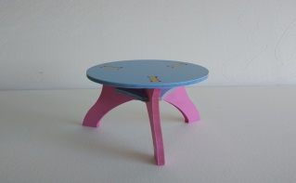
Model
Digital recording

