Fabrication Session 1: Jellyfish
Laser is booked 4-6pm
Intro the GGR along the lines of for the design session:
~~REVEAL~~

Intro to project
What?
IMAGINE - 4-10 yo develop ideas for an imaginary world that would be fun to visit and party. (output: ideas)
DESIGN – big people (interested in designing interactive creative space) interpret the ideas and turn them into practical designs for installation at the Great & Grand Rumpus. (output: resolved designs)

FABRICATION – Young Adults and young-at-heart community members (interested in hands on and digital making). Cut out, Finish and construct designs.
EXPERIMENT – SLQ’s school holiday workshop program will offer young people 10-15 yo an opportunity to be inspired by these product of this creativity to explore animating the installations with light, sound and movement.
RUMPUS – a team of young people and young-at-heart community members will transformed Level 1 of The Edge into a space for party, play and activities. Everyone whose been involved can invite their friends and family to come along on the XX July and immerse themselves in the imaginary worlds we’ve created together.

Why?
Why collaborative?
Why community?
Why start with children – imagination is a muscle that can be exercised– use it or lose it parameters- aesthetic, resources (budget space and tools) and timeline, integration with other programming.

Why you?
- Fun & Productive
- Share & Learn
- Meet & Connect

Hands on making
2. Discuss the palette (in particular, colour and texture) Discuss the space that they are intended for as well. Depending who is there (talk to the Kaiju and the smaller versions from FA's). The internal structure and the outer structure. Some may require more detail than others.

3. Safety talk of Fab Lab and hot glue. Restrictions of making (that what is assembled needs to fit into the staff area)
4. See the cut parts of the ones that we will be making in this session (Gregory would have done these) (if Gregory is still cutting opportunity to go and see that and chat with him)
5. Set up in a space working in small groups if possible
Option to laser any extra parts that may be required
Chips and water on hand for the whole session.

Reflection
During this session we focused on making the Jellyfish (of which there was 25 to make). We discovered that the best material was the cotton after all and not fishing line which had been suggested

Photos
Working on using the construction of cardboard techniques
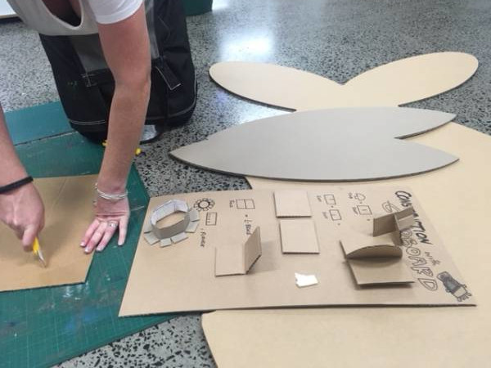
Jellyfish
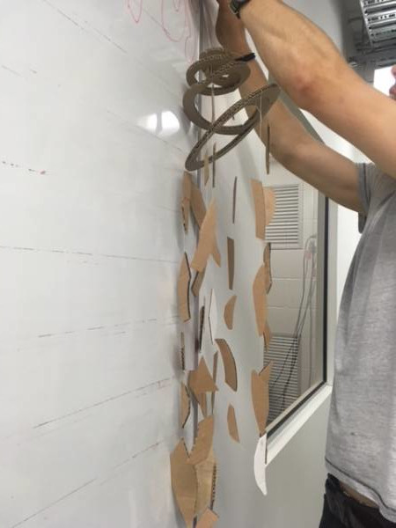
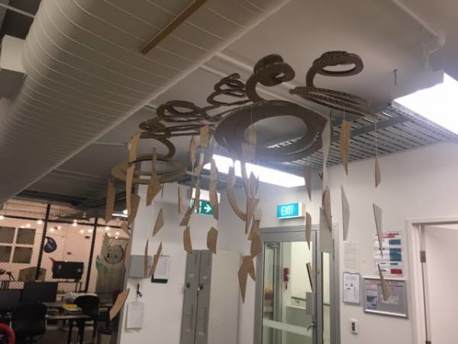
Lots of jellyfish

