Drop in Making Session 2
The foyer Saturday 10th 10am-2pm

Prep
Take the following up to the foyer
- Container of hot glue
- 3x hexes
- Cardboard
- Box cutters
- Chips
- Music player?
- Cold water and glasses

The Plan
- Look at the model that was created digitally
- work on plan to begin building
- get into building

Journal Entry- How it panned out & What we learnt
The process of converting a very rough modelling clay model into a visually dynamic, anatomically correct, portable and structurally viable cardboard maquette is kinda demanding. This is the second time we have run through this process. The first time The Edge built a giant Cardboard Kaiju there was no modelling clay model or cardboard maquette produced. Emma Che & I on a Friday afternoon hastily came up with a rough plan after learning our contract facilitator was too ill to lead the session. After looking at images of snakes and blue tongue lizards online we used a piece of twisted newspaper wrapped in masking tape to make a very brief study of the subtleties of snakieness. As such there was a plan, its just that this plan was mainly in my head... and probably was slightly flawed.
As such we basically jumped straight into the construction of the full size Kaiju. We literally started building from the ground up and without a specific strategy for an internal frame/scaffold (we really didn't know if we'd need one).
The problem with a design that's in your head, is that its difficult for others to collaborate in the construction. With the previous experience in mind we made more time to plan this beast and committed ourselves to making actual prototypes
- A simple modelling clay model the beast and
- A maquette of the internal structure made from scale appropriate cardboard.
A major learning from our first Kaiju was that not only did a scaffold or framework support the mass of the cardboard and glue, it provides a physical representation of conceptual or an anatomical structure. From an internal frame collaborators can extrapolate and contribute a vision for the appearance and construction approach to the external. Just like in Jazz impro the basic structure to jam and riff on is important to facilitate collaboration. “it's what's on the inside that counts”.
Thursday (2nd Session ), we created modelling clay representations of an anatomically correct manta ray (albeit a dead manta ray that we performed a virtual post mortem dissection on to gain an understanding of the structures of the animal) and a more animated/ caricatured representation of the Kaiju with its main features:
- Cycloptic dual-light-level eye structure (bender eye and sideways eyelids. Externalised cones and rods separated onto the anterior distal surface individual side by side discs) see Invertebrate Eyes and Evolution of the Eye
- fold out fan of peacock like wings for a defensive display
- whip tail with finned barb end for propulsion and defence
- bitey worn double row of teeth
- oversized Manta ray lobes
- oversized manta ray hip stumps for land travel.
So today we planned to create a maquette of the framework – but again we ran into the problem not all activities are suitable for community engagement. We were encouraging community to come up with a structural plan without any cardboard experience or the most basic understanding of Giant Cardboard Kaiju construction techniques.
One doesn't always appreciate the level of idiosyncratic skill and experience you develop making something like a Giant Cardboard Kaiju. On reflection I can boast that I've been free-forming with Corrugated Cardboard for a couple of years now. You get to know what you can do with the material with this largely ignored and underestimated material. I've also been hacking together designs for larger 3D builds. I’ve collaborated and mused with community and co-workers at The Edge on the use of a range of construction strategies and different features from a range of software applications to get these hacky assemblages to hang together. From this experience I've developed a body of expert knowledge on the best way to build a Giant Cardboard Kaiju. I've even coined a new acronym for Giant Cardboard Kaiju (GCK). Members of the Edge team regularly joke about adding a new pointless skillsets to our Linked In profiles.
Now objectively speaking there is probably a better way to go about building a GCK but I only know my hacky version using the tools, resources and institutional context I find myself in.
And this is how we do it:
After creating a modelling clay model I attempted to sculpt a digital model in Meshmixer.
We then tried to demonstrate frame construction for this basic shape - mix of methods available in 123D Make or Slicer for Fusion 360 - Stacked sheet, Interlocked sheet and curves - this kinda needs to be designed by an experienced GCK builder or group of people who understand GCK methodology especially with the requirement for full size to be built in detachable segments - for portability. probably need to do more prep on this or instead have some cardboard examples already made.
After establishing a concept for a frame we move onto a wrapped conduit construction for the tail and outside skin construction - folded polygon panels - just about anyone who can cut cardboard and use a HGG can do the outside panelling

A list of concerns that should inform a GCK design
- Honour the collaborative design developed by community
- Aesthetically pleasing and has a critical depth (intellectually, social or politically sophisticated.)
- Visually dynamic, See http://headforart.com/2016/04/14/composition-in-sculpture https://www.ipoxstudios.com/laocoon-analyzed-sculpture/ for a discussion of Dynamic composition in sculpture.
- other worldly (novel) yet anatomically correct (look like it has mutated from a plausible xeno/exobiological reality and evolved to take advantages of environmental niches and mechanics of known and imagined evolutionary forces.) https://en.wikipedia.org/wiki/Xenobiology https://en.wikipedia.org/wiki/Astrobiology
- Makes intelligent, elegant use of the grammar of construction materials.
- Portable – deference to portability and manual handling of the structure was sacrificed in the rush to complete the first Kaiju for its hard deadline. Portability and manual handling impose a structural overhead.
- Structurally Viable and an elegant design – the improvised approach to the first Kaiju meant that individual structural issues were resolved on the fly resulting in a chaotic, heavier, inefficient and ugly internal structure

Internal Framework
The Internal framework was worked out pretty quickly once we'd discussed what materials we'd use for the different parts ( Xcore & double ply cardboard for Frame, single ply cardboard for skin and details) and actually started building it. I started with a simple “TT” shape frame leaning on its tail. This would allow us to centrally support the weight of the wings and incorporate the concept of detachable wings to make manual handling/ storage more efficient.
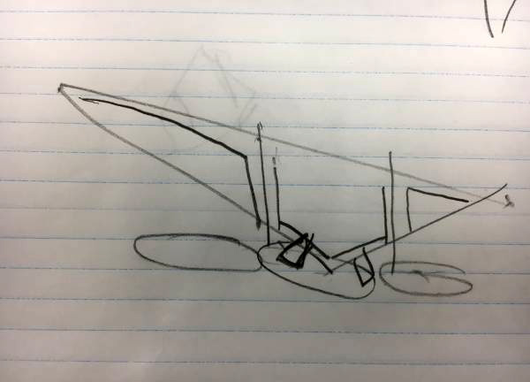
We then looked at how we could make incorporate this frame design with the requirement of dynamic composition ( twisting and off balance. Wavey wings undulating underwater.
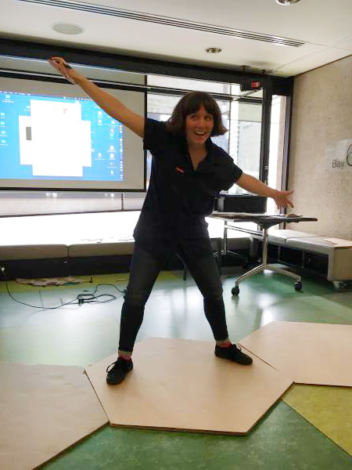
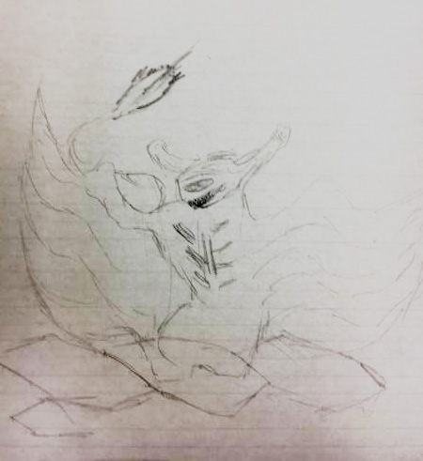

Photos


