Drop in Making Session 1
This session will focus on building a making community. It will be in the Fabrication Lab and there will be a sign out in the foyer that it is a drop in session. It will happen from Thursday 8th March, 4pm onwards

Preparation
- Make a sign (drop in session)
- Have a link to the Slack group on the sign as well as on a board in the drop in session
- prepare a music play list (see if there is a spare device to play music from)
- Decide on one person being the welcome person into the space

Materials needed
- Cutting boards
- Plasticine
- Cardboard
- box cutters
- hot glue
- Laptops
- A sign for out in the foyer about the drop in session

The Plan
- introductions
- look at the designs that we have from the design session
- group chooses one to work with
- model using plasticine
- maybe some more anatomy research of an animal to be able to make a more stable shape. (think of making the overall shape dynamic as well as opposed to flat and boring to look at)
- translate a design to using cardboard
- work with the design digitally
- Tinkercad
- 123d make
- Mesh mixer
- make a mock up of the Kaiju design on the laser

Reflection
The session was drop in and did not require sign up. In hindsight, as we are at the beginning of the process for this project and for the year, creating events for each session is needed.
Only 1 person came specifically for the session (from Monday nights design session). There were 2 other people who engaged in the process during the session.
There was some great research moments in the session. looking at the details of animal eyes and applying rods and cones to the design of the eye.
A Kaiju was chosen and worked on and applied digitally. We did not make it to doing a laser mock up of the design.
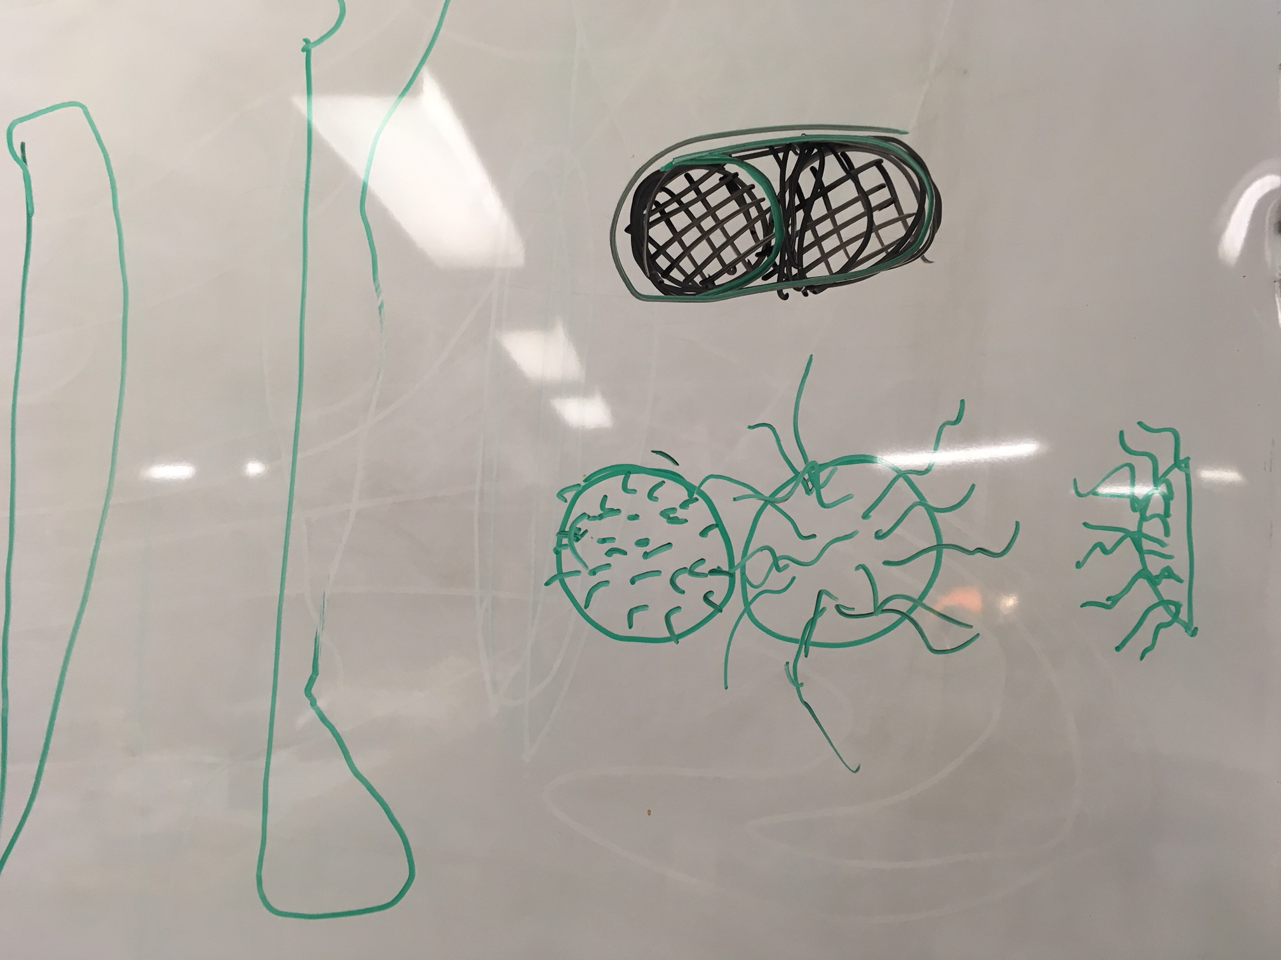

Photos
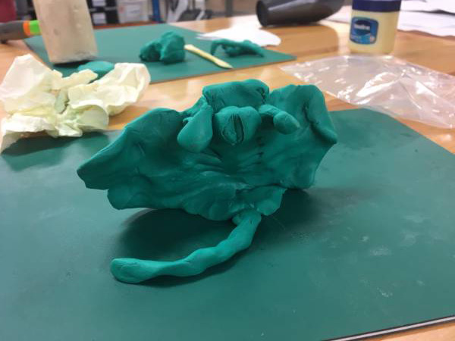
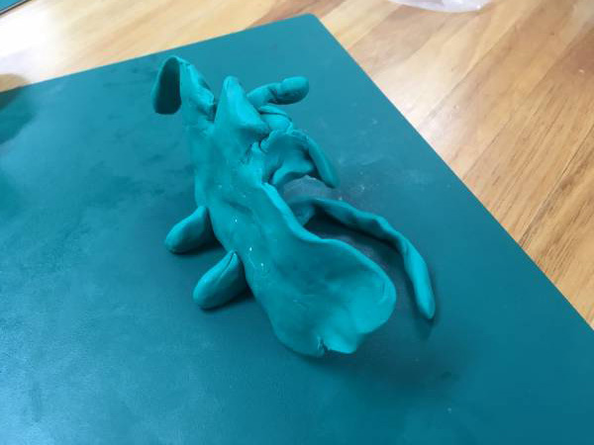
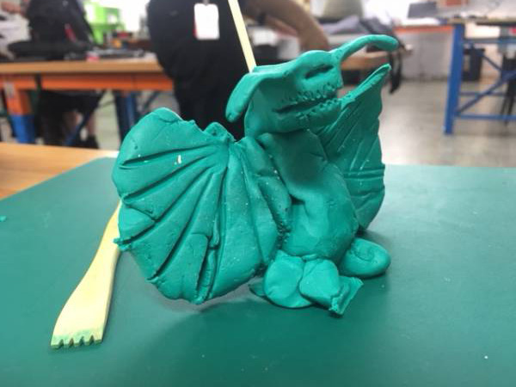
Bone research (in particular the lobes and pelvis of the mantaray)


