Clown Fish Eye View
clown-fish-marquette.cdr
clown_fish_1.ai
Cut files for clown fish
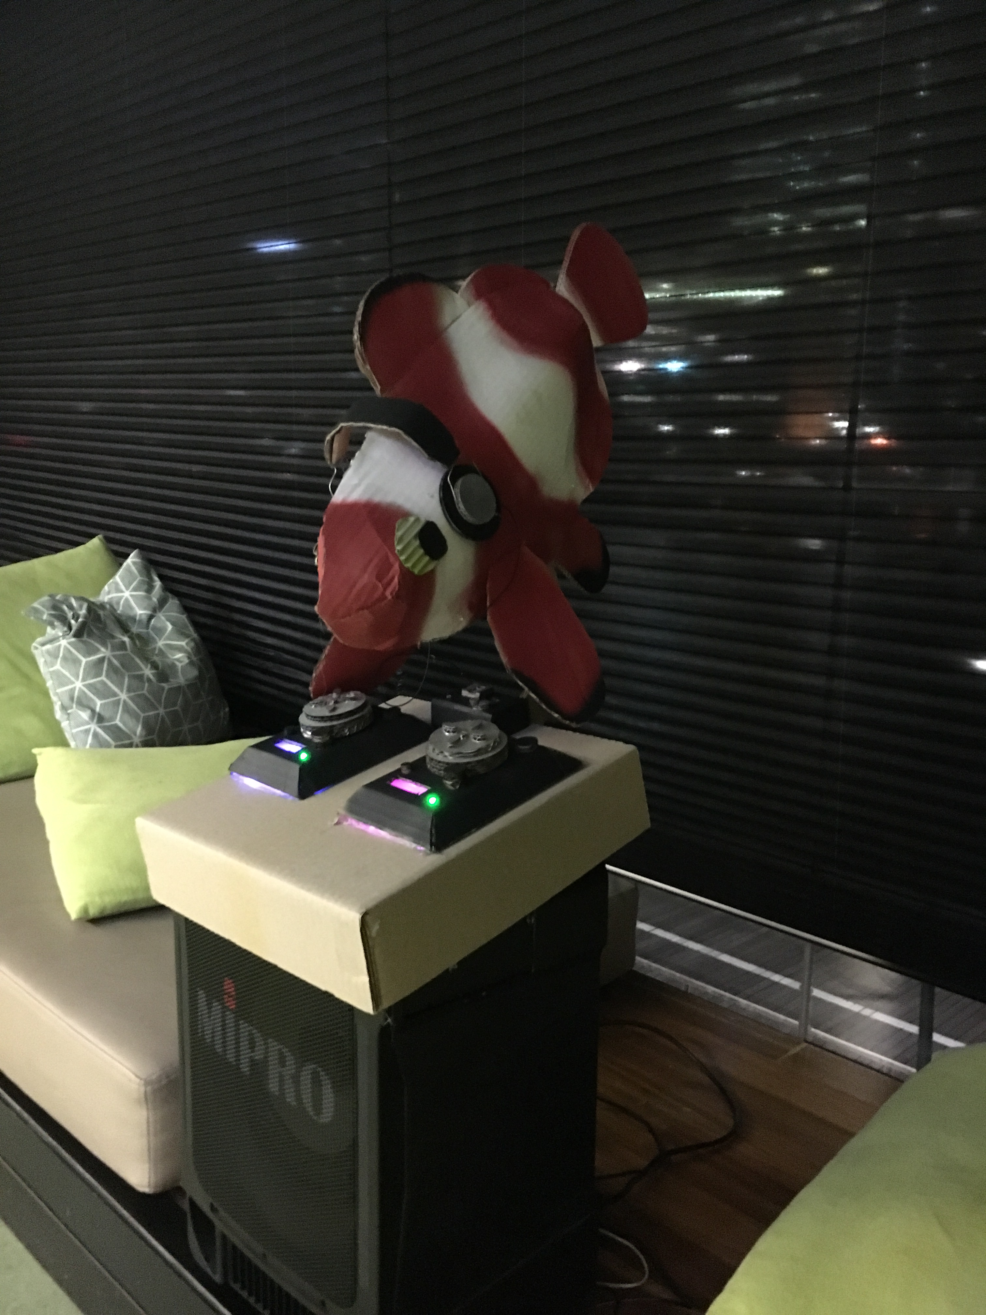
back to project matrix
Project Progress Table on Gdrive

