Cat in a Catamaran
Idea came from and the process for this idea:
IDEAS BRIEF 3: Cat in a Catamaran; Fashion Designer from Candytown; Star Making Bullfrog; Pluto Whispering Booth
Designed by:
Two university students worked on the design for the catamaran. Brianna was one. They had a few prototypes and then.... came back in to fabricate what you see here.
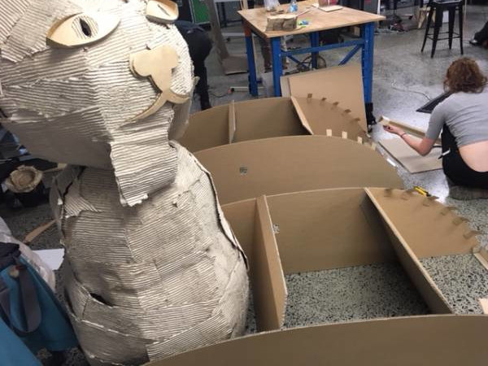
Story #9752-Cat in a Catermaran
Welcome aboard The Catamaran Catch. My name is Katsa Awesome. I will be your cat-ain and co-superhero today. Our job is to take passengers across the river, provide an audio tour of our beautiful city and to avert cat-aclysmal cat-astrophes. In the event of a cat-aclysmal cat-astrophe, hoist the ninja flag onto the mast. If the nature of the cat-astrophe is animal, vegetable or mineral, switch out to the sparkle flag. If the cat-astrophe is a natural disaster, raise the rainmaker flag. If the cat-astrophe is supernatural, feed me a tin of sardines in brine. It will turn me into an inflatable life raft for our escape. Alternatively, feed me sardines-in-oil to turn me into a powerful cat demigod.
Idea by Jack (5). Designed by Sofia an Breanna Made by Sofia and young people from Flying Arts.
back to project matrix
Project Progress Table on Gdrive


