Making the Apocalypse 3
This session will be from 9-12 in the actual space that the experience will happen

The Plan Saturday 4th Nov
- Touch base as a group.
- Step through the space as the narrative is read aloud
- Record narrative A.I with zoom or in recording studio
- make tunnels
- test headphones and device
- mark up the space
Break off into appropriate groups
- recording
- experience design (lock down the space for the final words and what this is)
- making helmets and dr cards
- planning out the tunnels in the space and so on

Preparation
have shopping list drawn up
Have roles and responsibilities drawn up
get plinths
Daniel: - zoom - tunnel materials to test a tunnel - new headphones to test

Reflection
This session was very productive with groups breaking off and getting things done. First up we all read through the script and walked through the actual space with it. Many alterations were made based on this walk through. After this the person with the role of the A.I went into the recording studio and we recorded all the audio that needed to be.
Another group marked up the space and measured out the tunnels. They drew it up along with where objects would be.
Another group who have called themselves the branding team worked on poster and aesthetic design. They are also planning to meet up during the week.
Finally, a group member continued to work on the design files for the helmet design to be laser cut.
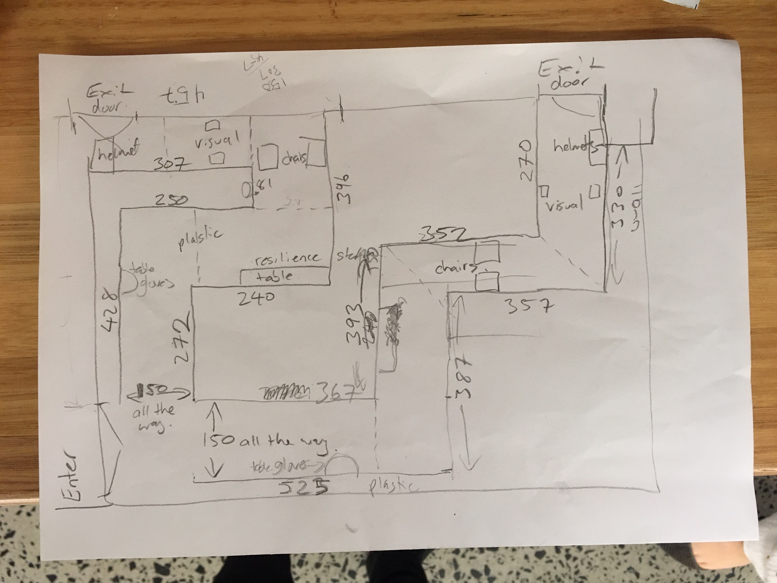

Where we got to
- We still need to lock down a tunnel design
- Test the experience with audio (and will it be triggered and then if so by whom?)
- make all of the other things (posters, helmets etc)
- place an order for materials that are needed as well

