Albert Park Flexi school Tuesday 13th June 2017
The First meeting with Albert Park was at a staff meeting where most of the schools teachers were present. Both myself and Mick were present. I shared the overview of the OLA and then the teachers shared that it sounded exciting. In particular the following ideas came out- Ideas of sound, airplanes, Steam punk and baby dragons. The concern that came out was that if the young people did not maintain interest throughout the whole process that they themselves would need to drive the project and due to this they expressed that they would like an option to not continue if this arose. Both Mick and myself expressed that this is sometimes what happens in process like this one for The Edge and that would be fine. To bring the event together we may need to put in extra work from our end to make it all come together. The group expressed that they liked the idea of having a partnership much more than just sending youth to the onsite program. The term ‘node’ was coined.
Inductions were of huge interest and the potential to fit in with the drama department to design a set. OLA was seen to potentially offer a rich learning experience to complement the curriculum needs. We are scheduled to have our second meeting on Tuesday 20th June.

Albert Park Flexi school Tuesday 20th June 2017
Today we met with Heidi, Julie and Kim at the school. We chatted about what they are trying to achieve in terms of the steampunk baby dragons agenda. They are aiming towards a promenade performance on the 1st Sep. There was genuine interest in social literacy and immersive nature of the playing of 'quiet year'. Also, inductions on the laser printer with the aim to design or to make tokens. There was also interest in Illustrator laser printer workshop.
3 students are already working on Event planning skills with invisible ink and they were flagged as potential individuals who may be interested in continuing with these skills. A design project could continue within the school curriculum heading towards the Edge event. we all could see that their steampunk promenade is very focused on safety week and has the potential to open out to bigger ideas after this event. Also, there was interest that there are sewing machines at the edge and making this aware to the young people.
We discussed the importance of that the person/s that come out to Albert Park also are the people they see at The Edge. That the relationship that is being built is of importance. There was interest in joining in on Avengers (of course!) One of the teachers Kim was very interested in attending the design weekends (she could be an advocate for getting young people involved)
As I see it moving forward- a before steampunk phase and an after steampunk phase of engagement.
I see that while the youth are firstly a part of imagining a new steampunk world and creating that event and design as a first step. The second step is to have access to a larger design process with other people and different resources.

Albert Park follow up email 21st June
I sent through the following proposal to begin the process of working out how to move forward together:
- PART 1
Wednesdays?
1. Play 'The quiet year' at Albert Park: 19th July (Discussion of steampunk through the game format. The game explores social lit, immersive experience, beginning of design)
2. Albert Park comes to The Edge for inductions: Wed 2nd Aug (Choice of- laser printer, 3d printer, soldering or CNC: Options to make a certain object in the induction) or design workshop and then design and cut
3. Option to attend Avengers at Goma with the Book Club participants from The Edge: Wed 2nd Aug
Week of 9th August Design workshop....? or come in and cut designs?
——————————— PART 2:
-
4. Design weekends: Choose one or do both: Sun 27th Aug/Sun 17th Sep (skills dev and design challenges)
5. Mondays and/or Sundays to come in and write/design with the larger project: Sun 8th Oct/Mon 16th/Sun 22nd/Mon 30th Oct
6. Sundays in November Event Planning: Sun 5th Nov/Sun 12th Nov/Sun 19th Nov (Learning new event management skills to run/be involved in the final event.)
7. 19 Nov-1st Dec prep for the Final event
7. Final Event 2nd Dec

Playing quiet year at Albert Park
5 young people in attendance as well as one teacher. The 'how to play' felt soooo long. I am going to create a one page doc with the dot points of how to play for facilitators. Then they can refer to the projection pages for clarification when needed (like the rule book)
Today we were divided into 2 groups. 2 separate games. Young people were engaged and very polite with each other. No contempt tokens used and issues were easily resolved.
When a young person took a while to come up with ideas other young people were impatient and would look at phones. Not all the time but some of the time. Keeping the pace up is really important for the success of this game. Also having an experienced playing in the mix. One of the groups didn't have anyone (I facilitated from the sidelines) due to the numbers and how the group chose to break up into the two groups.
The teacher Heidi was sick today. It was so great of her to come in today for us. I mentioned to Heidi that I am happy to pop out again if she sees that it is needed for engagement. Looking forward to seeing what numbers we get for inductions next week.
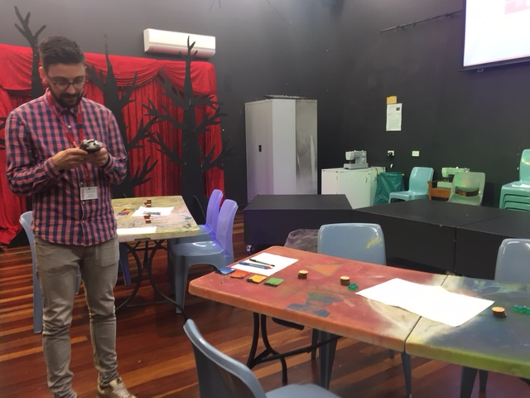

Deception Bay conversations:
I have spoken with Gail twice on the phone as well as emails with the community. There was keen interest to partner with The Edge. It seems to hold technology interest to the community. Access to how to offer a world of wider access to technology and knowledge. The community has noticed that the transition to highschool is a large leap and they want to find ways for it to be exciting. See a way for encouraging seeing that there are other options of gaining knowledge. Library has ipads that they are keen to use. 13-15year olds come to ‘game on’ on Tuesdays 5-6pm and they play games on tech. DBCYP has a program for young parents to learn event management skills. They would be keen to jump in and to be involved with organizing the end event. Potential for flexi school to come on as well. We are currently in the process of organizing a meeting with the library and interested community groups to meet up with myself and Daniel Flood in Dbay so as to work out the best approach for all.

Dbay meeting at the Library 21st June
In attendance: Tracy (Library), Gail, Veronica (DBYC), Marylin (Neighbourhood centre), Mick and myself.
Community groups and the library already collaborate and work on projects together.
The Dbay library agenda: focuses on relationship building with the community and users, they want to influence youth and their literacy journey. The community as a whole enjoys celebrating. They are familiar to writing a sustainability plan into the project and will pick up on any successful componants to continue running them. Lisa is interested in having another meeting that involves Lisa the the Moreton bay coordinator as well as Dana who runs the 13-18yr old youth component.
DBYCP: young dads (interested in recording and writing lyrics and making) There is also a learning event management employment skills course. Participants about to finish want a pathway to volunteer opportunities (to work at the Edge) as well as the next round of participants the opportunity to work on community events as well as one of the OLA events at The Edge.
Flexi school- was mentioned as a possible outreach that would fit in.
To follow up- To write down the outline of the project and capture what a dbay satelite program could look like. Send to the library and community groups for discussion.

Dbay meeting at the library 13th July
In attendance: Lisa, Tracy, Dayna, Mick and myself
Lisa gave sign off of the program to go ahead. Tracy suggested a steering group to be set up for the community to move forward. She will aim to have this setup and to meet next. The idea is for the steering group to steer and lead the engagement. DBCYP, flexi school, neighborhood centre as well as the library were identified.
Tracy was clear that the community could only handle an outcome that was on a game board scale. Mick and I shared an example of making tokens, or characters on the 3d printers that then were found by audience in a adventure hunt style event at the library and through the community. This seemed doable.

DBCYP 20th July
A group of 13 came in today for a tour of SLQ as well as the edge. They saw all the event spaces and a couple of the young guys are interested in volunteering with Lance at SLQ. DBCYP are keen to explore how we can partner long term with their young people coming through the events skills course. The Edge facilities and programs got everyone excited.

DBCYP 29th August
Leoni, Andrei, myself and DBCYP.
DBCYP brought in a few of their event trainee people to share their ideas that they have come with for the shopping centre OLA engagements. They are exploring ideas of apocalaypse as revelation.
1. craft ideas of creating dolls from natural materials that reveals parts of self.
2. Projected images (map and locations in dbay) then people can add objects like large crabs, shells etc to the image on the wall.
This is the current timeframe for dbay deceptionbaytimeframe.docx
These are some of the images that they brought in to show us.
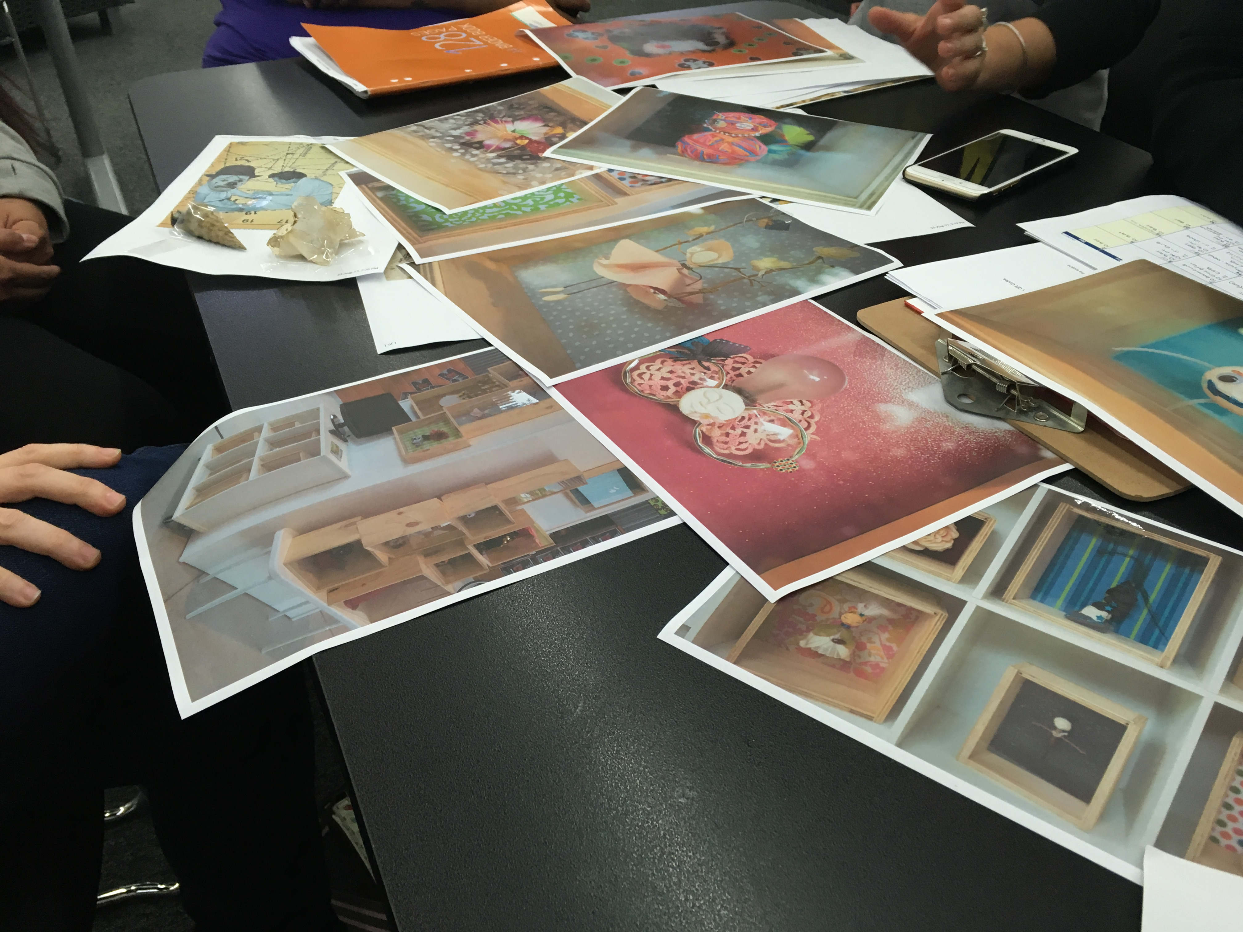

Dbay meeting at the library 12th Sep
There were 6 people in attendance- myself, Jennie, veronica, Gail, Tracy, Leonie & Kerry. It was a lively discussion with lots of ideas bubbling to the surface. We discussed 'scale' and how the games night could be big life size games as well as teeny weeny ones. All were excited and Leonie and Tracy put their hands up to write the plan for the first event. great outcome. DBCYP are all set for the shopping center. they have the iPad and projector and stencils that they cut out on the laser. The library has the iPad case as well. Flexi school was not present today. We put it down to the school holidays begin early for them.
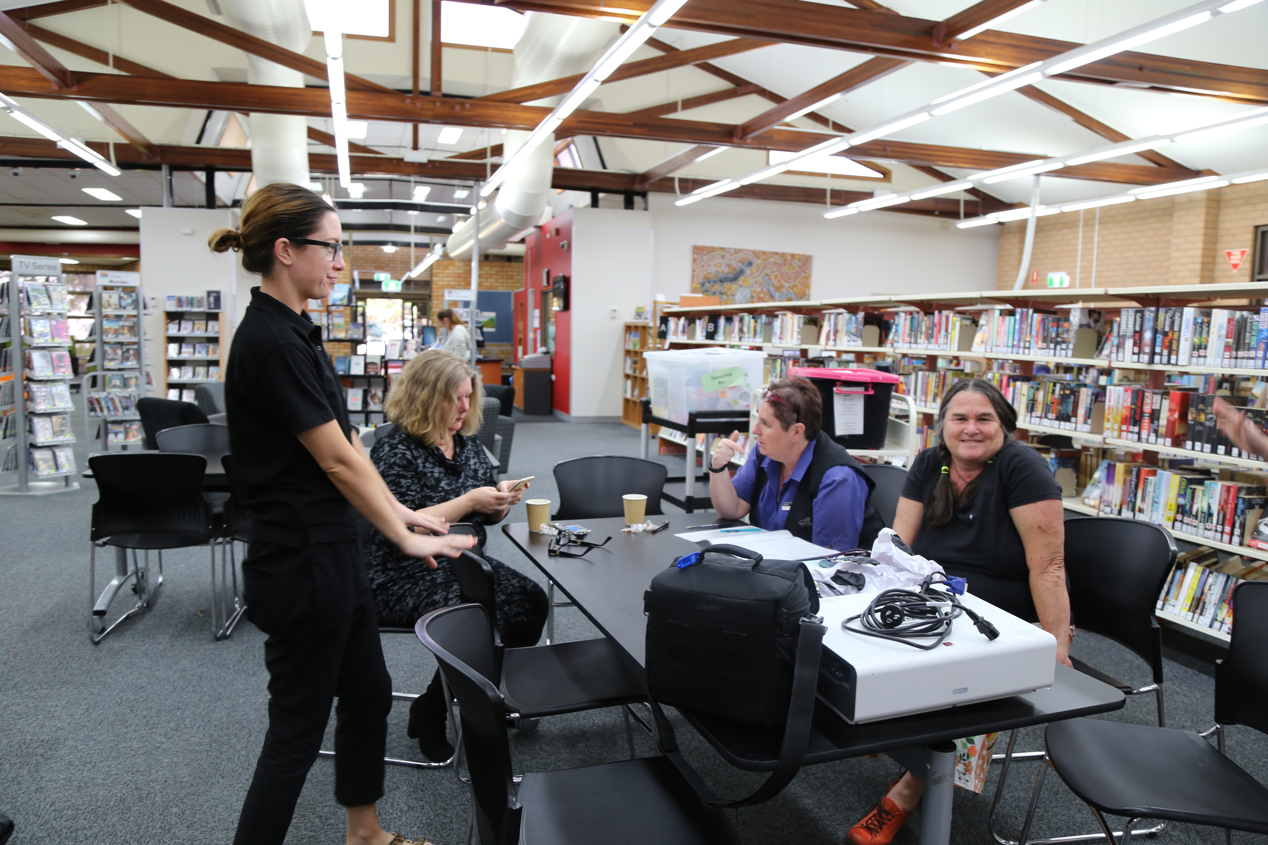

QPASTT
I spoke with Stephanie (the director) on the phone. She shared that the main areas that their programming is focussed on are: Refugee hearing Trauma recovery- it is like mental health but it is not mental health. I sent through more details to her further explaining the project. She then mentioned that they are over committed for the next 6 months however, they may have some clients/volunteers that may be interested in attending the public program onsite. She asked what resources we may have to support their clients to attend. I shared that we could put a call out to our networks to see if we could get one/some support people. I mentioned that it would be great to have the support from their end for feedback, i.e. that they have a way to speak in the languages and pass on any feedback so that we can better improve the public program. She was open to this. The next step is to follow up with the promo for distribution.
I followed up and there was no registered interest. I then followed up again via phone and offered inductions in the fabrication lab and a whole other conversation opened up. Steph identified a program- Ucan2 that is run by Meriam at QPASST that may be a fit for us to engage with. Steph and I just needed to keep chatting to work out a way forward. I have reached out to Meriam via email and am trying to reach her by phone now.
Conversations with Meriam- is super excited to bring in 12 UCan2 participants that are at TAFE with 5 support workers and volunteers. A 3D printing workshop was identified as being a great place to start with the group. She also has other groups at other TAFEs in the program that she is keen to bring in. I will aim to meet with her in person to chat the larger project and how we can work together more. There is also another group that has been identified as a potential by stephanie- young men. The interest is in Apocalypse and making music and recording it in the recording studio.
Victor from QPASTT came in on 5th Sep to see the spaces and chat about what it is we do here at the edge. We spoke about the young men and that they are super keen to come in. There is 8 of them and victor spoke to one when I was meeting with him to check on dates etc.

