Saturday Crew Session Wrapup- 2 Sep
Form Information
This workshop was facilitated by: | Mick Byrne
Name of any other State Library staff present: | NA
Workshop Date: | 2021-09-02
Workshop Location: | Machine Shop
How many Designed Things were sent into The Well? | 1
Notes regarding Designed Thing Submission
List the Imagined Things number or name that was used as inspiration: | Noname Rocu
What did you think was successful about the workshop?
* we reviewed the maquette that was made during the week
- Zac worked on an antler
- Shi and Courtney and
- Phil and i worked on
We also discussed the approach we would take making
- the beard
- skin
- antlers & bone |
^ What did you learn about the workshop? | Everyone is keen to make and enjoys the problewm solving |
Can you share any ideas for future implementation? | no
Are there any immediate actions arising from this workshop? | Mick to continue skinning skull in readiness for other features to
Can you share any memorable moments or quotes from participants?
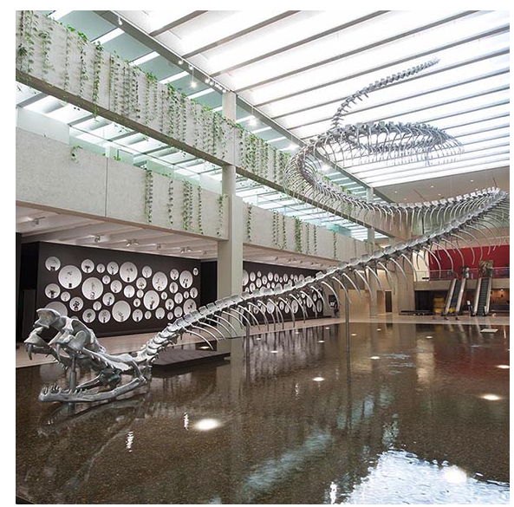 https://blog.qagoma.qld.gov.au/huang-yong-ping-ressort-2012
|
What was/were your favourite Designed Thing/s from the workshop?
Did you capture any images, audio or video to share from the workshop?

