Workshop Report - Brisbane State High Grumpus Design workshop 29 July
Form Information
This workshop was facilitated by: | Mick Byrne
Name of any other State Library staff present: | Billie
Workshop Date: | 2021-07-29
Workshop Location: | Brisbane State High
How many Designed Things were sent into The Well? | 4
Notes regarding Designed Thing Submission | These things for the well are part of the one concept that this group has arrived at after a facilitated selection process ( session on 21 07)
List the Imagined Things number or name that was used as inspiration:
What did you think was successful about the workshop?
* Using Straws and tape as a scaled down analogue for the beam construction worked really well. Participants in this activity quickly experimented with construction techniques for this and were well on the way to completing a sophisticated model by the end of the session.
- Participants in the playdoh activity grasped the concept of modelling a dead specimen of the creature.
- most groups engaged in some form of web research to inform their model.
- the capacity for smaller partnerships within groups to focus on a particular aspect, texture, a particular limb etc allowed for increased engagement. |^What did you learn about the workshop?| * Don't try and give a boring presentation on a Thursday Arvo after 3pm. - We had planned to spend the first half of the workshop discussing the topic of interacting and child centred design and some of the wider goals of the project (see above) but the Young People weren't really receptive to this and rather than push thru this, we went around it. On reflection this kind of discussion is best introduced as a response to something that is prompted thru a busy hands exercise.
|^Can you share any ideas for future implementation?| next session we could:
- further develop refine these designs maybe by passing them to the next group and further consider the biology and or Lore (magical mechanics of the creature.
- look at designing the Locale or consider the interactions that could occures between the 2 characters or the characters and the local
- consider whether we even need to represent both creature- maybe we could perform a subtraction of the dominant character (like Godot)
|^Are there any immediate actions arising from this workshop?| Ms Cooke created a Group padlet for for everyone involved in the group to upload resources or news about our design. This platform has a lot of potential to extend the young people's engagement beyond the once a week session and as such we need to populate it with interesting content. This may also be a good place to post our updates about the different crews' progress - something students seem interested in. |
Can you share any memorable moments or quotes from participants? | Would like to explore the traditional significance of Dragons and Koi and see how this resonates with the diverse cultural backgrounds of the young people in the room.
What was/were your favourite Designed Thing/s from the workshop?
* The detail of the Koi specimen (especial the care taken making dead fish eyes ( like you see in the market )
- the Koi skull that seemed to emerge out of nowhere
- The Moustache that made it onto both dragon and Koi specimens |
^Did you capture any images, audio or video to share from the workshop?|

Internal Structure (Skeleton) of the Dragon
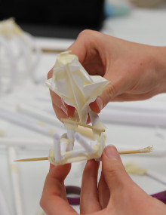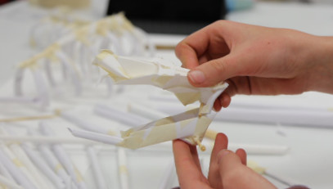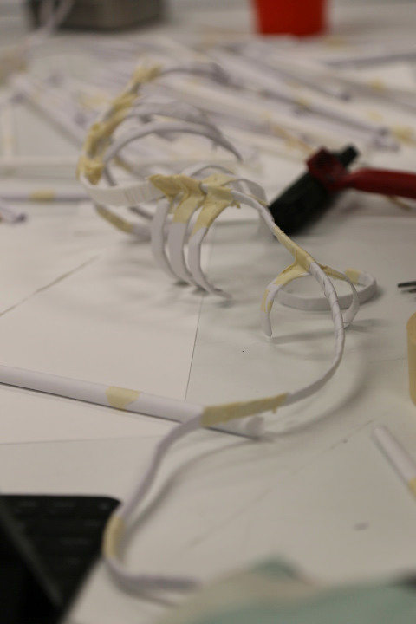
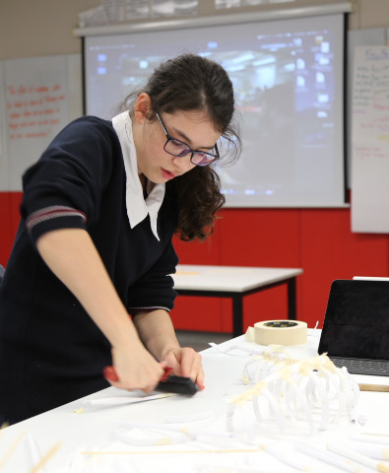Using a printing roller to crush straws and make them more malleable

External Structures of the Dragon (Specimen)
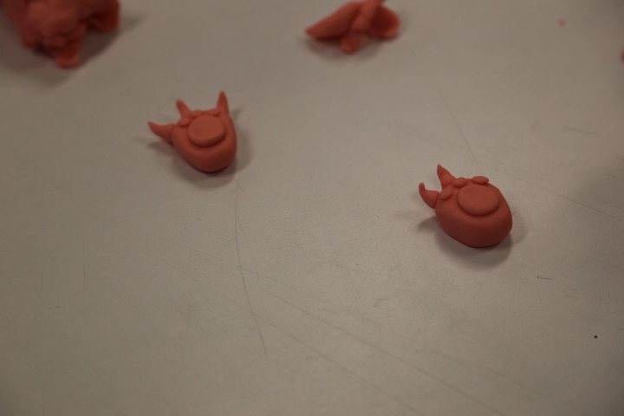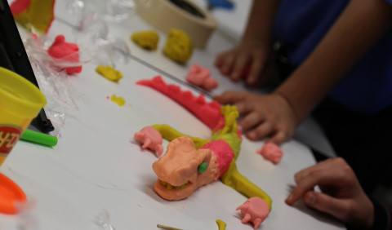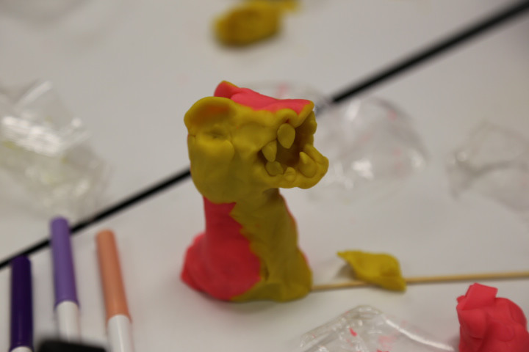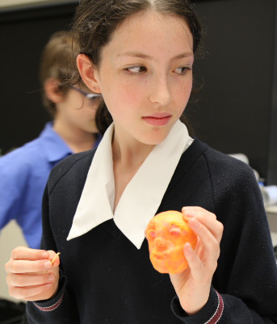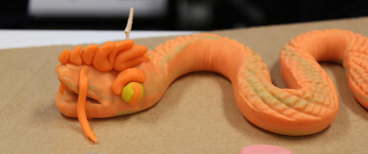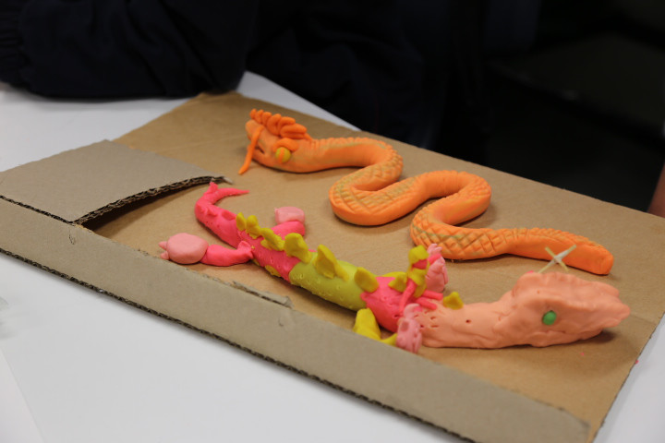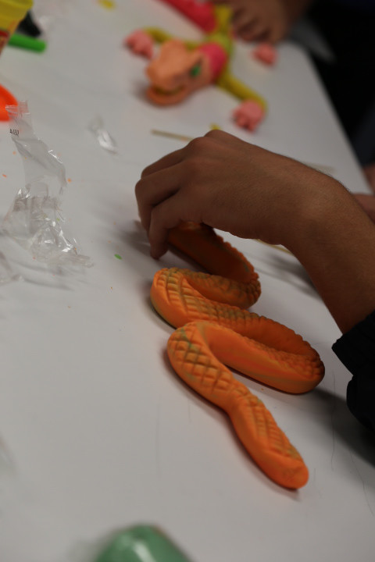

External Structures of the Koi fish (Specimen)
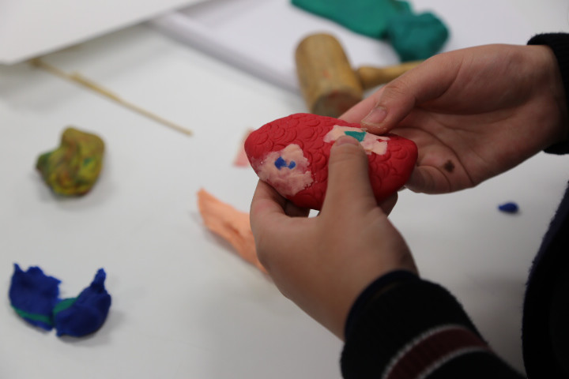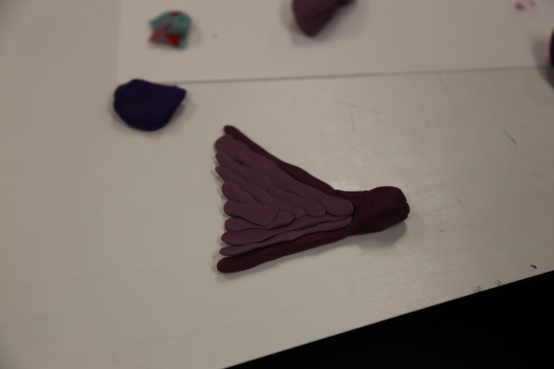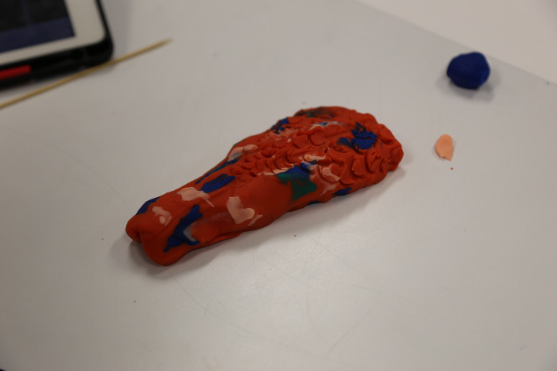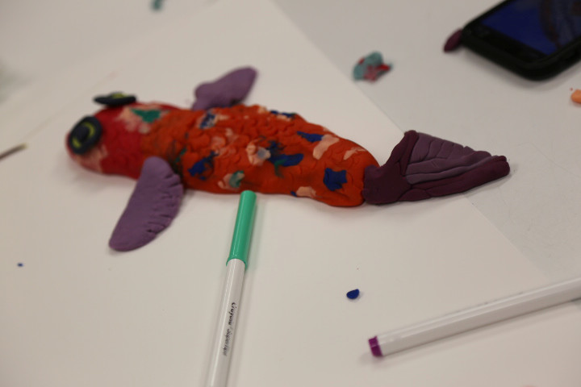

Internal Structure (Skeleton) of the Koi Fish


