QUT Workshops

QUT Workshops
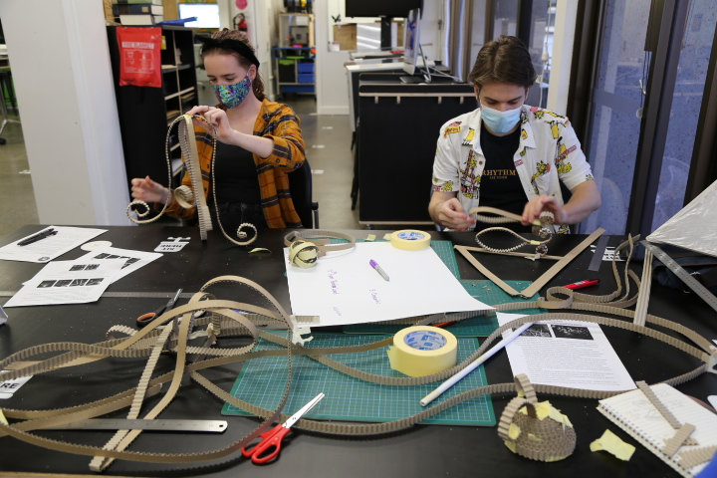
Welcome to the SLQ Wiki page for our QUT Creative Industries students (Crew) design workshops.
As you work with SLQ on this project, we want to capture your imagination and designs and add these to our Wiki. This is the place to document the creative process and how the sculptures are coming together.

Designed Thing
Add images and 3D models and any of the sculpture work here.
See Sketchup file here -

Fabricated Thing
Add images and info on the Sculpture as it begins to progress here.

Facilitators
Please add your session plans, inspiration and tasks to support students.
Please make sure to fill in a refection form at the end of the workshop if you are facilitating, these will be linked at the end of this page.
QUT Session Plan - 28 July
QUT Session Plan - 4 August
QUT Session Plan - 18 August
QUT Session Plan - 25 August
QUT Session Plan - 1 September
QUT Session Plan - 8 September
QUT Session Plan - 15 September
QUT Session Plan - 22 September

Facilitator Session Report
QUT Workshop Report - 28 July
QUT Workshop Report - 4 Aug
QUT Workshop Report - 18 Aug
QUT Workshop Report - 25 Aug
QUT Workshop Report - 1 September
QUT Workshop Report - 8 September
QUT Workshop Report - 15 Sept
QUT Workshop Report - 22 September

Fabrication Files

