Designed Things

Grumpus Sculpture Overview
As part of our Large Sculpture Workshops with school, Uni and community groups, we've asked them to choose inspiration from where the Imagined Things in The Well might come from (Grumpus Land).
One of the deviations from the original plan has been that the progressed Designed Things may be a combination of 2 or more Imagined Things rather than one.
This is a working page, updates are being made as we progress, you can check back in the older versions of this page if you need to see any former notes.

Sculpture 1
Name - Wobbly Tooth Shark
Shark Mouth - AC and Community, under construction
Placement - Gallery Entrance (airlock)
Dimensions:
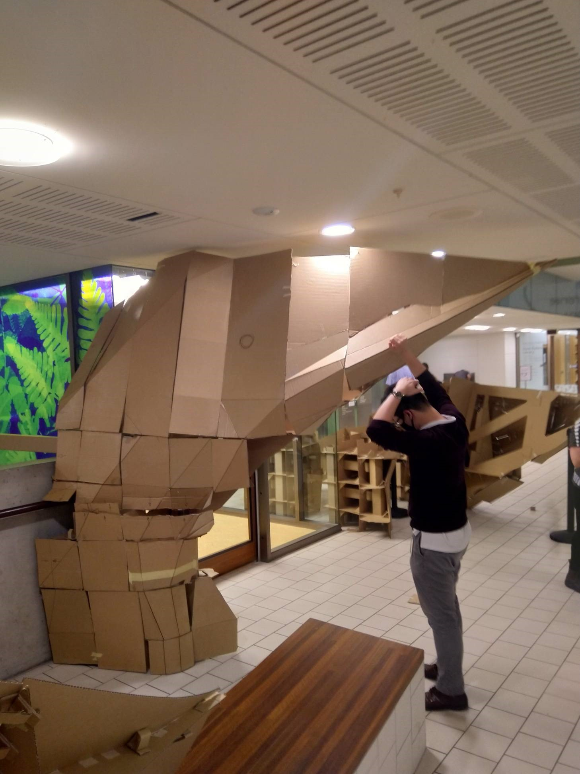
Read more about the original design from previous Great and Grand Rumpus here.

Sculpture 2
Name - A little like Alice
BSSSC have designed a Back Wall Relief that will be have a projection mapping from a contracted artist.
The design provided to fabricators:
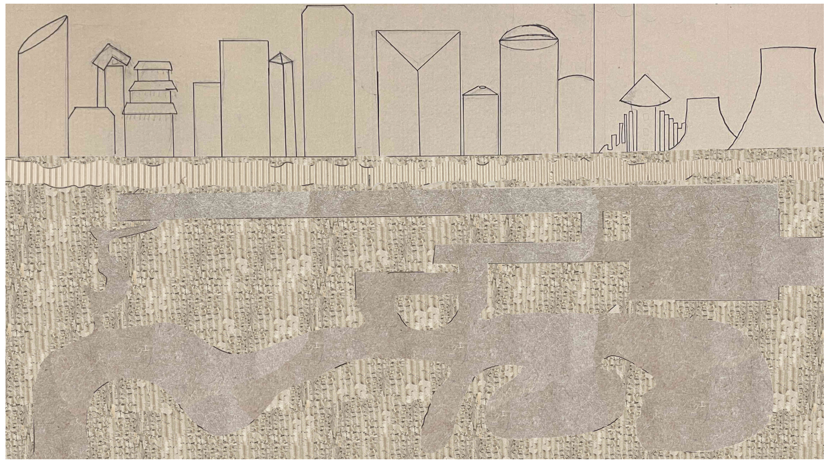
The design files can be downloaded here
Dimensions:
8m x 4.5m
Read more about the design here.

Sculpture 3
Name - Glitch Forest
QUT will be working towards 1 sculpture. Inspired by Glitch and mushrooms from The Great Darkness. The sculpture will consist of a collection of pieces to form a portal into a glitch forest vibe. The Glitch forest is made up of Mycelium. Inspired by the movement of a river, the Glitch forest is to be journeyed through. Mycelium is the connector of worlds and the nearest to a glitch of the natural world. It is also the Glitch between plants and animal kingdoms. Sound, movement and lighting will also be considered o the journey through the glitch forest.
Read more about the design here.
We will not be outsourcing QUT works as this is part of their assessment.
Dimensions:
Progress: 60%
Multiple Objects
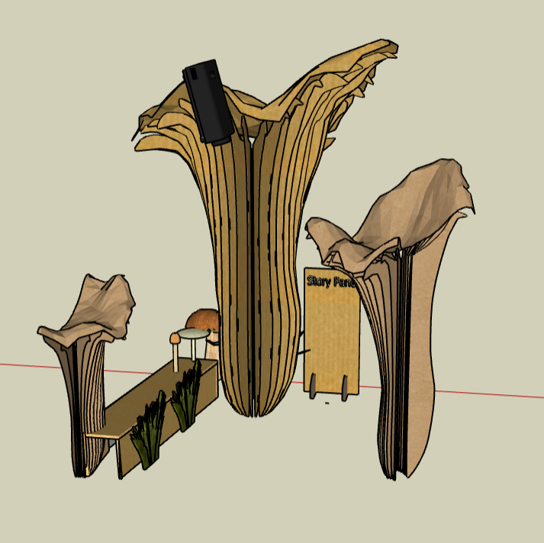

Sculpture 4
Name - The Dragon and the Koi
Brisbane State High will be working towards a combination of Things for their Designed Thing, it includes; Koi fish, Dragon and Underwater Cave.
Designed Things: Koi, Seadragon and Cave.
Check in on the progress here.
Dimensions:
Progress: 80% (dragon and cave are nearly complete)
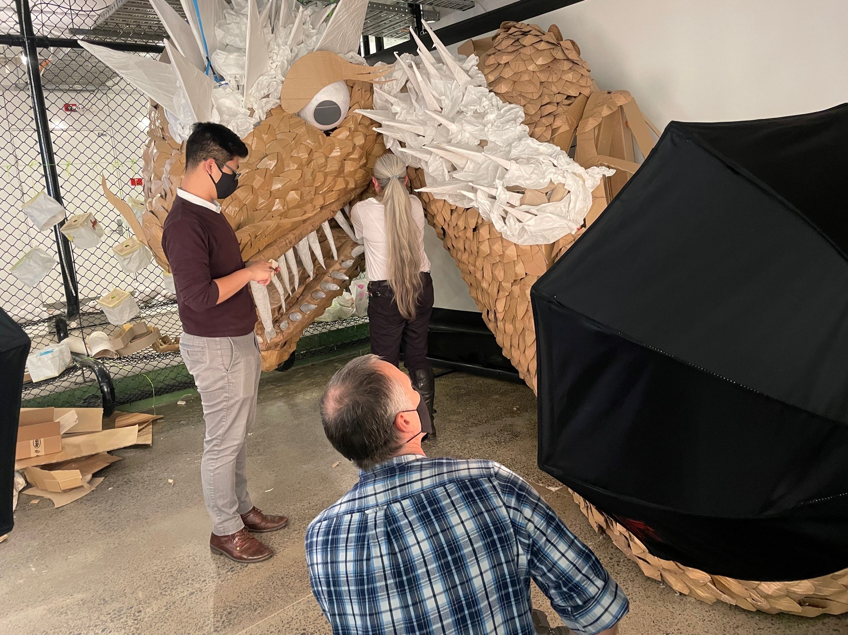

Sculpture 5
Name - No Name (ROCU)
Saturday Community Group will be working towards a hybrid ROCU/No Name skeleton horse/deer.
Check in on the progress here.
Dimensions: TBC
Progress: 50%
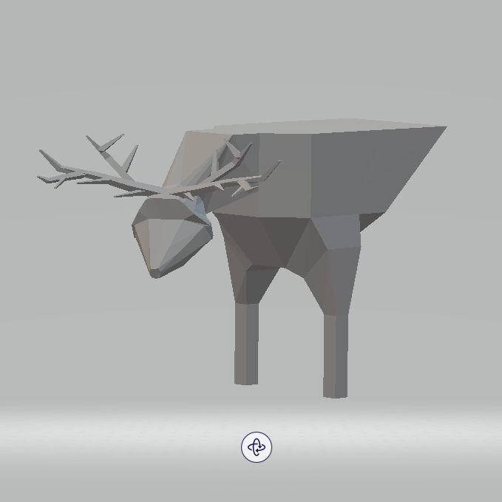

Sculpture 6
Name - Angre Cow
Griffith QCA Southbank are working on a version of Angre Cow.
Fabricated by students on site at their Uni.
Dimensions:
Progress: 80%
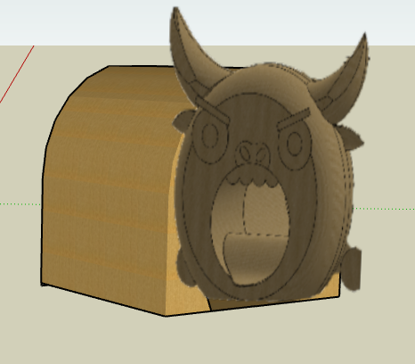

Sculpture 7
Name -One Eye
Griffith (Gold Coast 1)
This will be facilitated through their own onsite fabrication.
Dimensions: Floorspace 4x4m x 4m high
Progress: 90%
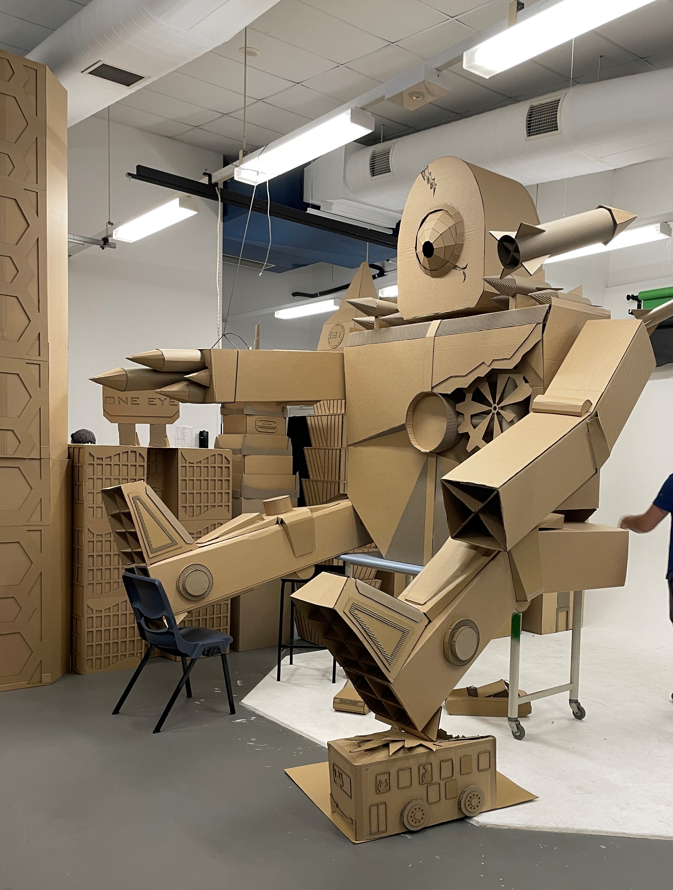

Sculpture 8
Name - Beast X
Griffith (Gold Coast 2) are working towards creating Beast X as their sculpture.
This will be facilitated through their own onsite fabrication.
Dimensions: Floorspace 4x4m x 3.7m high
Progress: 90%
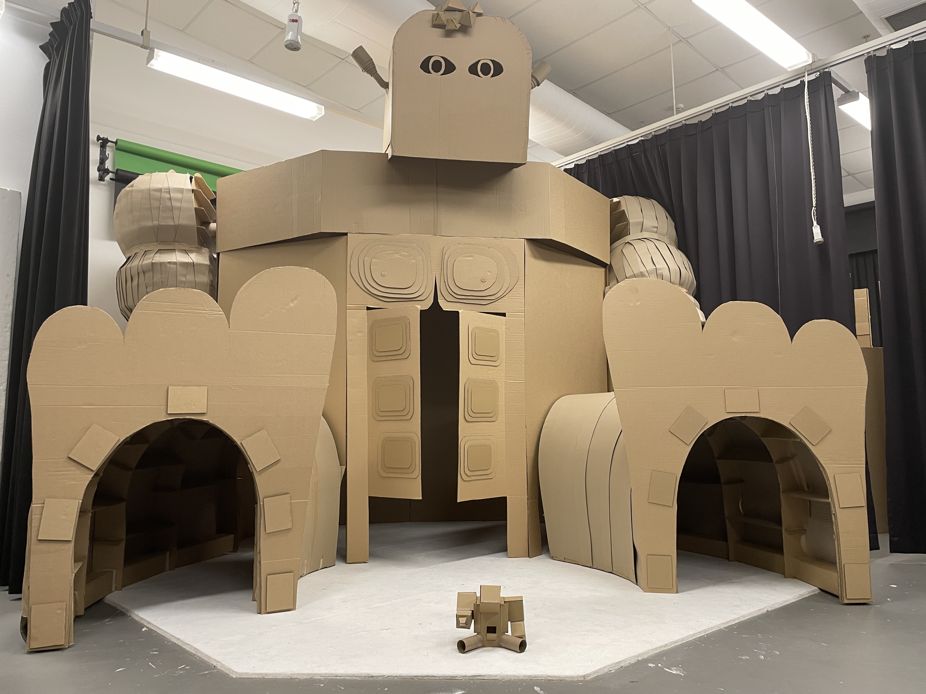

Sculpture 9
Giant Sign (Great & Grand Rumpus).
To be placed as the Gallery entry wall (where the usual exhibition signage would live)
This will have 6 screens for each RUMPUS letter displaying the Vis ID visuals.
Dimensions:
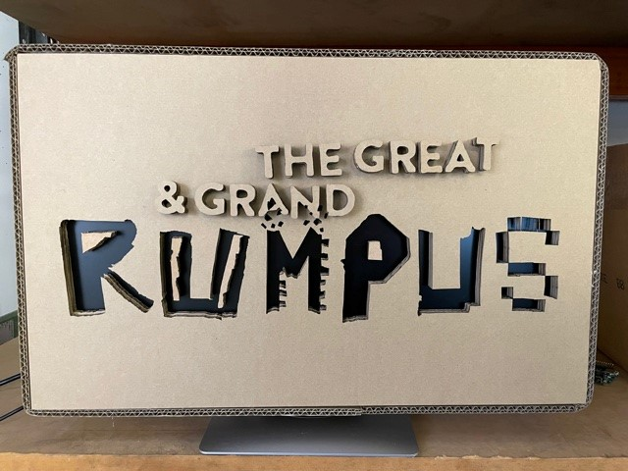

Spirits - 10
There are currently 170 (need to count again) shadow spirits and ** general Spirits.
These do not all need to live in the gallery and could live in clusters in other parts of the library potentially (with standard lighting).

