HERE LIES THE ENTRY FOR A DESIGNED THING

Sat Crew - ROCU No Name 2
Full Name: | Saturday Crew
Suburb/City where you live: | Brisbane
Provide the link or name of the Imagined Thing from The Well you are responding to?: | No name and ROCU
What is different about your idea from the original Imagined Thing?: | Conceptual designs developed
What is similar or inspired by the Imagined Thing: | Skeleton beard tiny arms
Provide a brief update on your progress: | Conceptual designs developed
What new thing did you learn as part of the process: | NA

Your files can be found here:
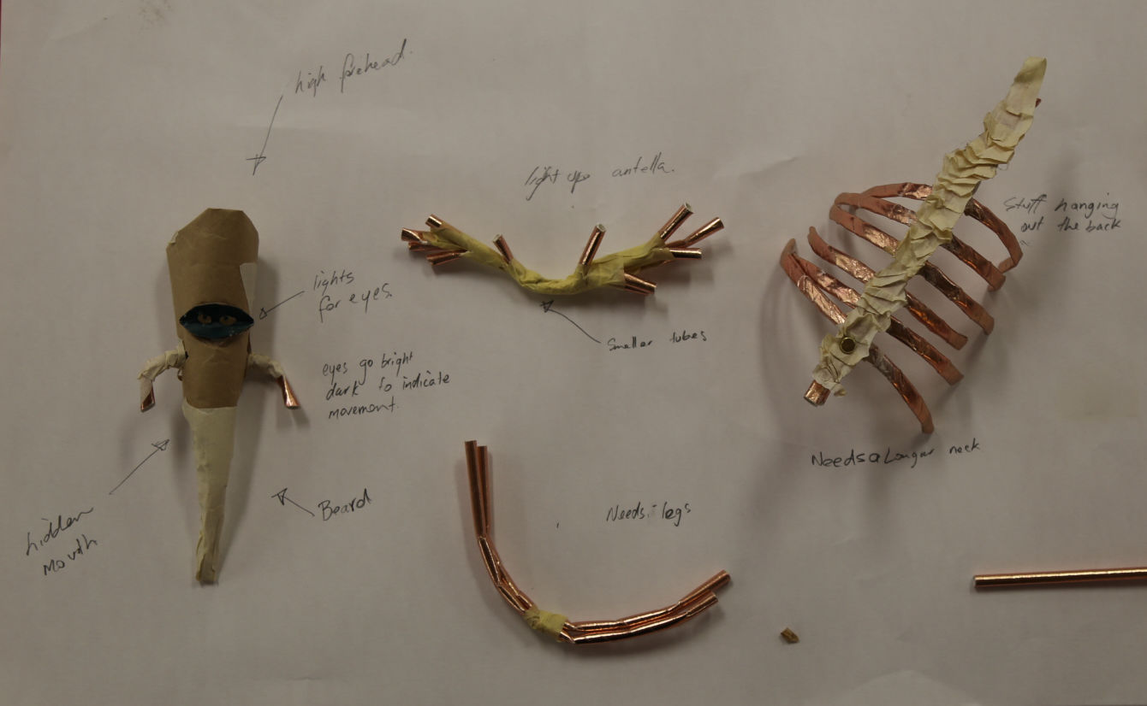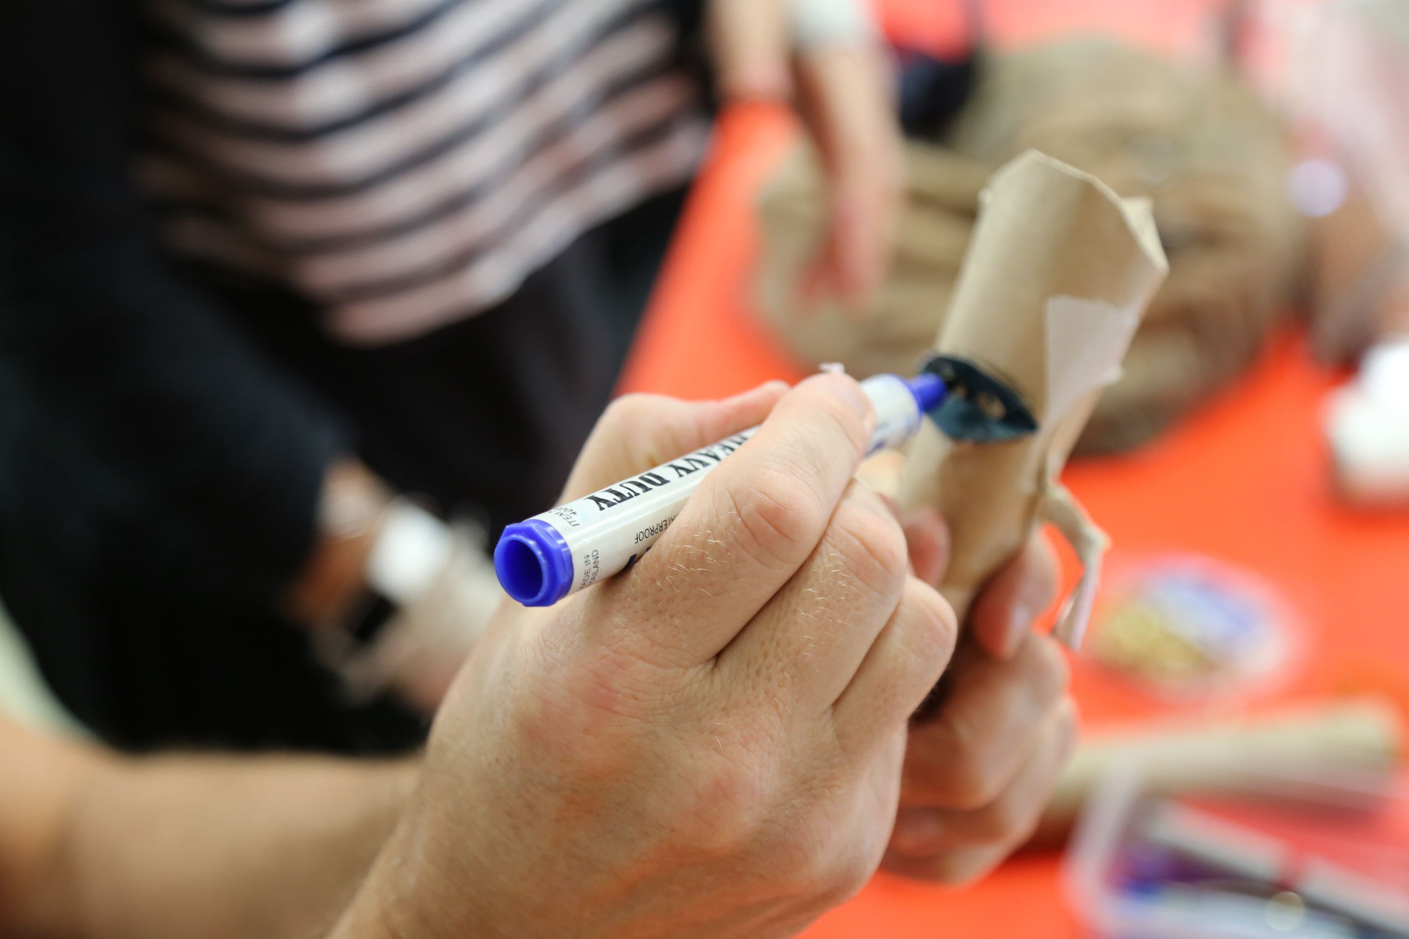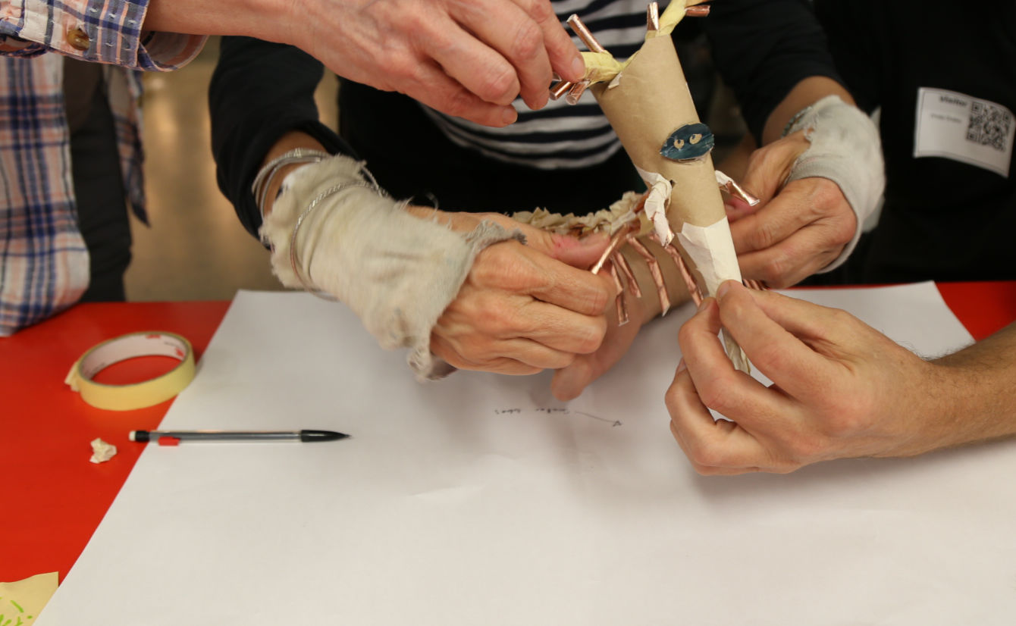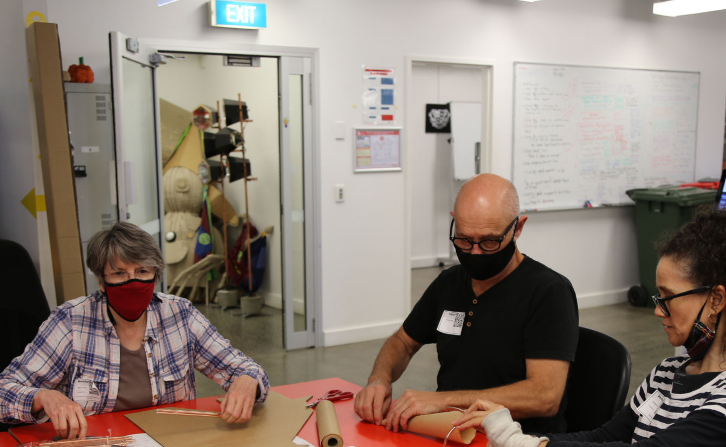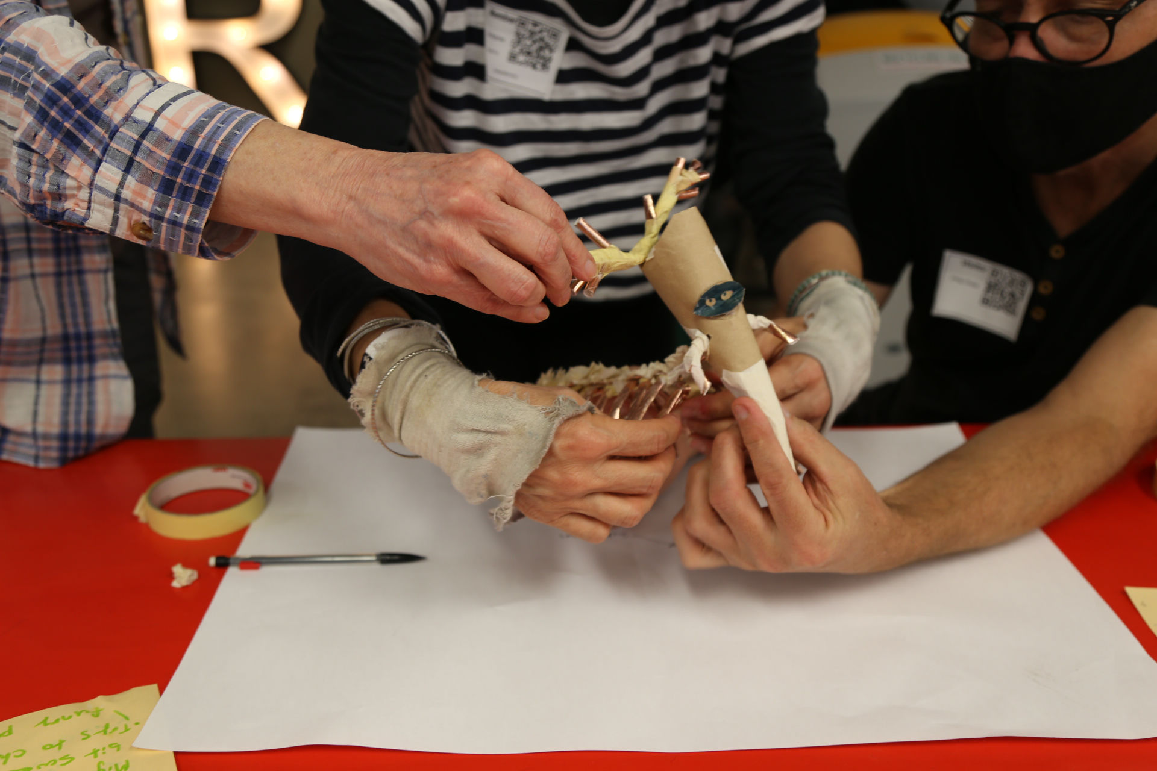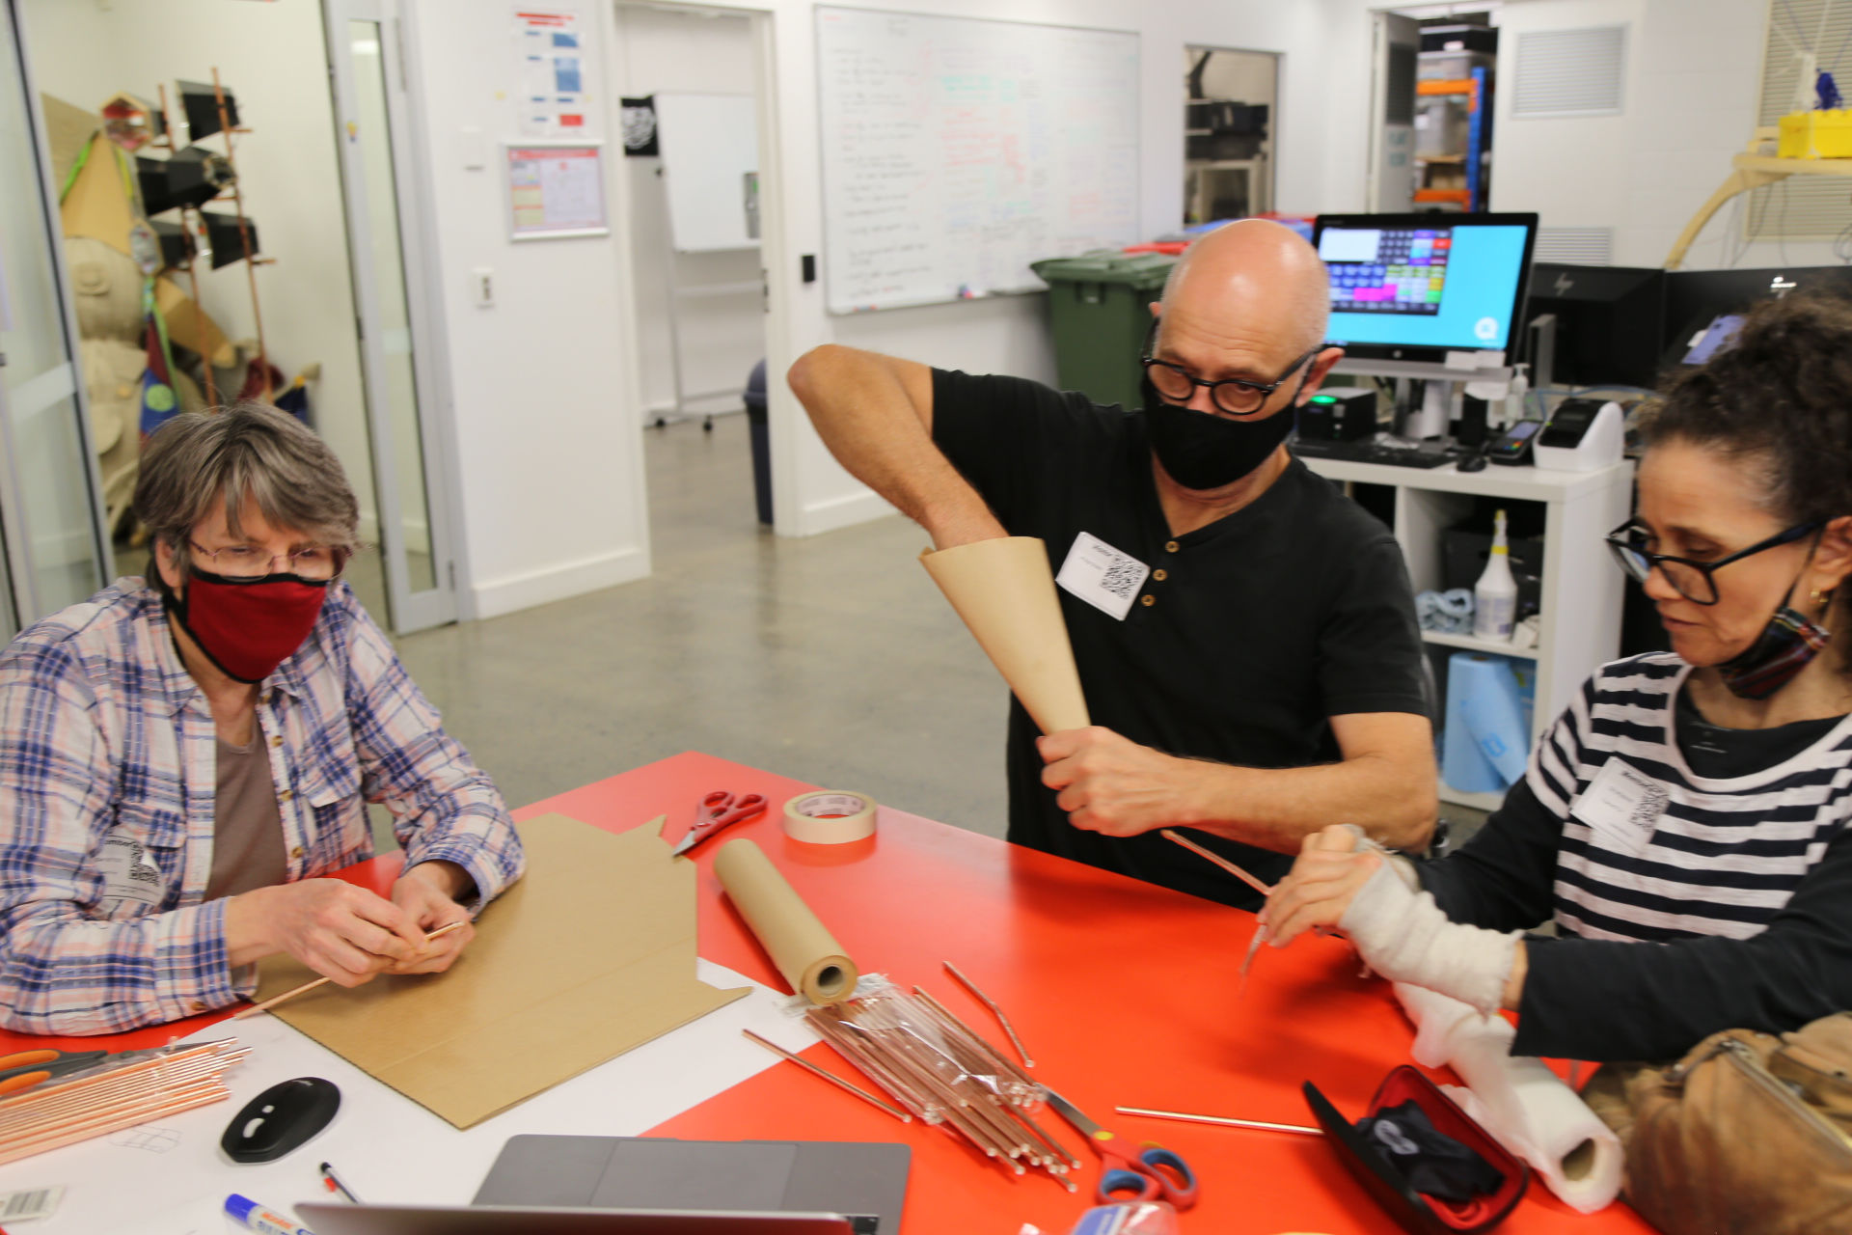

This is the unique QR code for this Designed Thing. Right click it to save then share it, so you and others can find your way back to here to this point of The Well.

IT IS KNOWN! HUZZAH FOR THE GREAT & GRAND RUMPUS!

