99. A.X.L
HERE LIES THE ENTRY FOR AN IMAGINED THING
This is a thing imagined by Lenny, aged 9, on Thursday September 16
The full name of this thing is: A.X.L
It can be found in: A meatle factroy
It is known that: A.X.L is a three headed monster that is intirely made out of meatle and is verry strong.
This thing has three important features: Spinning cog made for slising, meatle, and farst

An image of A.X.L can be found here:
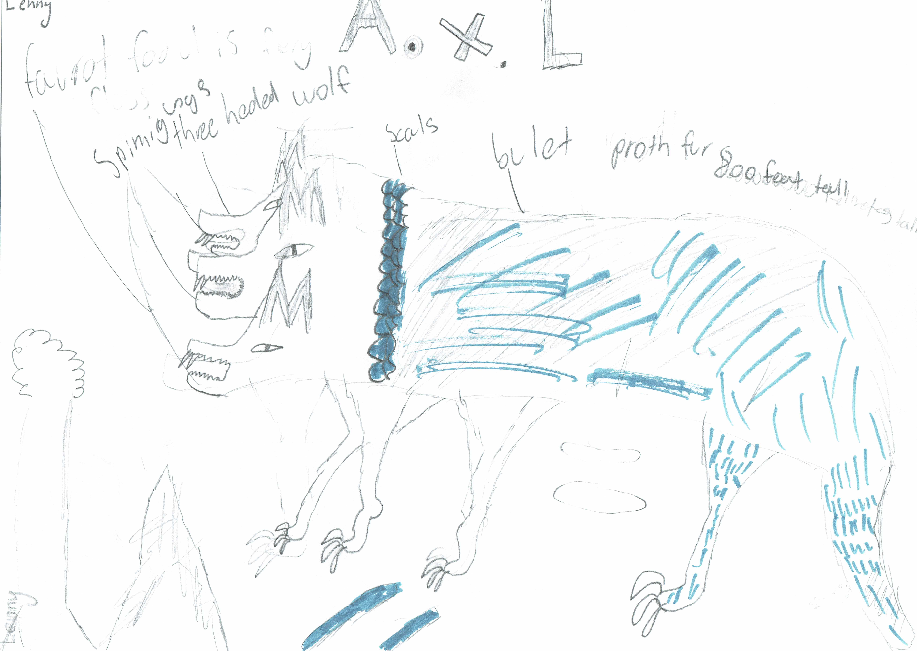

This is the unique QR code for this Imagined Thing. Right click it to save then share it, so you and others can find your way back to here to this point of The Well.

IT IS KNOWN! HUZZAH FOR THE GREAT & GRAND RUMPUS!

