98. The big purple dragon/Biggy
HERE LIES THE ENTRY FOR AN IMAGINED THING
This is a thing imagined by Yianni, aged 9, on Thursday September 16
The full name of this thing is: The big purple dragon/Biggy
It can be found in: A whole other universe
It is known that: My dragon went through a portal from another universe to Australia. He destroyed everything and everyone apart from me.
This thing has three important features: It's the biggest thing in the world, It shoot Fairy Floss, and It shoots Fire

An image of The big purple dragon/Biggy can be found here:
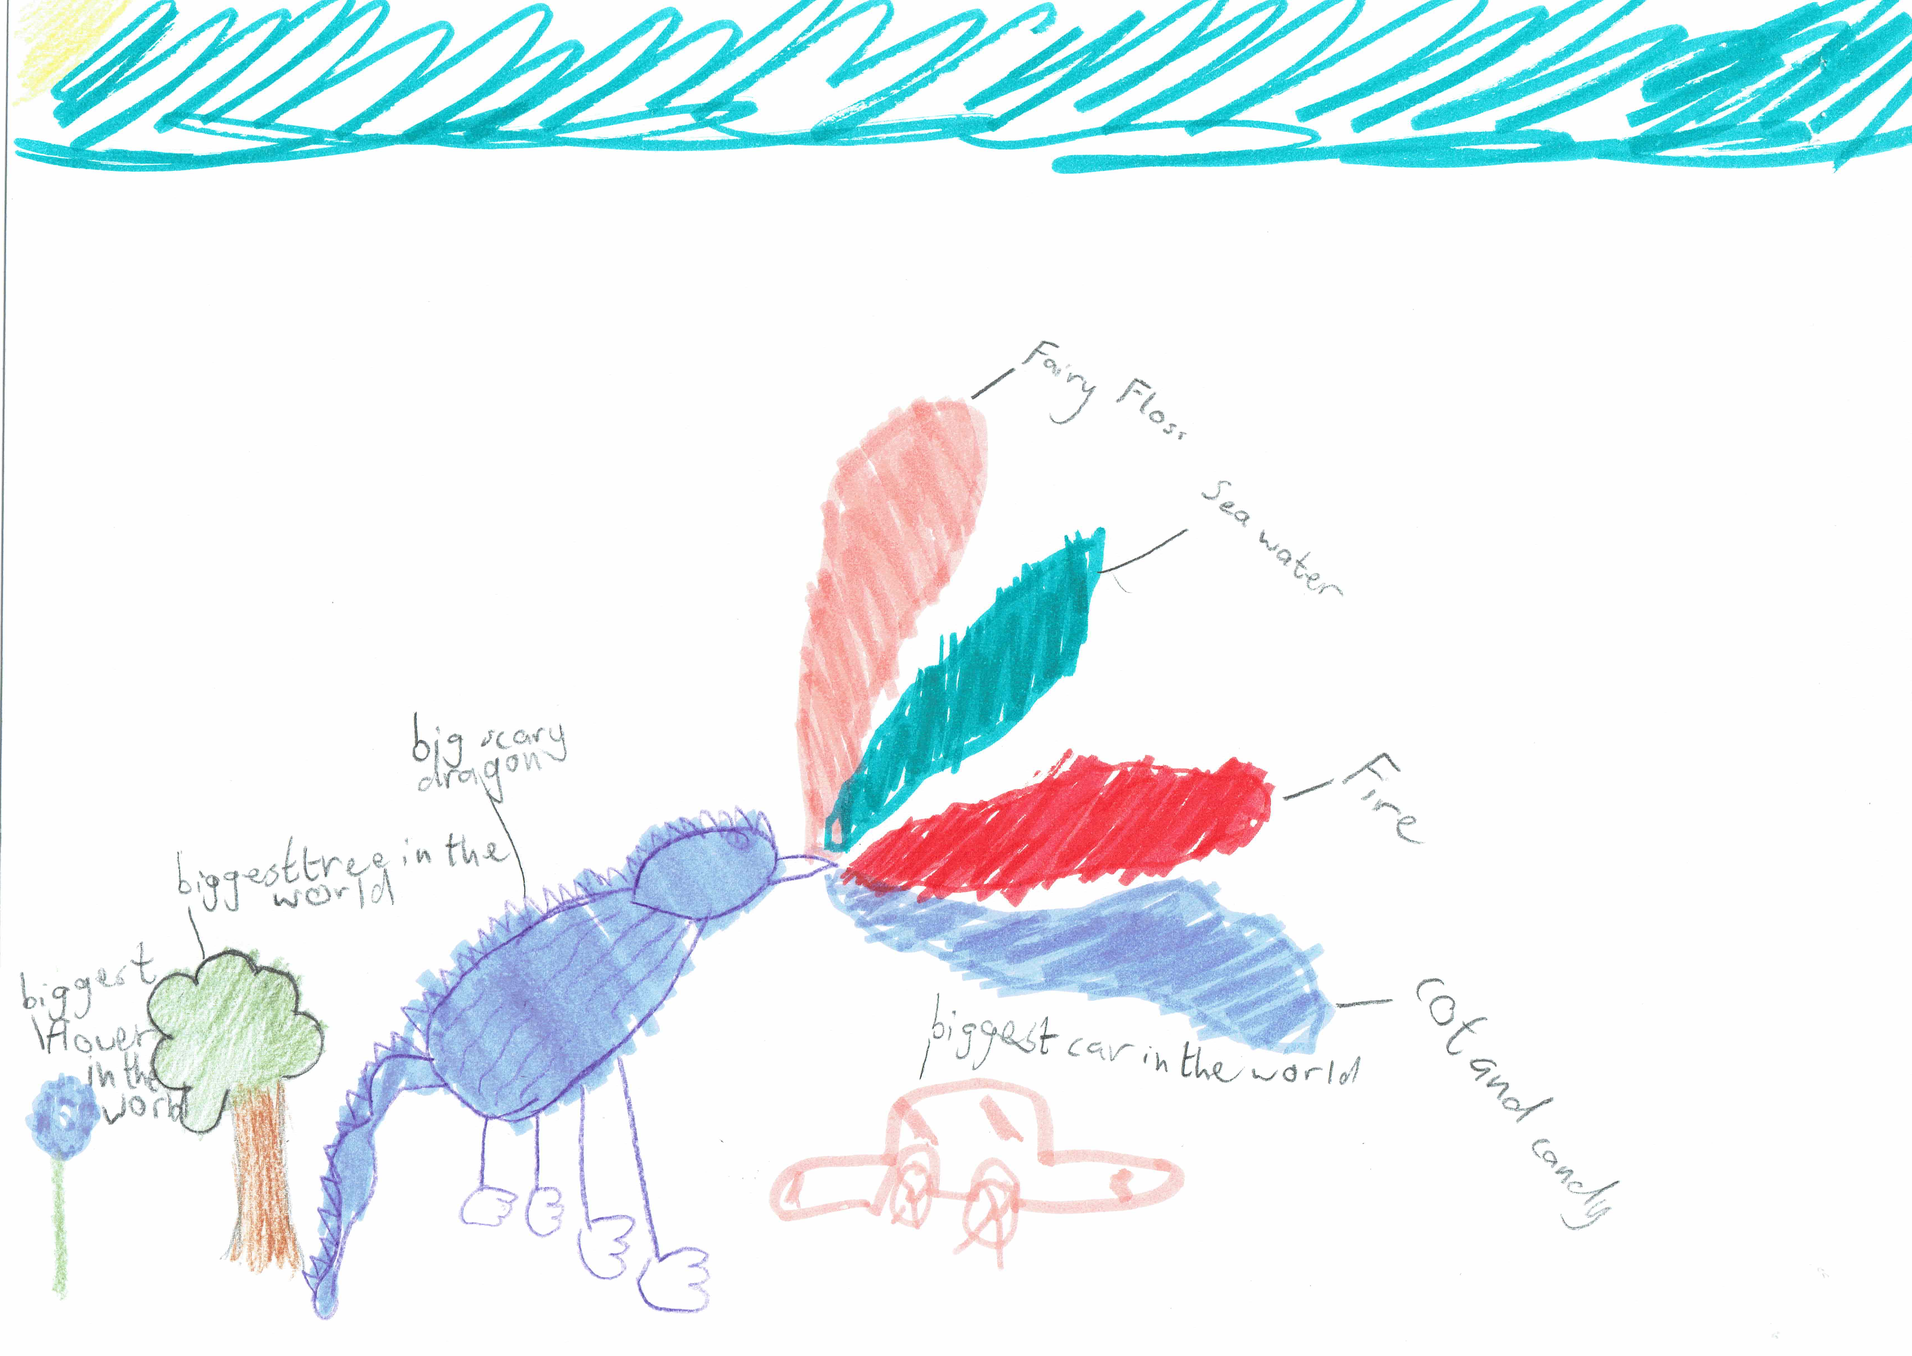

This is the unique QR code for this Imagined Thing. Right click it to save then share it, so you and others can find your way back to here to this point of The Well.

IT IS KNOWN! HUZZAH FOR THE GREAT & GRAND RUMPUS!

