96. Cryo Regisvine
HERE LIES THE ENTRY FOR AN IMAGINED THING
This is a thing imagined by Yifan, aged 9, on Thursday September 16
The full name of this thing is: Cryo Regisvine
It can be found in: Underground
It is known that: It was banished and sent underground by the Yaksha, ordered by the Geo Archon, Zhongli.
This thing has three important features: Core, Eye, and Roots

An image of Cryo Regisvine can be found here:
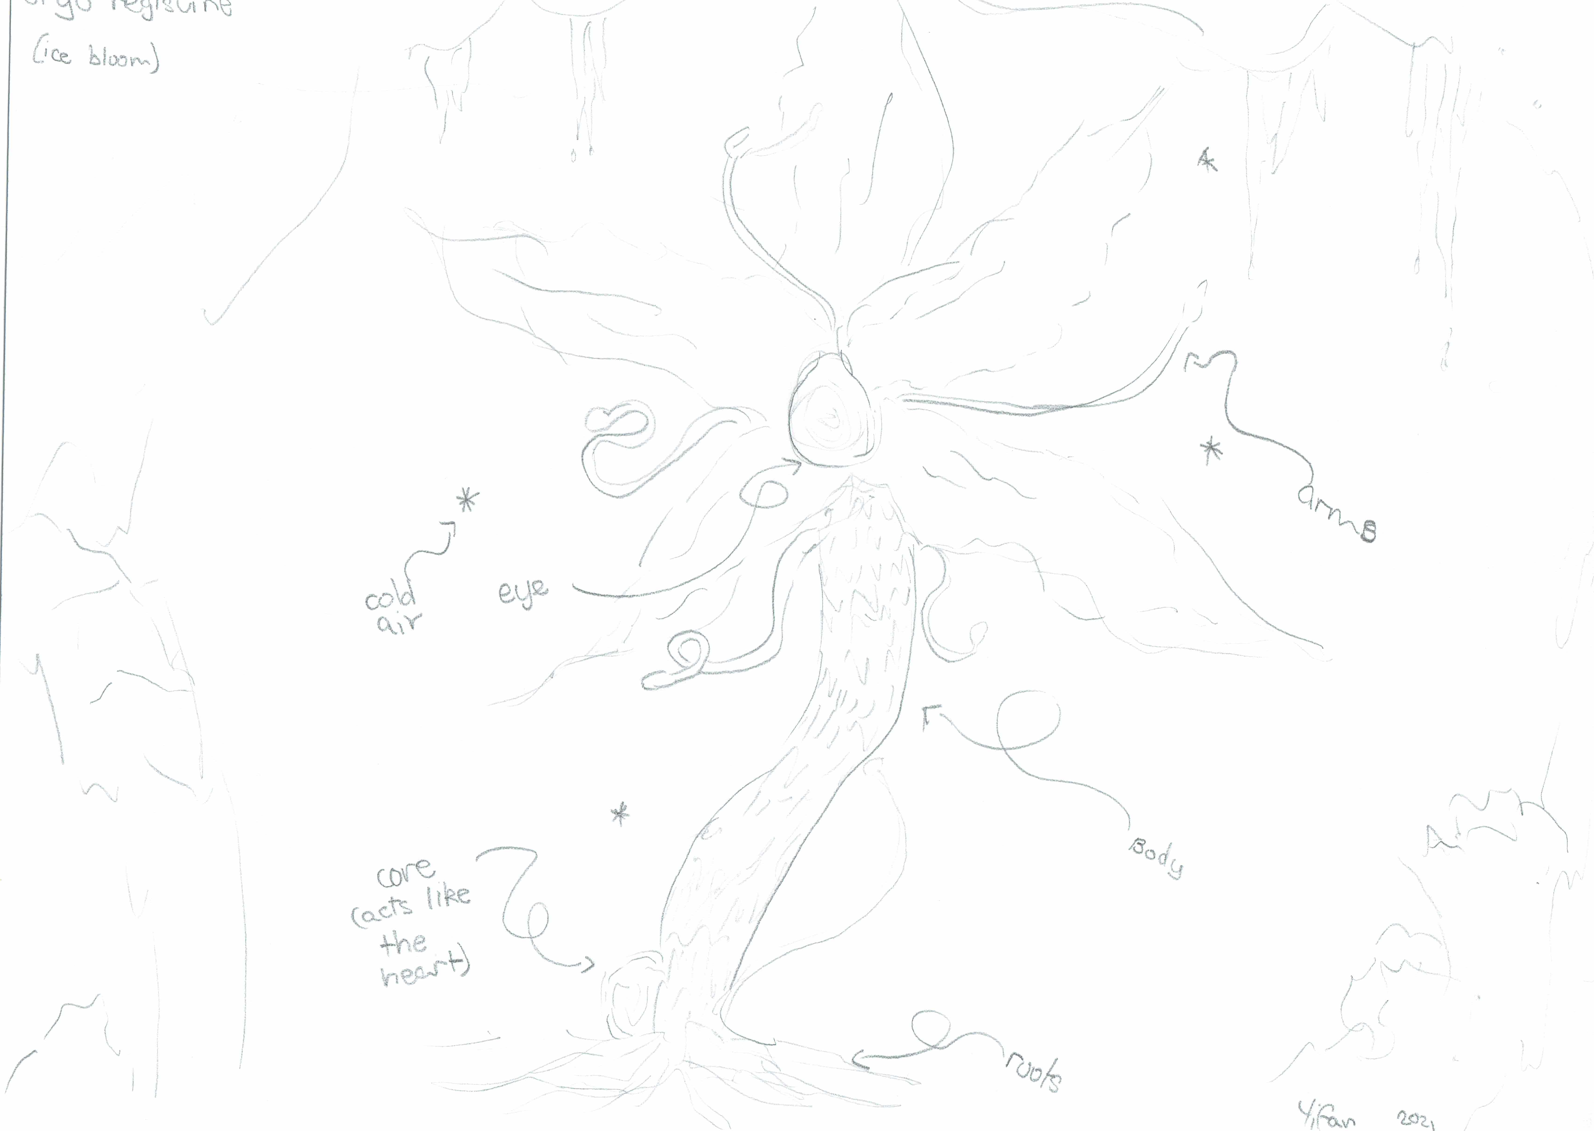

This is the unique QR code for this Imagined Thing. Right click it to save then share it, so you and others can find your way back to here to this point of The Well.

IT IS KNOWN! HUZZAH FOR THE GREAT & GRAND RUMPUS!

