94. drahorse
HERE LIES THE ENTRY FOR AN IMAGINED THING
This is a thing imagined by Lily-Rose, aged 9, on Thursday September 16
The full name of this thing is: drahorse
It can be found in: stairs
It is known that: she was born in stairs and she ended up making a bed and she tried to live by herself.
This thing has three important features: little, cute, and nice

An image of drahorse can be found here:
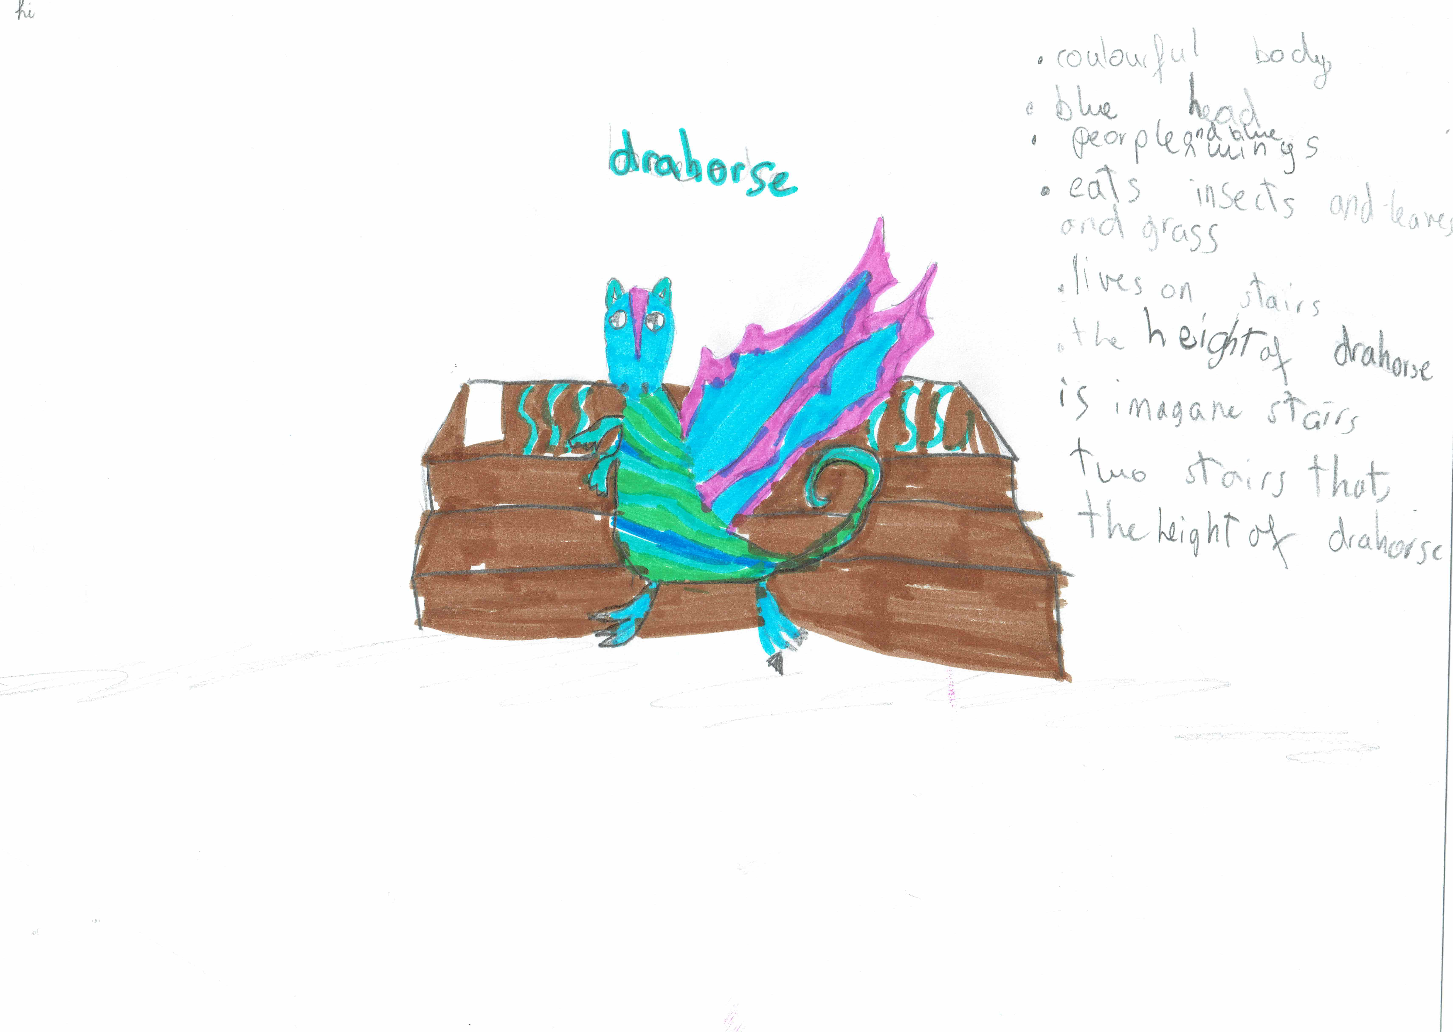

This is the unique QR code for this Imagined Thing. Right click it to save then share it, so you and others can find your way back to here to this point of The Well.

IT IS KNOWN! HUZZAH FOR THE GREAT & GRAND RUMPUS!

