92. dead forest
HERE LIES THE ENTRY FOR AN IMAGINED THING
This is a thing imagined by Jayla, aged 9, on Thursday September 16
The full name of this thing is: dead forest
It can be found in: monster land
It is known that: there once was a monster and she made a portal to monster land.
This thing has three important features: the cave, the trees , and the house

An image of dead forest can be found here:
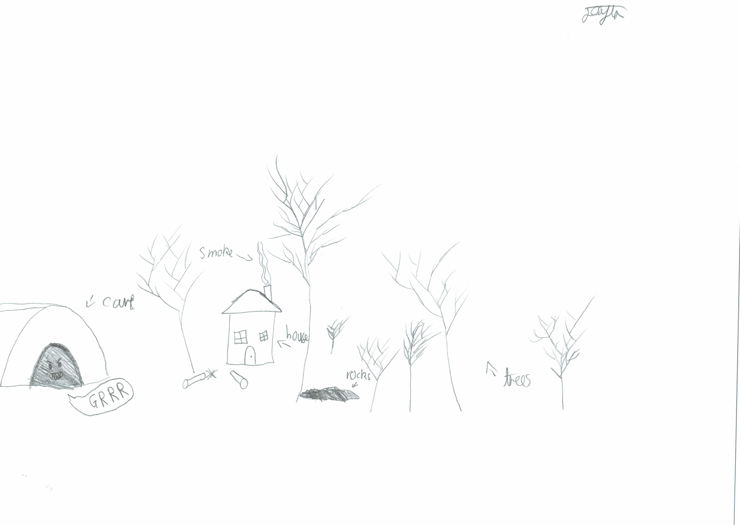

This is the unique QR code for this Imagined Thing. Right click it to save then share it, so you and others can find your way back to here to this point of The Well.

IT IS KNOWN! HUZZAH FOR THE GREAT & GRAND RUMPUS!

