91. Cabbage People
HERE LIES THE ENTRY FOR AN IMAGINED THING
This is a thing imagined by Jack, aged 9, on Thursday September 16
The full name of this thing is: Cabbage People
It can be found in: Cabbage Farm
It is known that: Once there was a cabbage that got mutated by radioactive fertiliser.
This thing has three important features: floating hands, it's a cabbage, and it's huge

An image of Cabbage People can be found here:
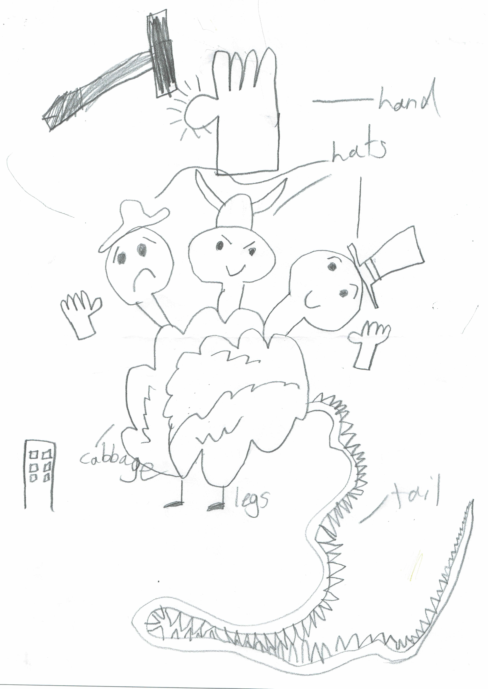

This is the unique QR code for this Imagined Thing. Right click it to save then share it, so you and others can find your way back to here to this point of The Well.

IT IS KNOWN! HUZZAH FOR THE GREAT & GRAND RUMPUS!

