9. The Rabbit Hole - Chosen Thing
HERE LIES THE ENTRY FOR AN IMAGINED THING
This is a thing imagined by Athena, aged 10, on Wednesday April 21
The full name of this thing is: the rabbit hole
It can be found in: under a rabbit hole.
It is known that: I saw a rabbit hole and jumped to it.
This thing has three important features: the creature, the drink, and the flowers

An image of the rabbit hole can be found here:
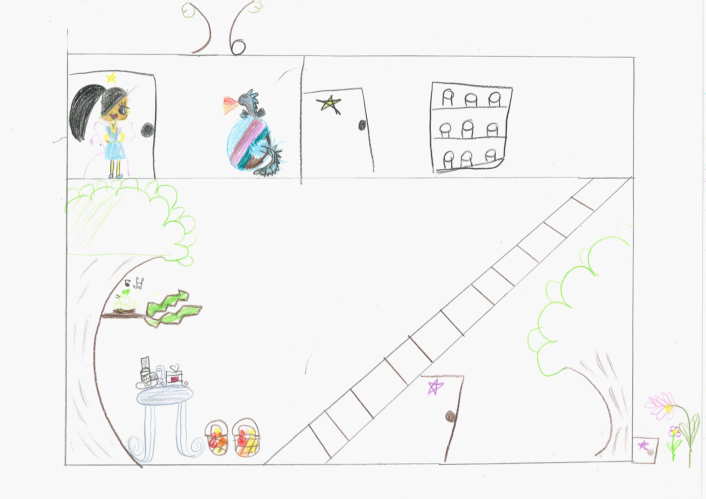400

A recording the rabbit hole can be found here:
400

This is the unique QR code for this Imagined Thing. Right click it to save then share it, so you and others can find your way back to here to this point of The Well.

IT IS KNOWN! HUZZAH FOR THE GREAT & GRAND RUMPUS!

