87. Mega Yum
HERE LIES THE ENTRY FOR AN IMAGINED THING
This is a thing imagined by Violet, aged 9, on Thursday September 16
The full name of this thing is: Mega Yum
It can be found in: In the sky floating above the dessert
It is known that: One day there was Tom Yum cup noodles and that stick bug. They had a baby, and that's the baby. Big size for some reason, nobody knows how it happened (scientists trying to figure out)
This thing has three important features: Stick arms and legs, Can't say anything but 'eat me' , and Loves Cake

An image of Mega Yum can be found here:
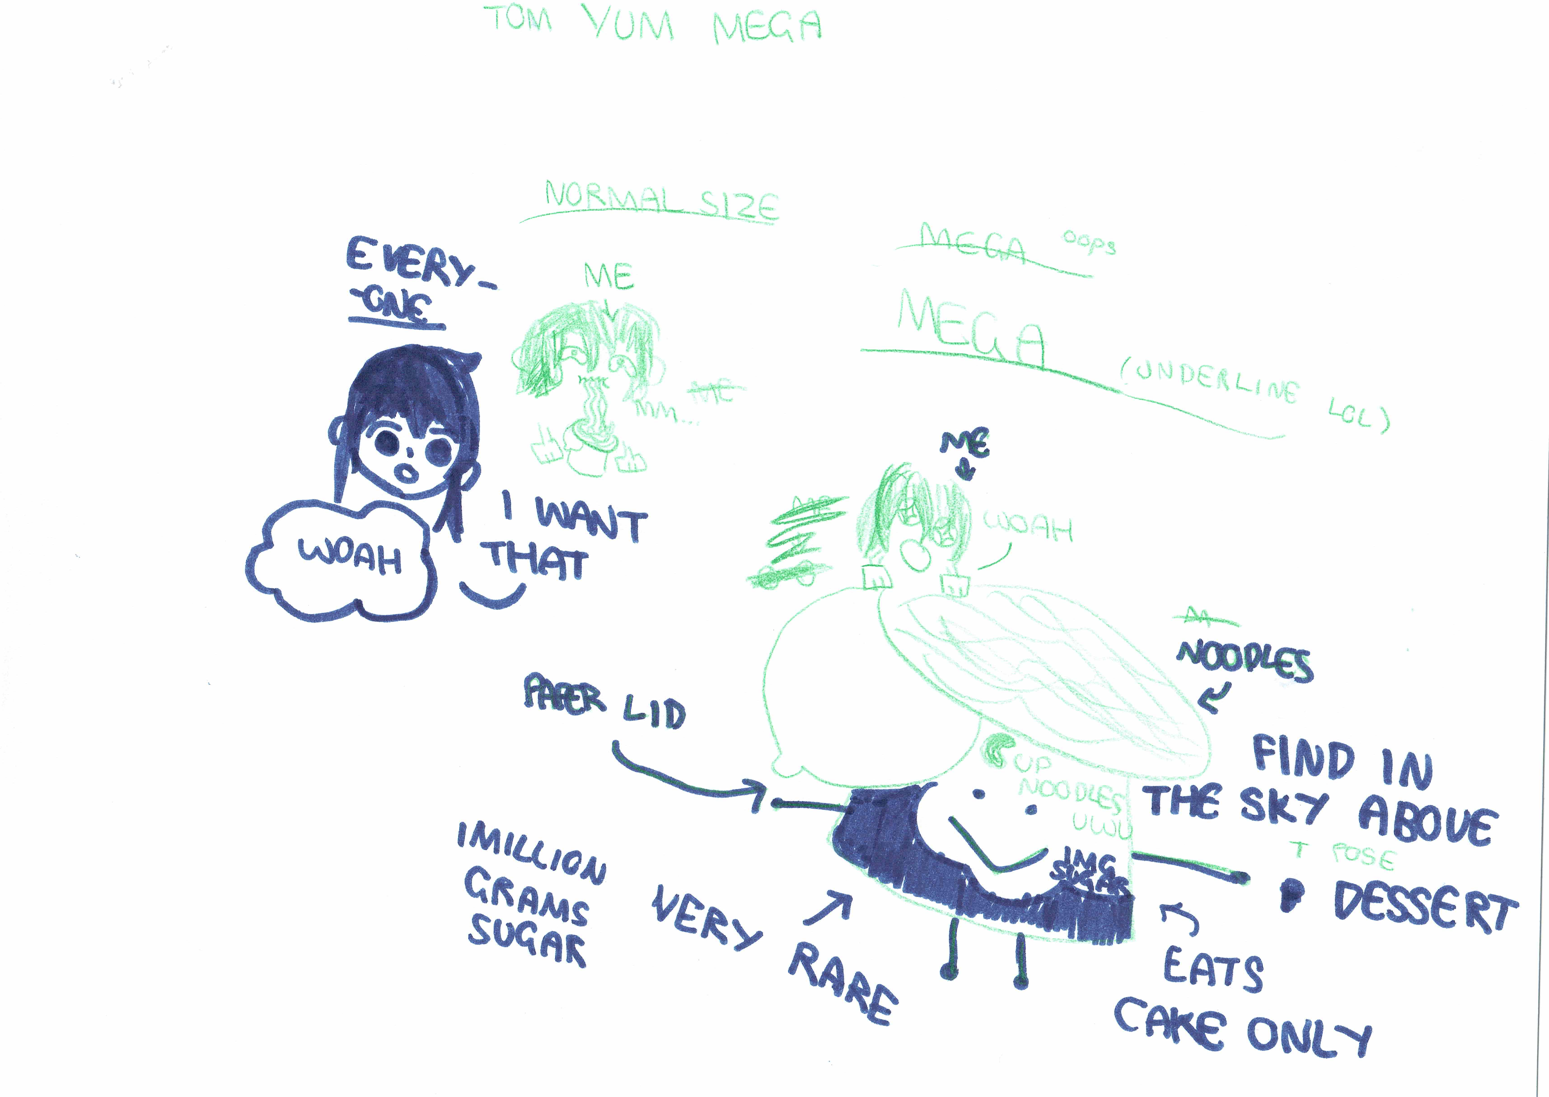

This is the unique QR code for this Imagined Thing. Right click it to save then share it, so you and others can find your way back to here to this point of The Well.

IT IS KNOWN! HUZZAH FOR THE GREAT & GRAND RUMPUS!

