85. Paper with mouth
HERE LIES THE ENTRY FOR AN IMAGINED THING
This is a thing imagined by Jeongwoo, aged 9, on Thursday September 16
The full name of this thing is: Paper with mouth
It can be found in: In a space
It is known that: Paper with mouth was a paper. But it came alive and atack the people. But people rip the paper with mouth so he never came again.
This thing has three important features: Paper with mouth, paper with two hands, and paper with two eyes.

An image of Paper with mouth can be found here:
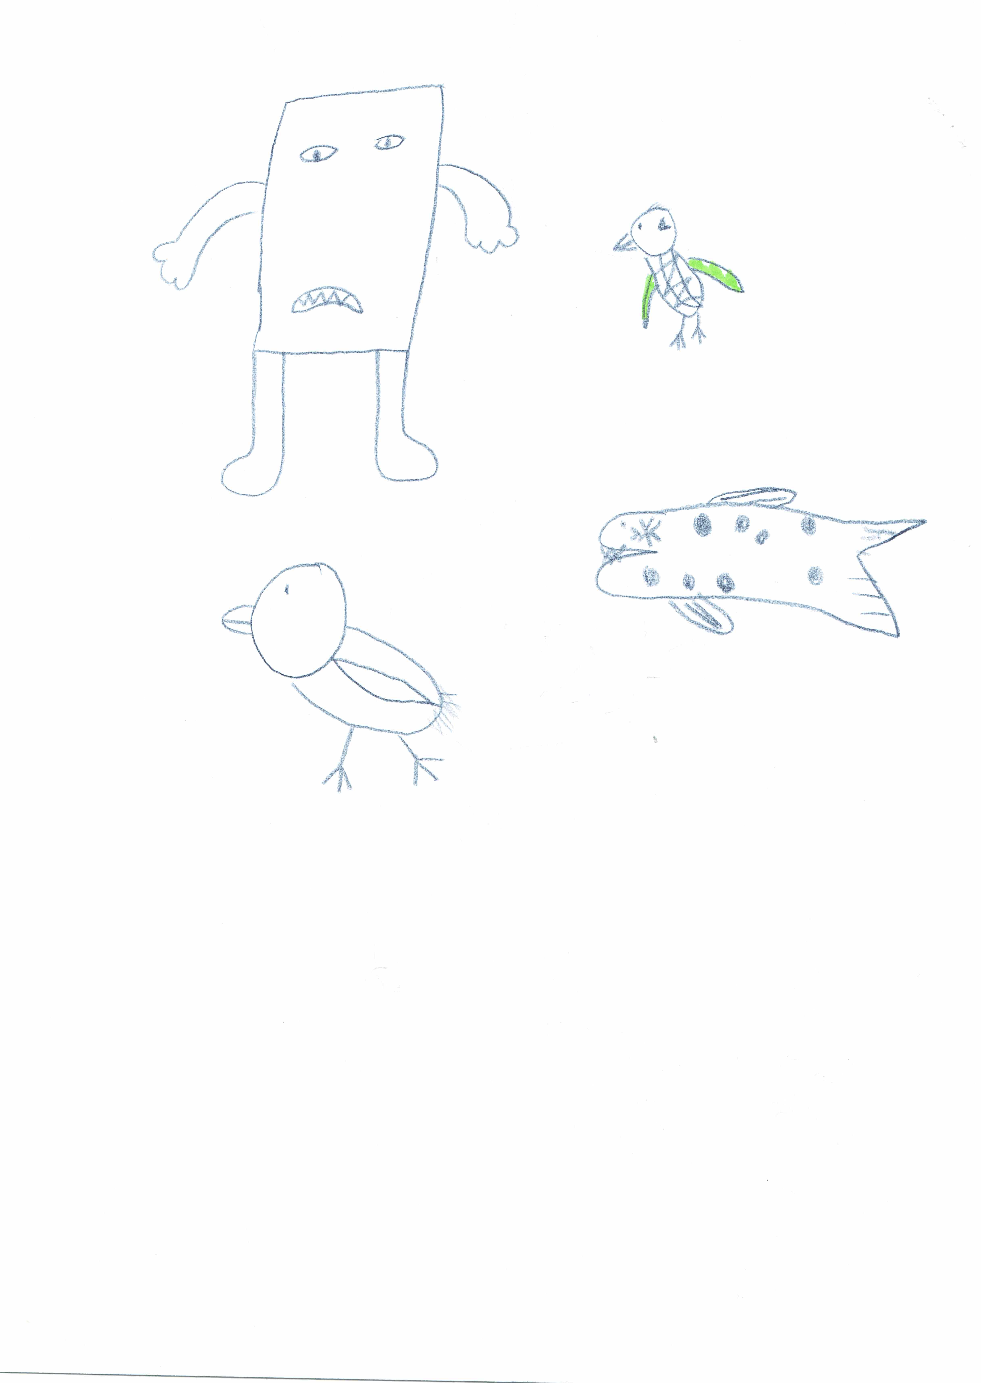

This is the unique QR code for this Imagined Thing. Right click it to save then share it, so you and others can find your way back to here to this point of The Well.

IT IS KNOWN! HUZZAH FOR THE GREAT & GRAND RUMPUS!

