83. Under Water Egg Man
HERE LIES THE ENTRY FOR AN IMAGINED THING
This is a thing imagined by Aaron, aged 9, on Thursday September 16
The full name of this thing is: Under Water Egg Man
It can be found in: Ocean
It is known that: A Eggman (guy in egg) invent not drowning stuff
This thing has three important features: Egg man, Water, and Jellyfish

An image of Under Water Egg Man can be found here:
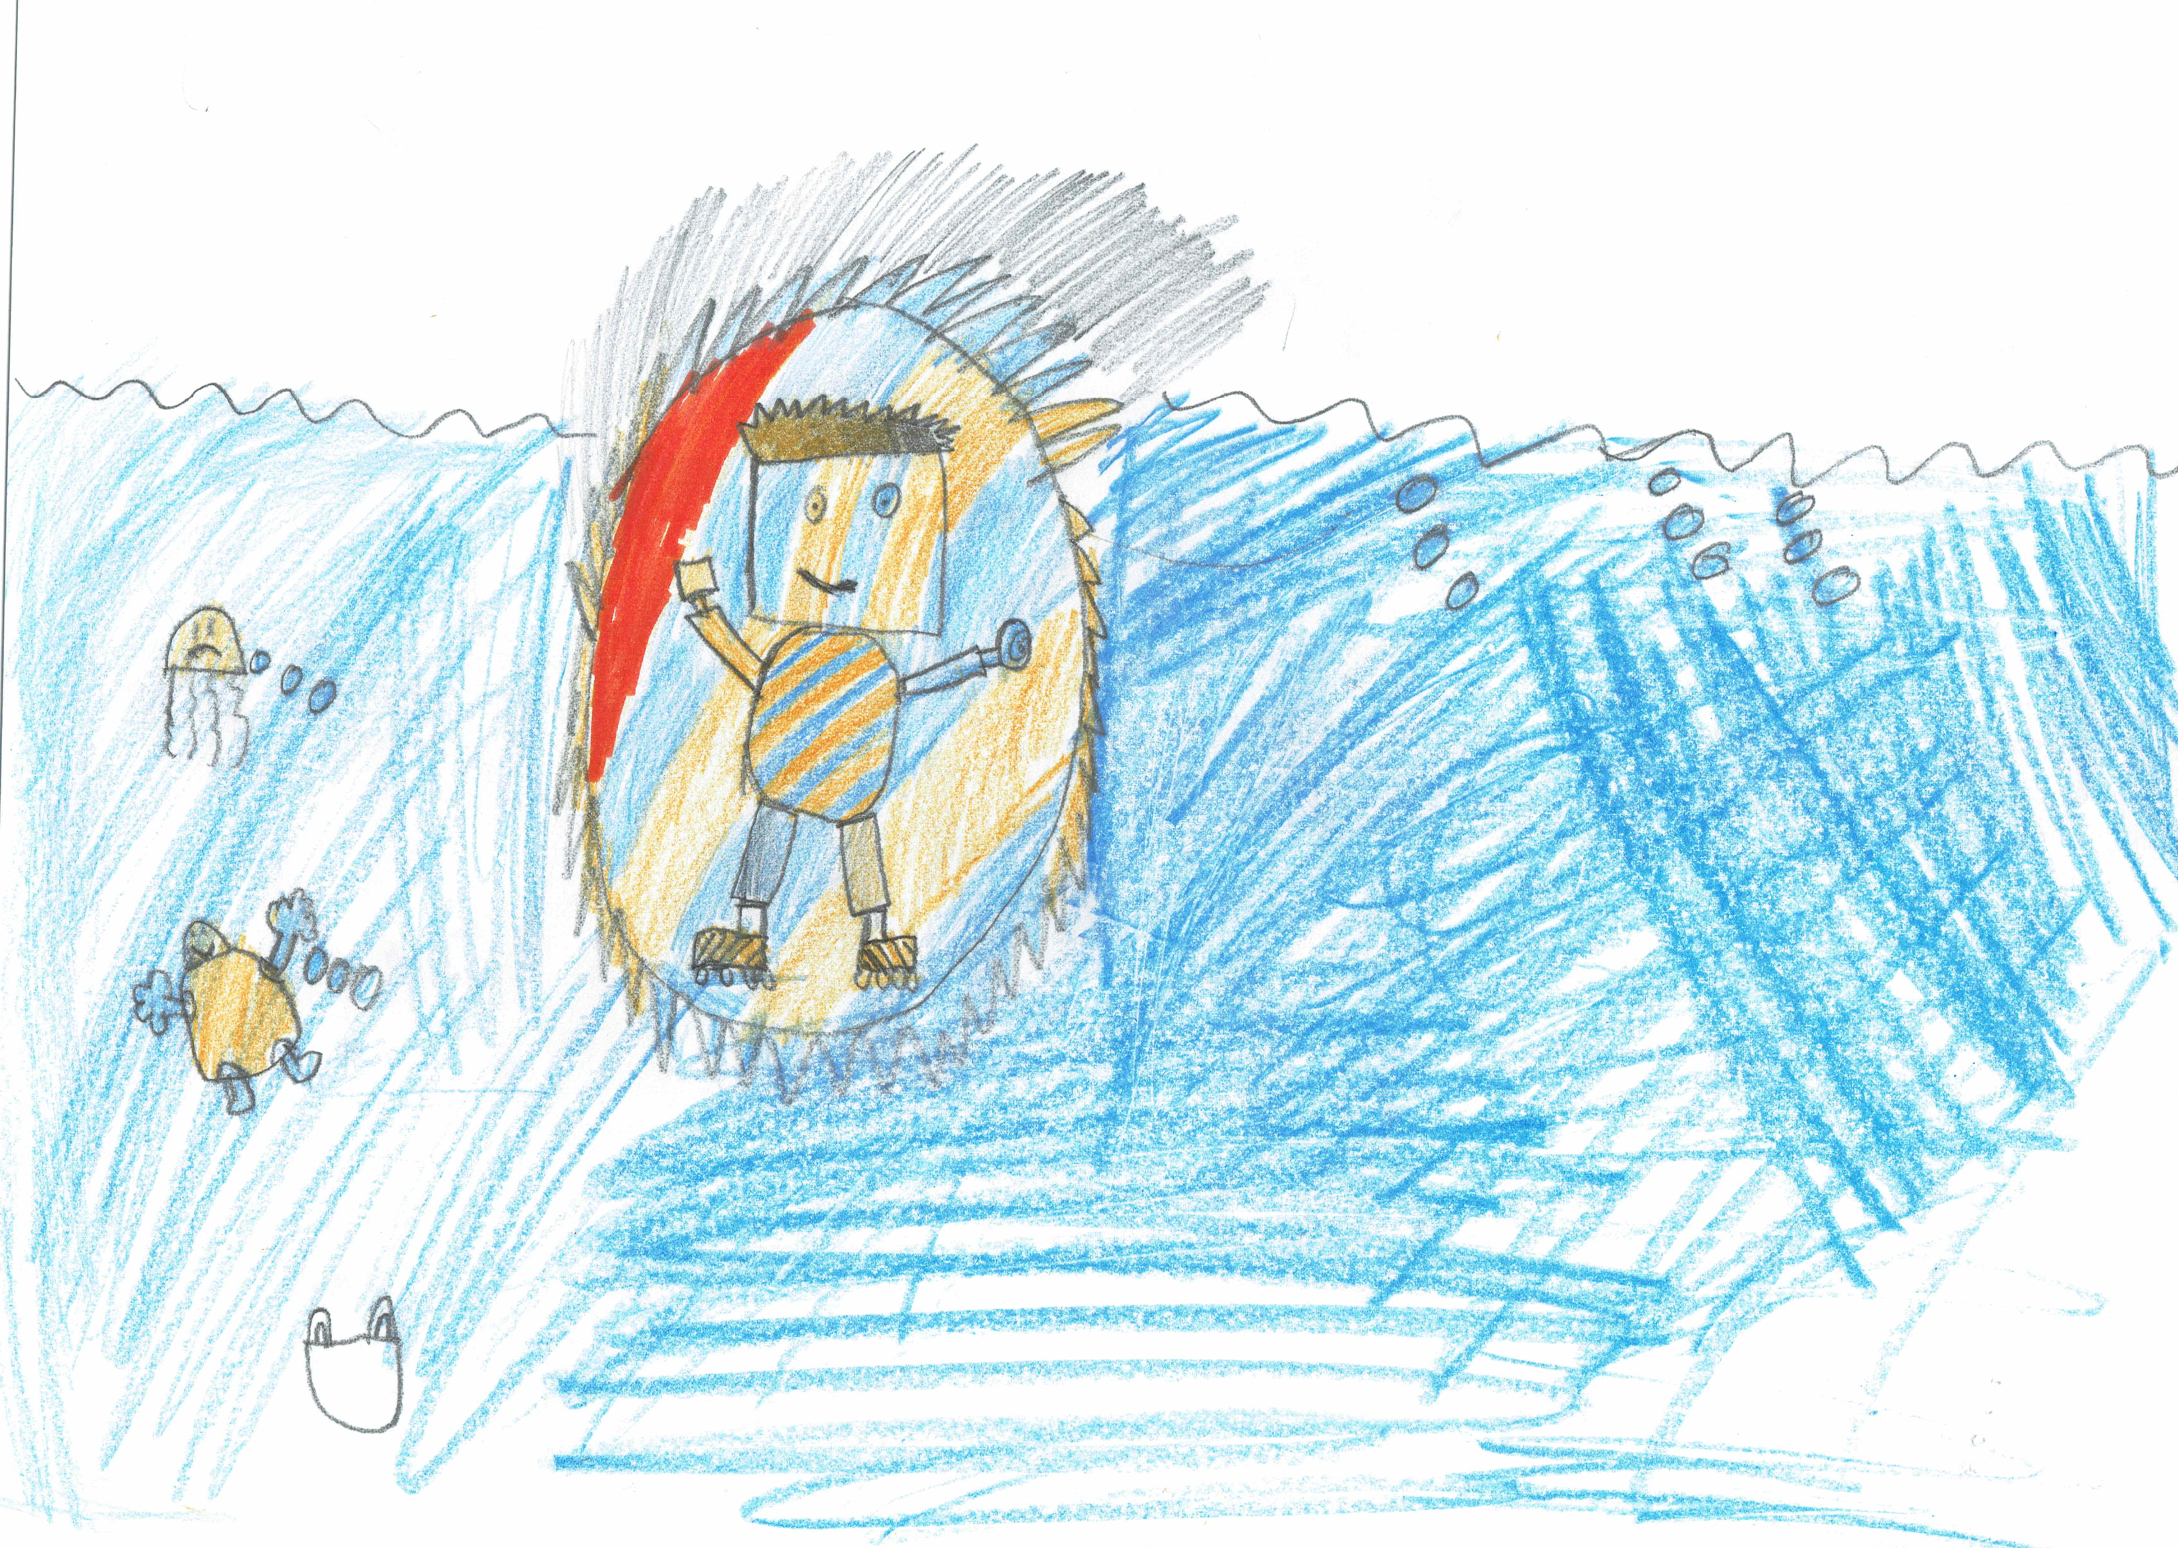

This is the unique QR code for this Imagined Thing. Right click it to save then share it, so you and others can find your way back to here to this point of The Well.

IT IS KNOWN! HUZZAH FOR THE GREAT & GRAND RUMPUS!

