80. Chloe
HERE LIES THE ENTRY FOR AN IMAGINED THING
This is a thing imagined by Ella, aged 9, on Monday August 30
The full name of this thing is: Chloe
It can be found in: the jungle
It is known that: Once upon a time lived a furry animal named chloe she loved the shade and really soft grass. She had many friends and owns a huge tree house she plays in it every day.
This thing has three important features: wings, pattern on fur, tail

An image of Chloe can be found here:
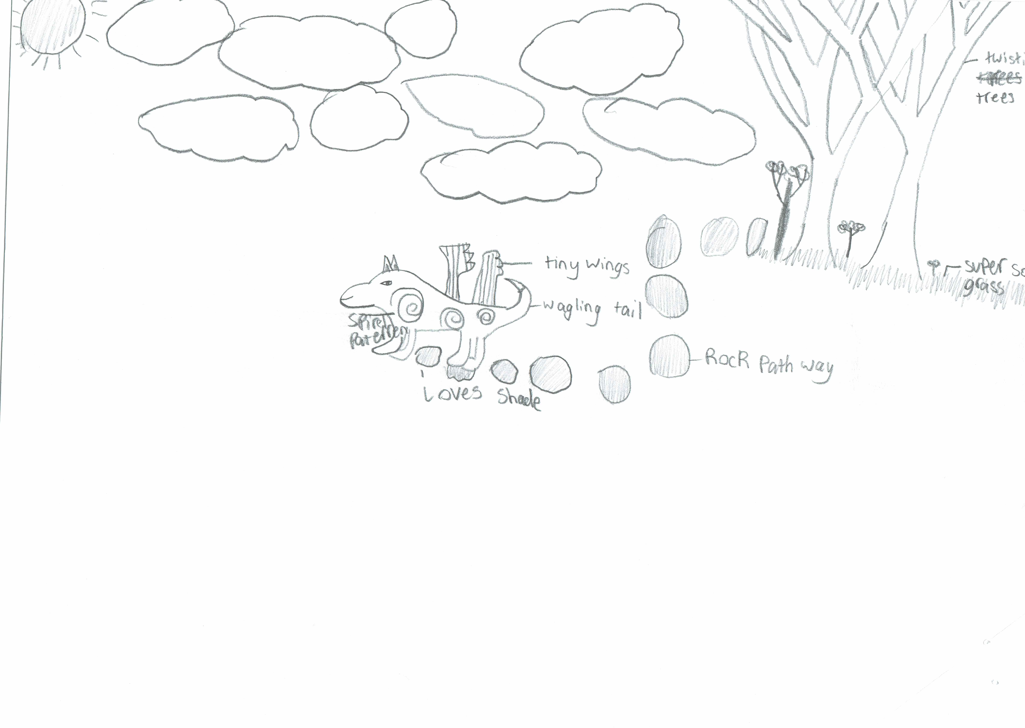

This is the unique QR code for this Imagined Thing. Right click it to save then share it, so you and others can find your way back to here to this point of The Well.

IT IS KNOWN! HUZZAH FOR THE GREAT & GRAND RUMPUS!

