79. Pearl
HERE LIES THE ENTRY FOR AN IMAGINED THING
This is a thing imagined by Anna, aged , on August 30
The full name of this thing is: Pearl
It can be found in: The Ocean
It is known that: Pearl the sea dragon got lost in storm and seperated from her family. Pearl has found herself in the Gold Coast and has a little baby sea dragon.
This thing has three important features: leathery scales, Huge transparent wings, breath ice

An image of Peal can be found here:
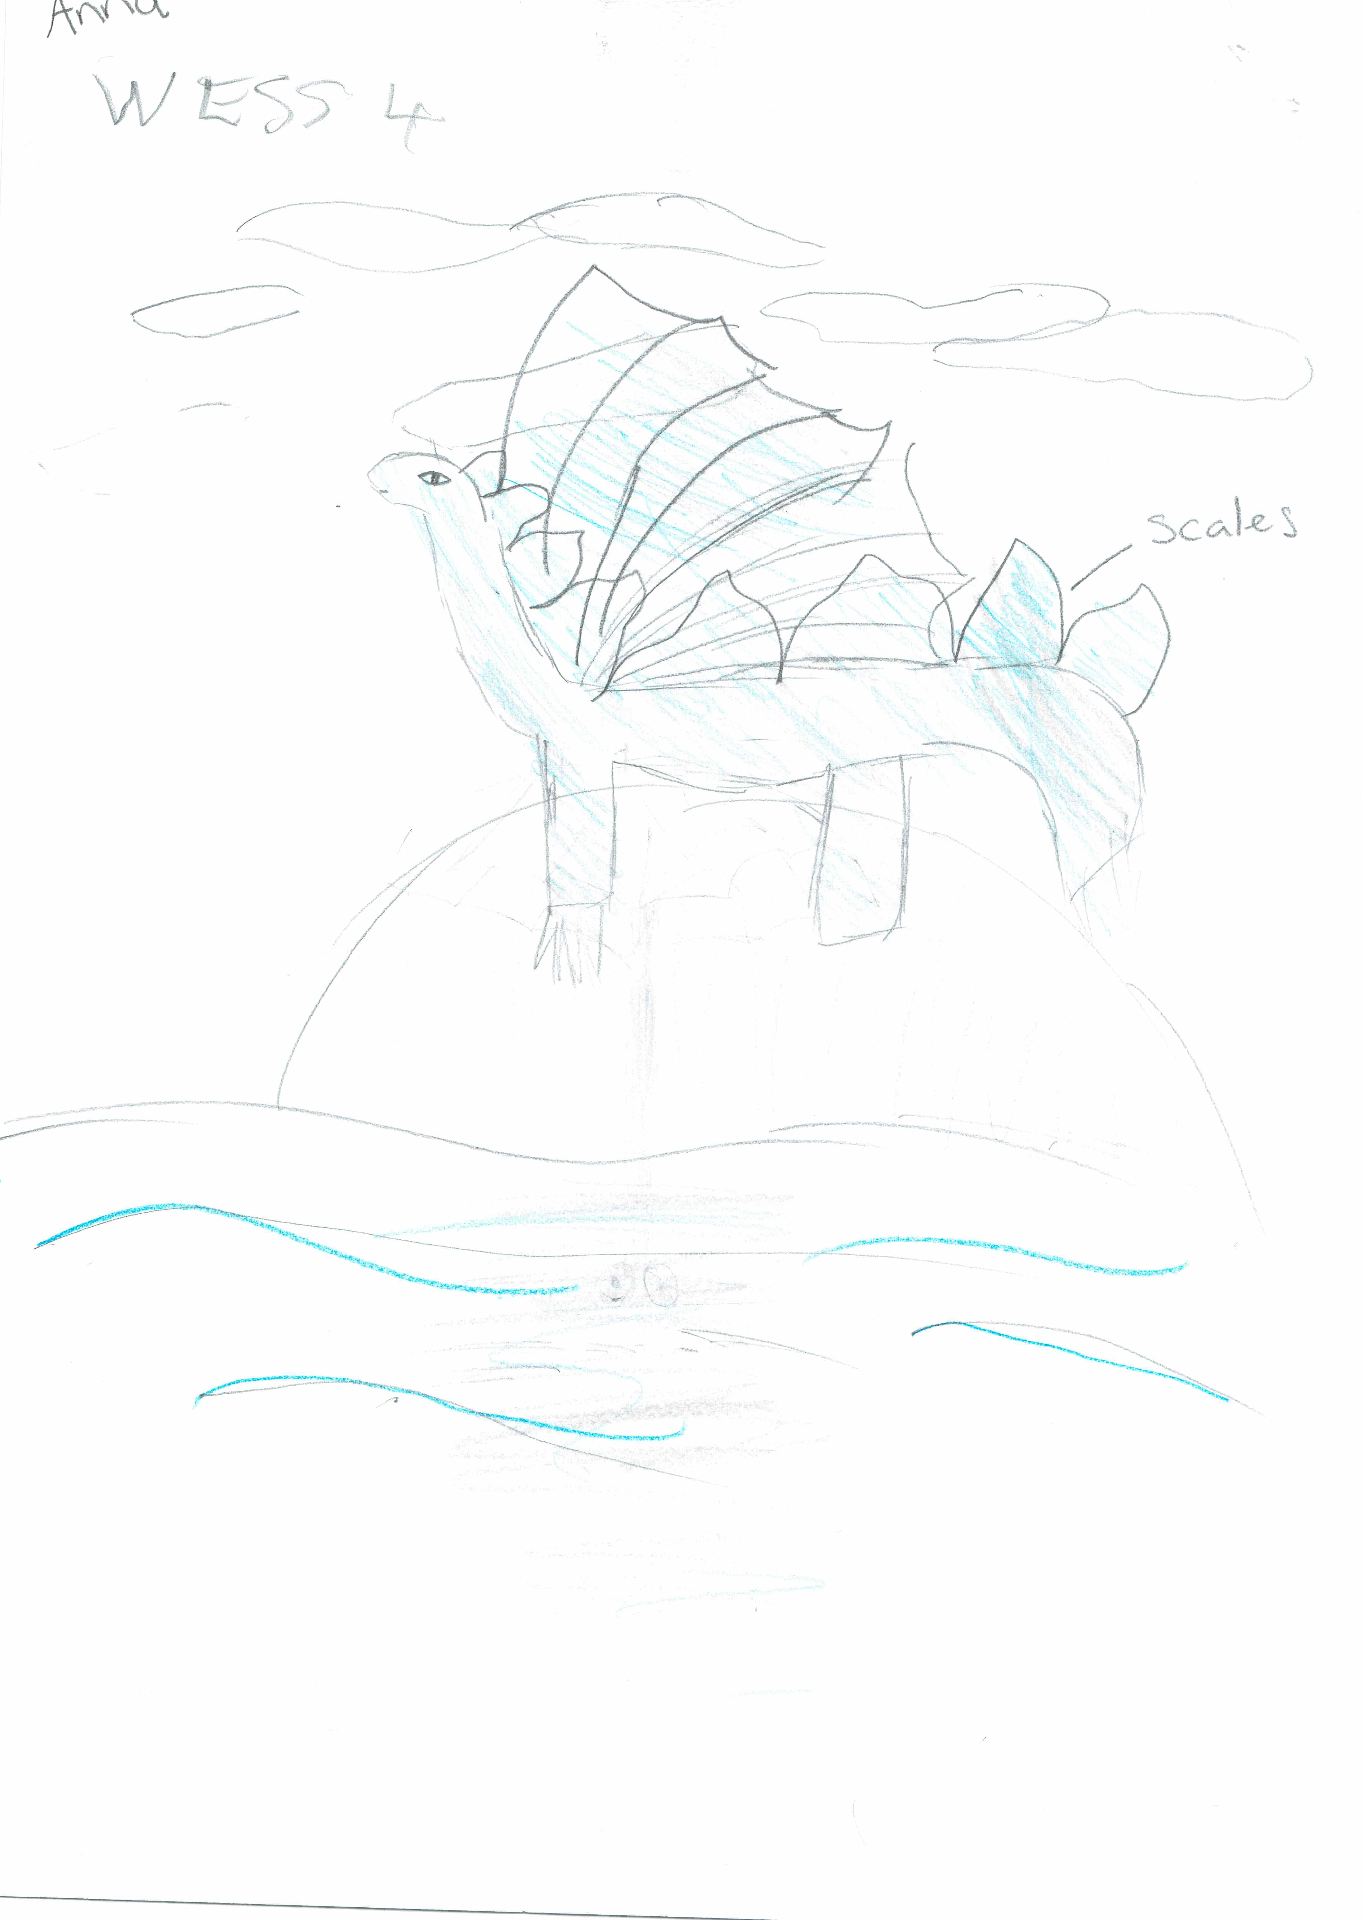

This is the unique QR code for this Imagined Thing. Right click it to save then share it, so you and others can find your way back to here to this point of The Well.

IT IS KNOWN! HUZZAH FOR THE GREAT & GRAND RUMPUS!

