78. No Name from the Swedish Wilderness - Chosen Thing
HERE LIES THE ENTRY FOR AN IMAGINED THING
This is a thing imagined by Andrew, aged , on Thursday July 8
The full name of this thing is: No name
It can be found in: Swedish wilderness
It is known that: NA
This thing has three important features: The face, Ribs, and Antlers

An image of No name can be found here:
upload_image_file_2400 upload_image_file_3400 upload_image_file_4400 upload_image_file_5400
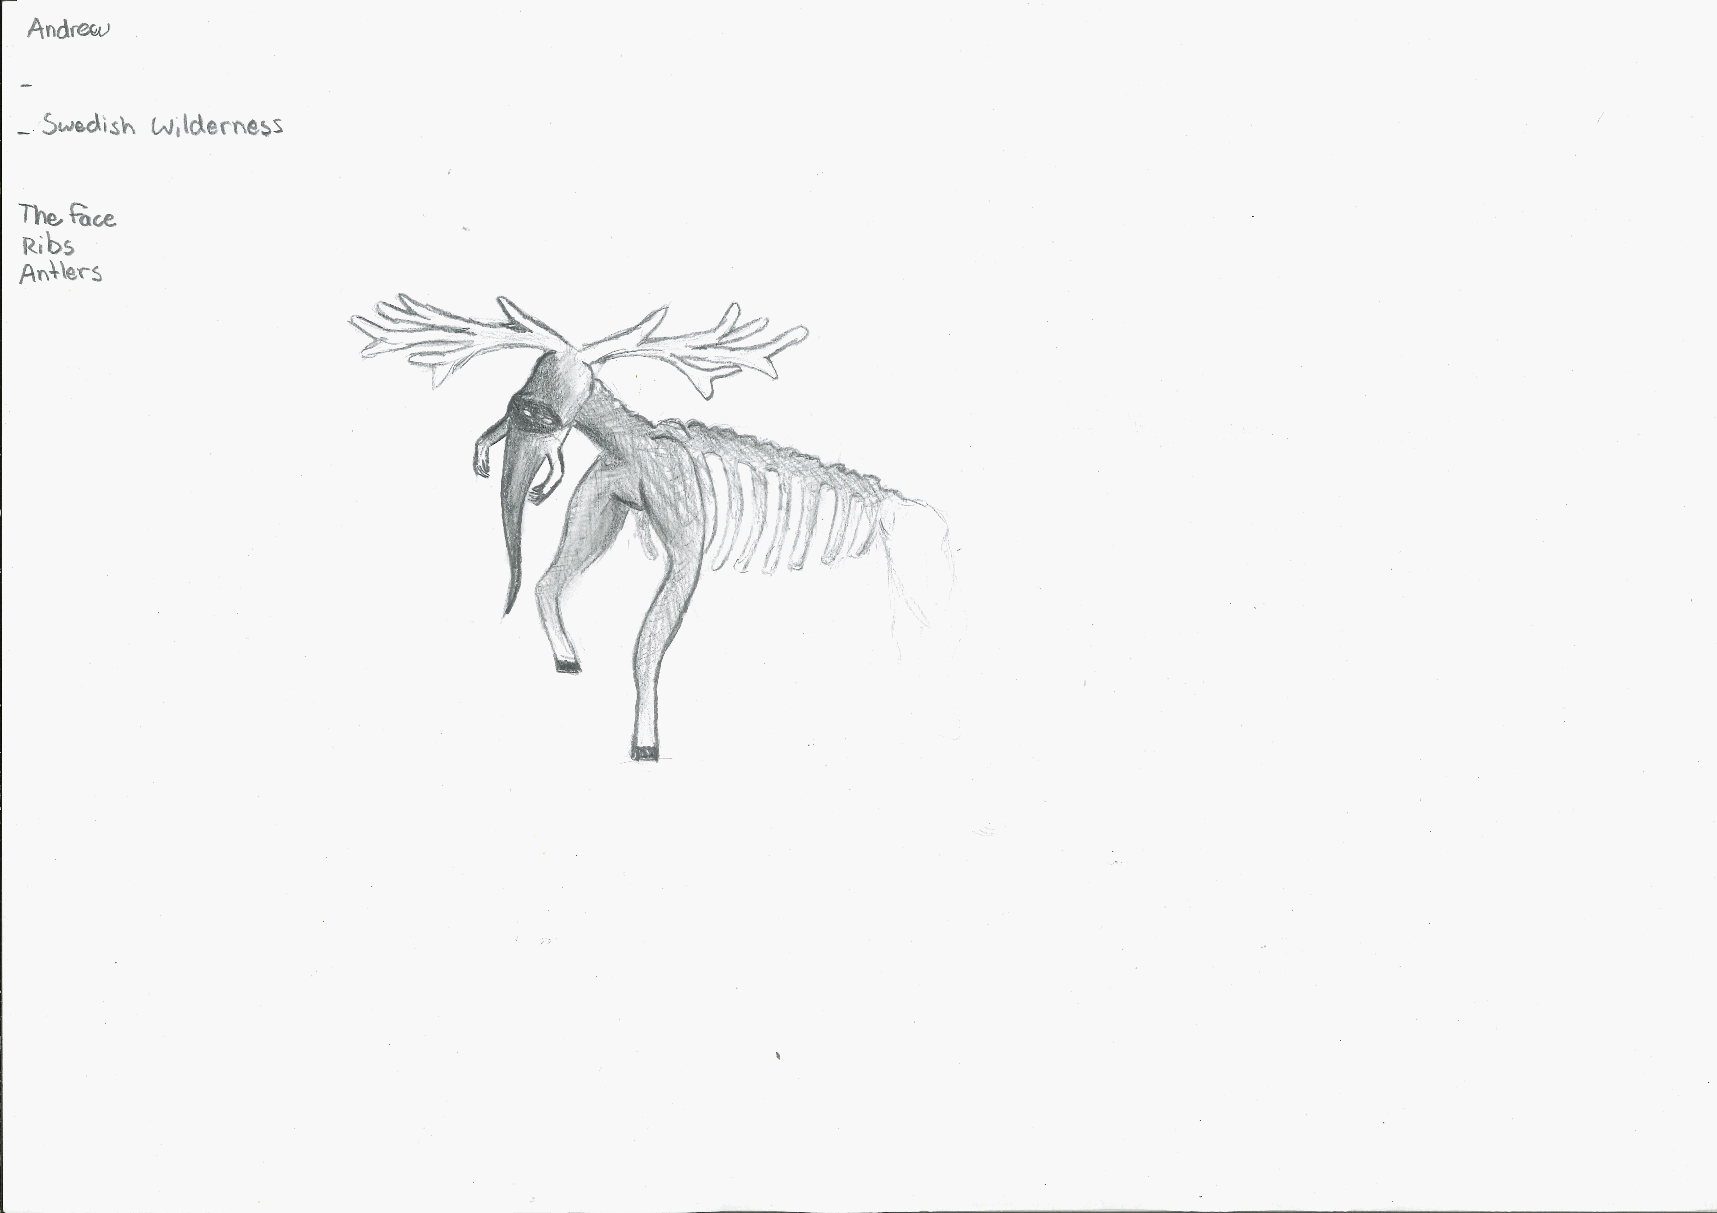400

A recording No name can be found here:
upload_your_audio_file400

This is the unique QR code for this Imagined Thing. Right click it to save then share it, so you and others can find your way back to here to this point of The Well.

IT IS KNOWN! HUZZAH FOR THE GREAT & GRAND RUMPUS!

