77. Hannah's Lab Creatures
HERE LIES THE ENTRY FOR AN IMAGINED THING
This is a thing imagined by Hannah, aged , on Thursday July 8
The full name of this thing is: Hannah's lab creatures
It can be found in: Multiple creatures
It is known that: Multiple stories
This thing has three important features: @@Feature 1@@, @@Feature 2@@, and @@Feature 3@@

An image of Hannah's lab creatures can be found here:
upload_image_file_2400 upload_image_file_3400 upload_image_file_4400 upload_image_file_5400
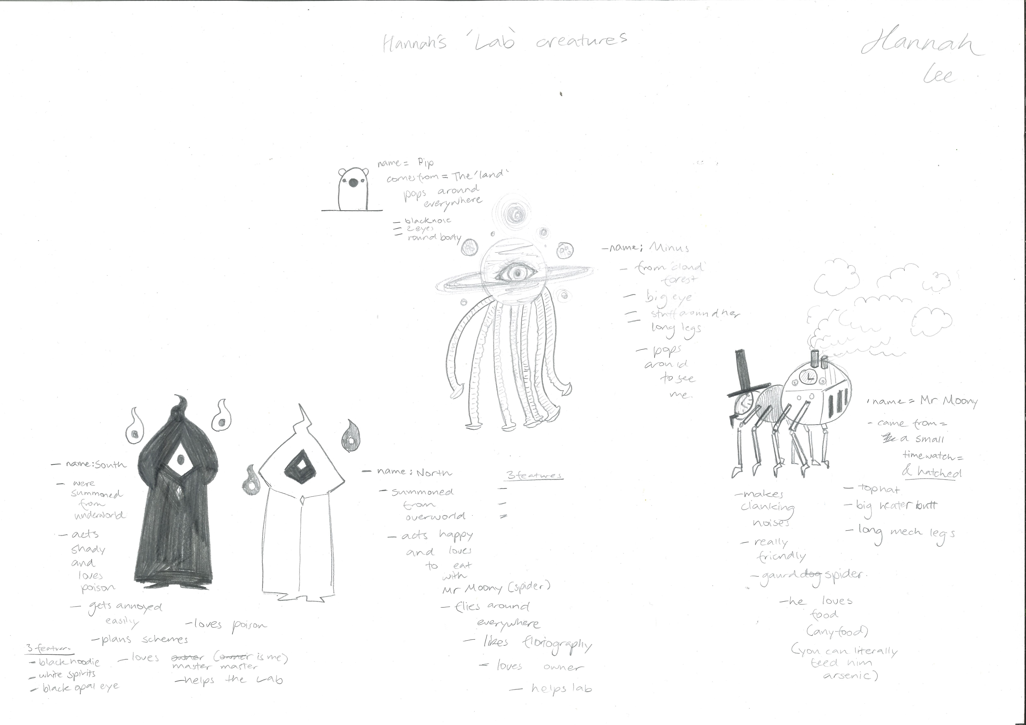400

A recording Hannah's lab creatures can be found here:
upload_your_audio_file400

This is the unique QR code for this Imagined Thing. Right click it to save then share it, so you and others can find your way back to here to this point of The Well.

IT IS KNOWN! HUZZAH FOR THE GREAT & GRAND RUMPUS!

