76. Trevis 2.0
HERE LIES THE ENTRY FOR AN IMAGINED THING
This is a thing imagined by Seanna, aged , on Thursday July 8
The full name of this thing is: Trevis 2.0
It can be found in: NA
It is known that: My creature was originally designed by humans as an AI, used as an all-terrain transport vehicle. However it has begun to think for itself and has developed into a creature which lives in jungle like environments and acts just like other animals.
This thing has three important features: Wings, Gears (mechanical insides), and Hand/feet

An image of Trevis 2.0 can be found here:
upload_image_file_2400 upload_image_file_3400 upload_image_file_4400 upload_image_file_5400
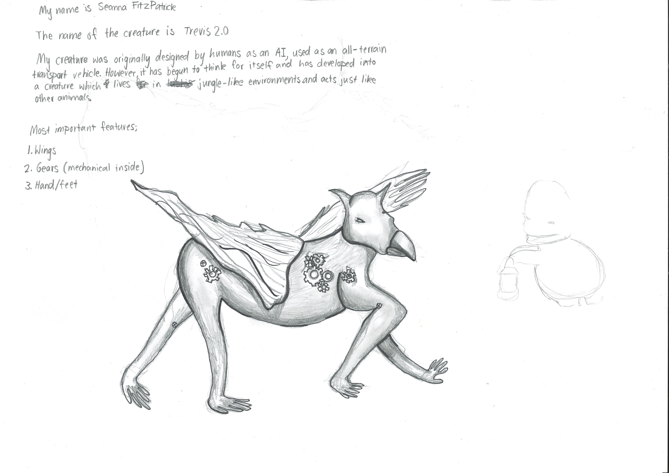400

A recording Trevis 2.0 can be found here:
upload_your_audio_file400

This is the unique QR code for this Imagined Thing. Right click it to save then share it, so you and others can find your way back to here to this point of The Well.

IT IS KNOWN! HUZZAH FOR THE GREAT & GRAND RUMPUS!

