73. Dave from the Dessert
HERE LIES THE ENTRY FOR AN IMAGINED THING
This is a thing imagined by Tadhg, aged , on Thursday July 8
The full name of this thing is: Dave
It can be found in: The dessert
It is known that: NA
This thing has three important features: Goat chain, Tail, and Sunflower afro

An image of Dave can be found here:
upload_image_file_2400 upload_image_file_3400 upload_image_file_4400 upload_image_file_5400
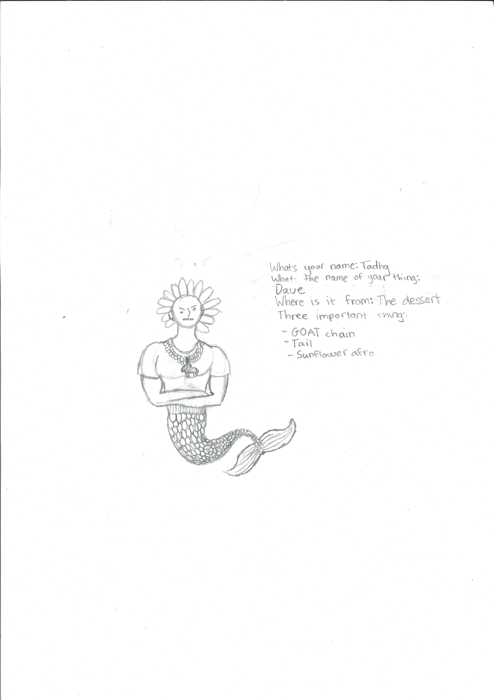400

A recording Dave can be found here:
upload_your_audio_file400

This is the unique QR code for this Imagined Thing. Right click it to save then share it, so you and others can find your way back to here to this point of The Well.

IT IS KNOWN! HUZZAH FOR THE GREAT & GRAND RUMPUS!

