7. Rainbow
HERE LIES THE ENTRY FOR AN IMAGINED THING
This is a thing imagined by Jennifer, aged 10, on Wednesday April 21
The full name of this thing is: Rainbow
It can be found in: Sky land
It is known that: I saw a light in my room I went in to sky land and unicorn and animals
This thing has three important features: Unicorn, Me, and Animals

An image of Rainbow can be found here:
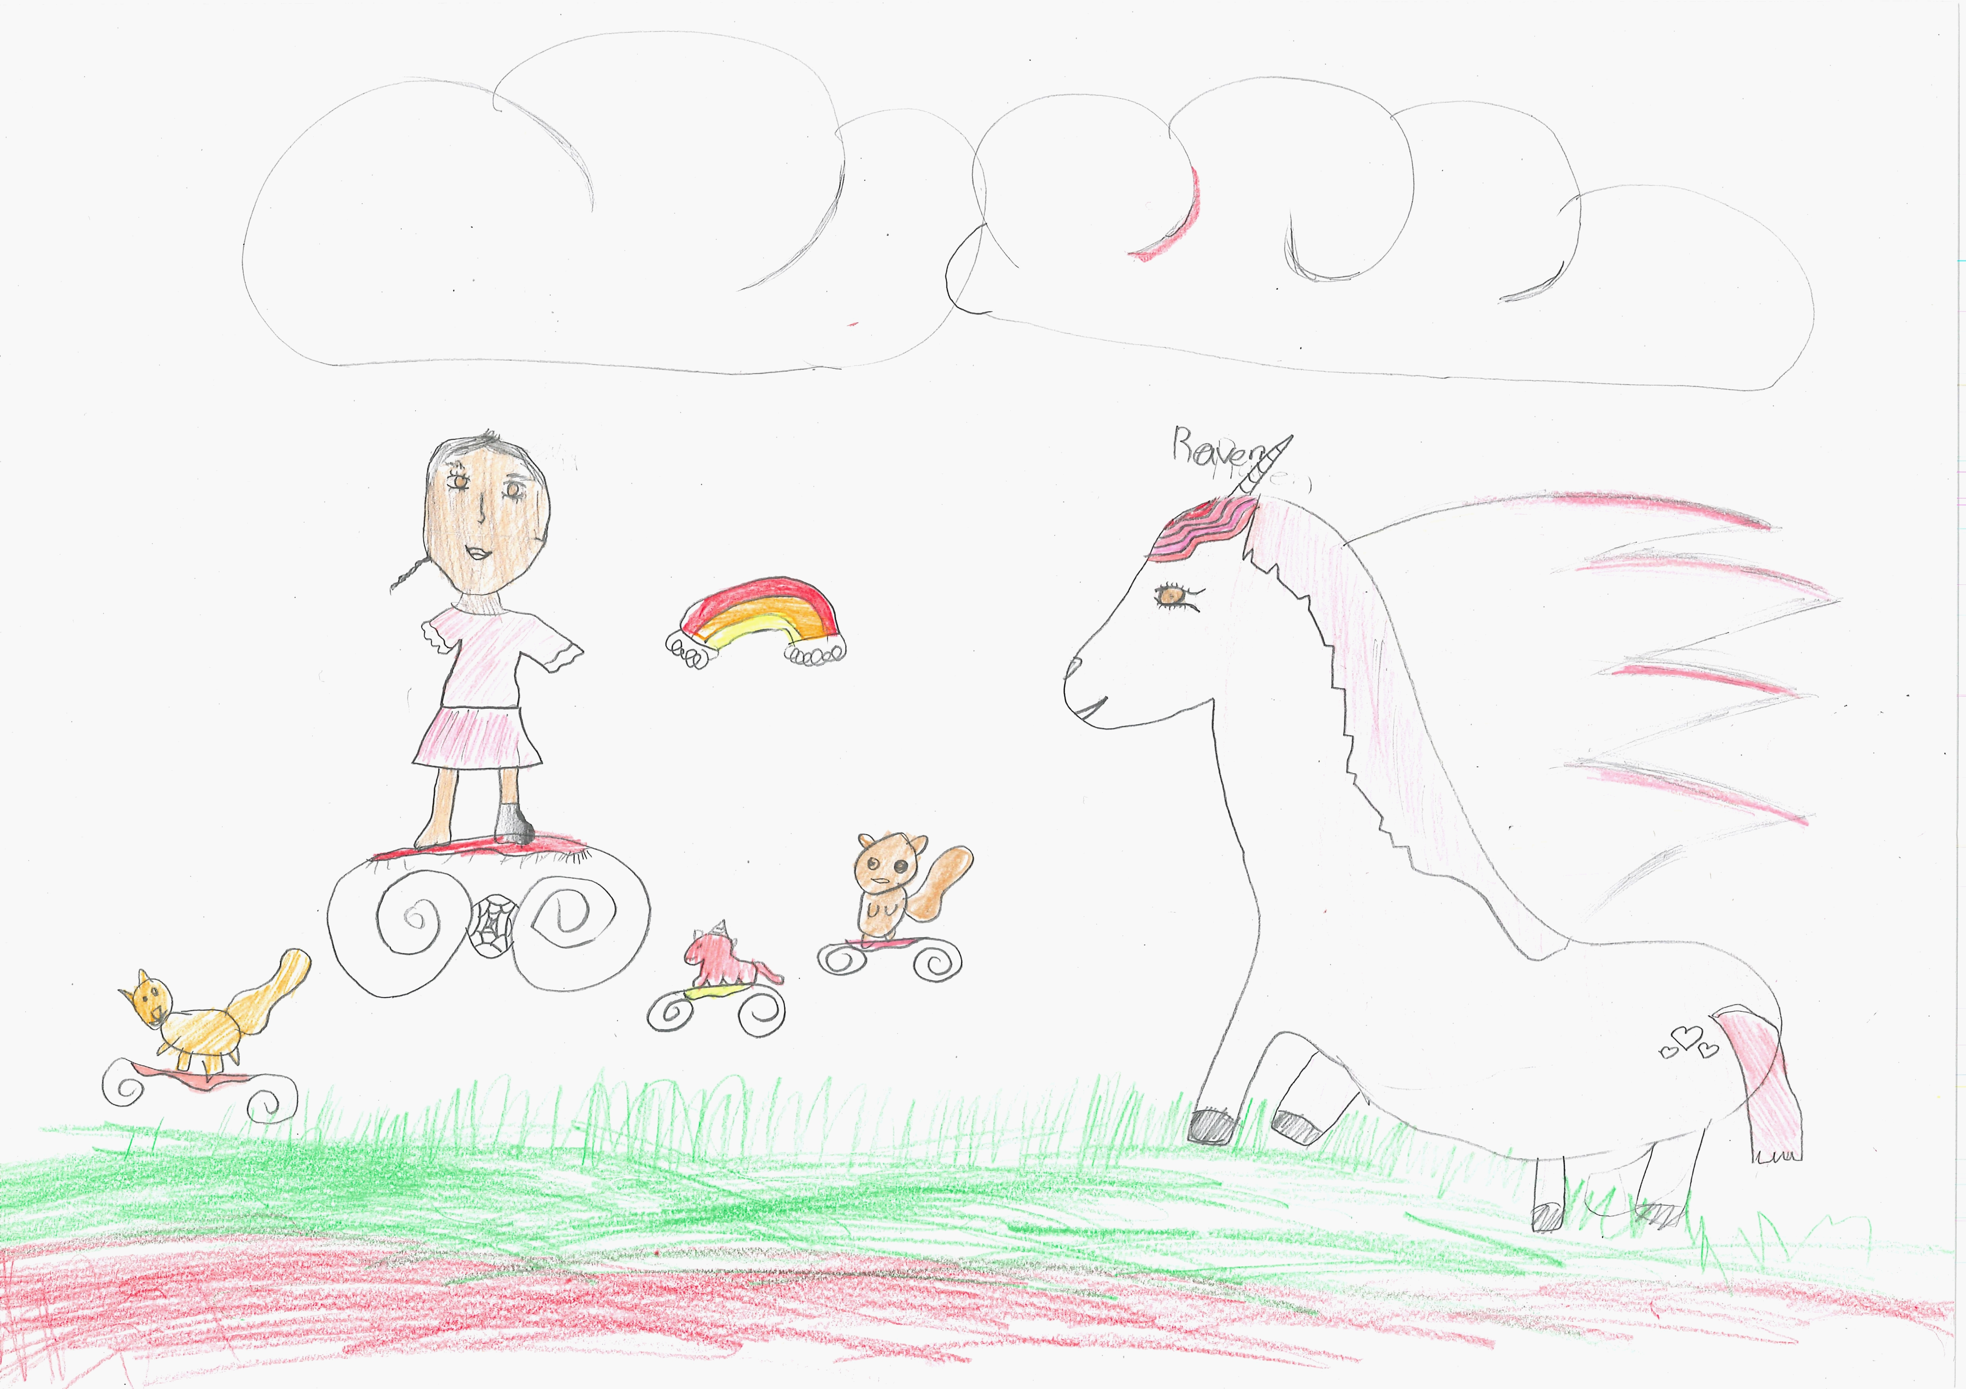400

A recording Rainbow can be found here:
400

This is the unique QR code for this Imagined Thing. Right click it to save then share it, so you and others can find your way back to here to this point of The Well.

IT IS KNOWN! HUZZAH FOR THE GREAT & GRAND RUMPUS!

