66. Subject 0
HERE LIES THE ENTRY FOR AN IMAGINED THING
This is a thing imagined by Catherine, aged , on Thursday July 8
The full name of this thing is: Subject 0
It can be found in: Cave environment
It is known that: 1. - Has a hidden mouth - speaks with its mouth closed - voice in your head - evolved to look harmless - test subject - doesn't eat, sleeps al day - preserves energy from sleeping - from the start of time 2. - very, very dumb/chaotic - furry AF/full of fur 3. Evil and good
This thing has three important features: Hidden mouth, Furry, and Evil and good

An image of Subject 0 can be found here:
upload_image_file_2400 upload_image_file_3400 upload_image_file_4400 upload_image_file_5400
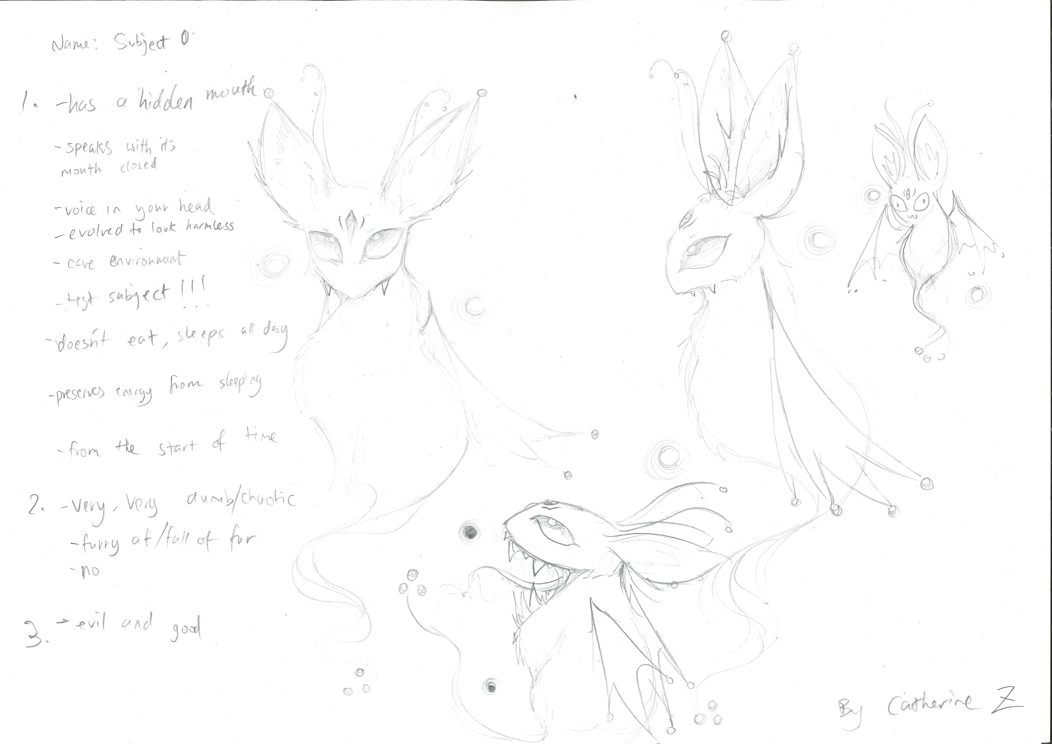400

A recording Subject 0 can be found here:
upload_your_audio_file400

This is the unique QR code for this Imagined Thing. Right click it to save then share it, so you and others can find your way back to here to this point of The Well.

IT IS KNOWN! HUZZAH FOR THE GREAT & GRAND RUMPUS!

