64. Pig Lump
HERE LIES THE ENTRY FOR AN IMAGINED THING
This is a thing imagined by Kai, aged , on Thursday July 8
The full name of this thing is: Pig Lump
It can be found in: The ground
It is known that: Comes from the ground
This thing has three important features: Spots, Pink mouth, and Round eyes

An image of Pig Lump can be found here:
upload_image_file_2400 upload_image_file_3400 upload_image_file_4400 upload_image_file_5400
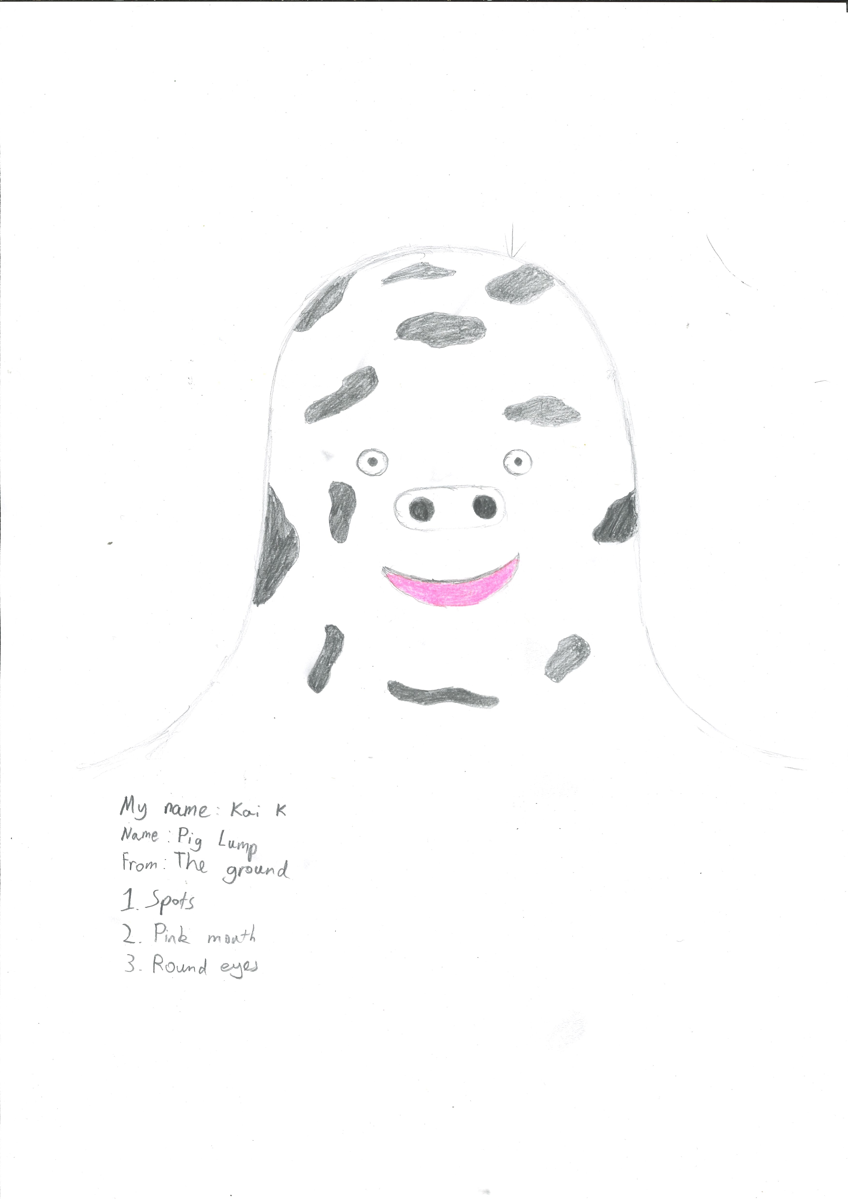400

A recording Pig Lump can be found here:
upload_your_audio_file400

This is the unique QR code for this Imagined Thing. Right click it to save then share it, so you and others can find your way back to here to this point of The Well.

IT IS KNOWN! HUZZAH FOR THE GREAT & GRAND RUMPUS!

