62. Monster
HERE LIES THE ENTRY FOR AN IMAGINED THING
This is a thing imagined by Reuben, aged , on Thursday July 8
The full name of this thing is: Monster
It can be found in: The hallway
It is known that: Evolution of a spider
This thing has three important features: Quick, Big, and Dark

An image of Monster can be found here:
upload_image_file_2400 upload_image_file_3400 upload_image_file_4400 upload_image_file_5400
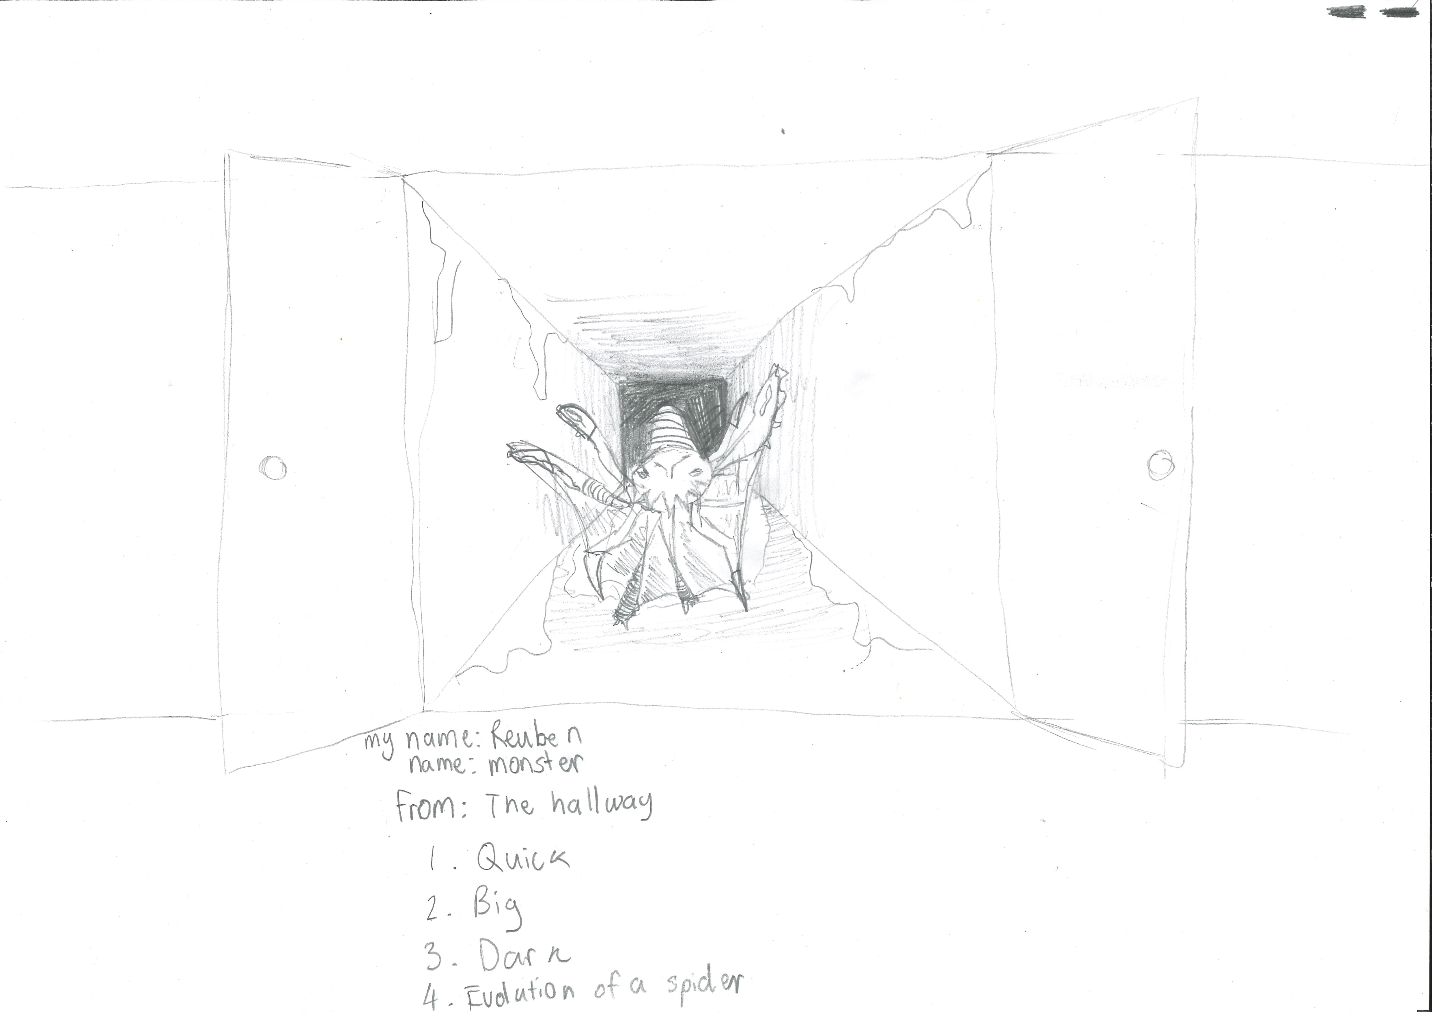400

A recording Monster can be found here:
upload_your_audio_file400

This is the unique QR code for this Imagined Thing. Right click it to save then share it, so you and others can find your way back to here to this point of The Well.

IT IS KNOWN! HUZZAH FOR THE GREAT & GRAND RUMPUS!

