61. Silly Sally
HERE LIES THE ENTRY FOR AN IMAGINED THING
This is a thing imagined by David , aged , on Thursday July 8
The full name of this thing is: Silly Sally
It can be found in: Forest
It is known that: Wobbles around 'cuz of thiccness
This thing has three important features: Big mouth - to scoop up children, Many hands to keep kid's belongings, and Mask stuck to face

An image of Silly Sally can be found here:
upload_image_file_2400 upload_image_file_3400 upload_image_file_4400 upload_image_file_5400
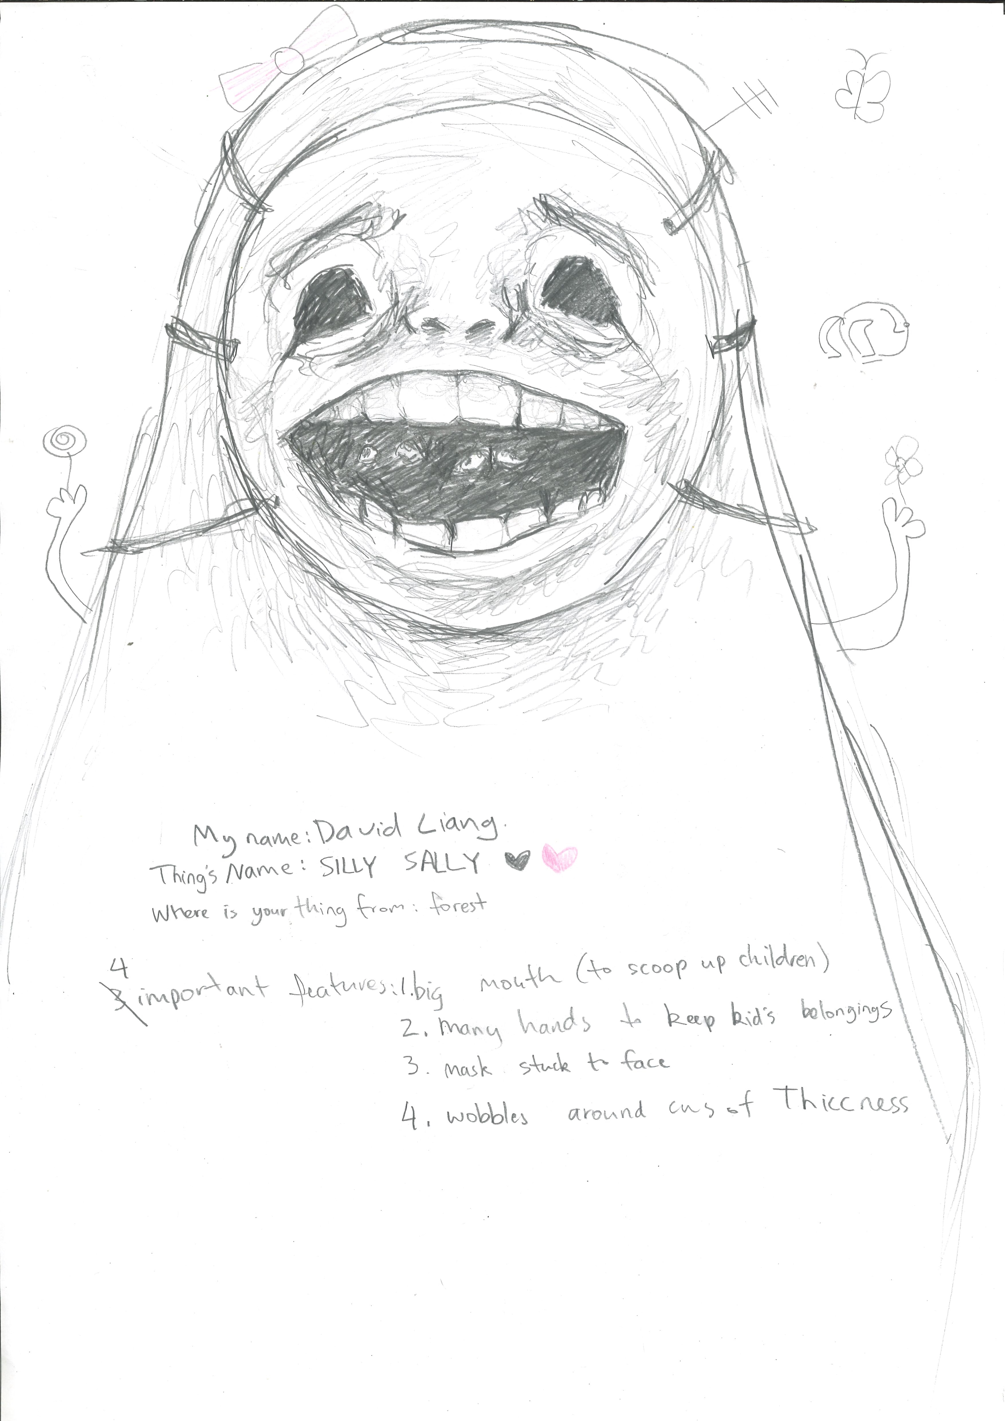400

A recording Silly Sally can be found here:
upload_your_audio_file400

This is the unique QR code for this Imagined Thing. Right click it to save then share it, so you and others can find your way back to here to this point of The Well.

IT IS KNOWN! HUZZAH FOR THE GREAT & GRAND RUMPUS!

